CONSED Quiz
Please download the file titled SequenceQuiz from WebCT. This folder will have the necessary files to view 3 contigs. Your task will be to open x11, open consed, and ultimately to join the three contigs into one. Answer the following short answer questions while you do so.
- Open assembly view. Please describe what each of the following indicate:
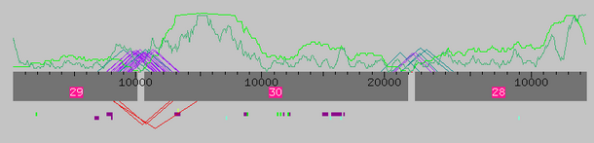
  - The light and dark green lines

  - The purple triangles above the contigs

  - The red triangles below the contigs

- Please examine how these contigs assemble. Run the necessary programs to show that the contigs do fit together and how. What does this program identify in the sequence that allows it to make these suggestions?

- Are all of the suggestions made by this program correct? What does this suggest about the regions that are highlighted?

- Examine the chromatogram of the consensus sequence. If you cannot do so, explain what about the consensus sequence does not allow you to do so.

- Examine the sequence comparison below. What is the significance of the X’s between the two alignments?
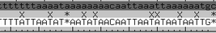

- Align for yourself two contigs in a way in which you feel they should be joined. I would argue that the match is poor because of the large amounts of mismatching How could you go about refuting this?

- Join all contigs. Save the file as Q2 and raise your hand. Stephanie or Paul will come over to examine if you have completed the assembly properly.

