Consed Installation Instructions for

Mac OS X

Installing X11
- Because Consed relies on an application called X11 (also known as XQuartz), you will need to install X11 prior to installing Consed.

  - Log into a user account with administrative privilege

  - Open a web browser and navigate to https://www.xquartz.org/releases/XQuartz-2.7.9.html
Note that we are installing an old version of XQuartz because newer versions of XQuartz (e.g., 2.7.11) are incompatible with Consed.

  - Click on the XQuartz-2.7.9 link to download the package.
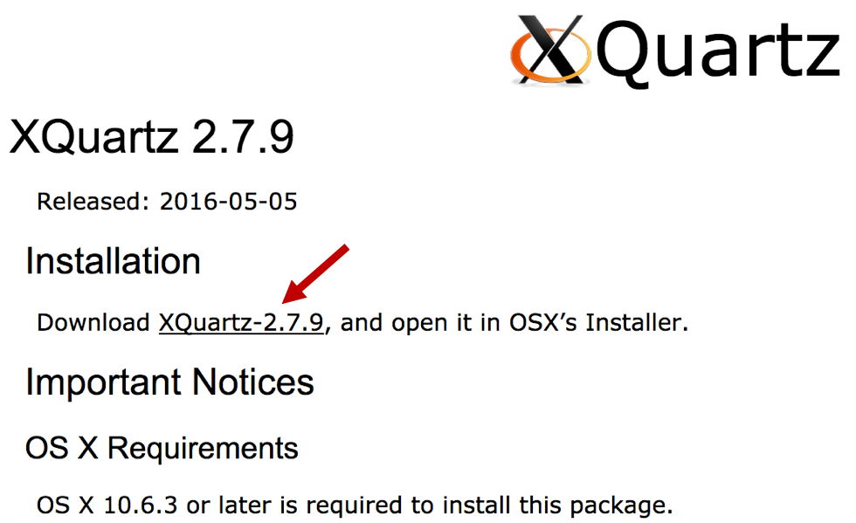

- Most web browsers will save the package either in the Downloads folder or on the Desktop by default. Once the download is complete, double click on the XQuartz-2.7.9.dmg package to expand the installer package. Double click on the “XQuartz.pkg” file to launch the installer.

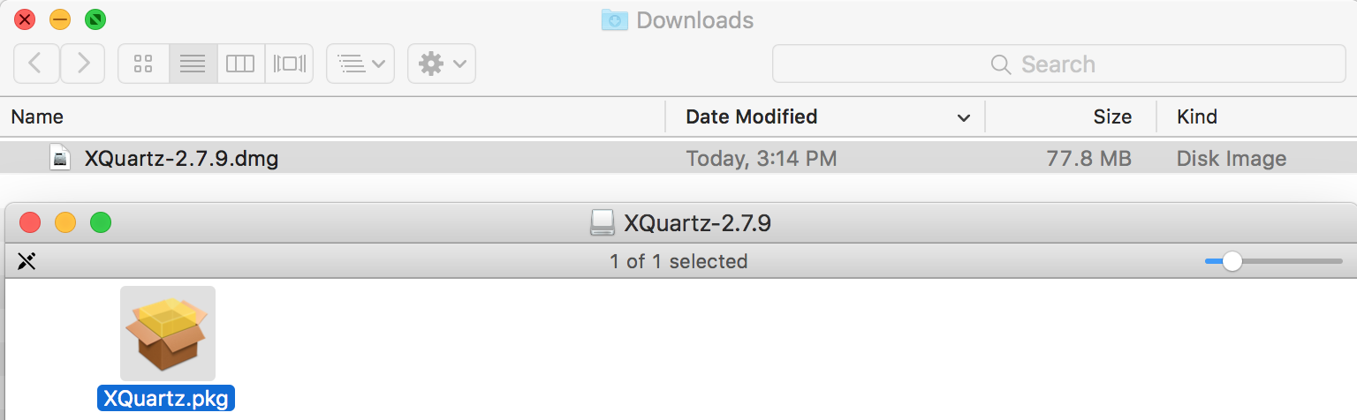

- Follow the instructions from the XQuartz installer to install the package (i.e., Continue → Agree to the License Agreement → Install)

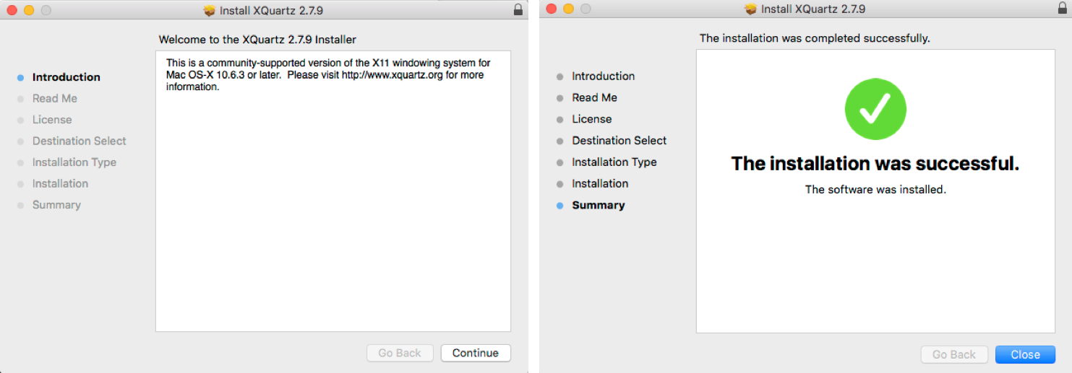

- The installer might take a while to complete (particularly at the “Running package scripts…” stage), so be patient.

- Restart your computer once the XQuartz application has been installed successfully

Installing Consed

- Log in to your administrative account. Open a web browser and download the Consed installation package at:
https://wustl.box.com/v/consed25-mac-installer

Please contact the GEP staff for the password required to download the installation package.

- Navigate to the directory where you have saved the package

  - Most web browsers will save the file in the Downloads folder or on your Desktop by default. For this tutorial, we will assume that the package is available in the Downloads folder.

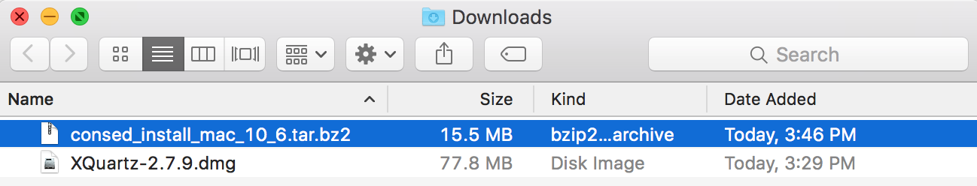

- Double click on this file (consed_install_mac_10_6.tar.bz2) to expand the Consed installation package
  - A new folder called consed_install_mac_10_6 will appear in the Downloads directory

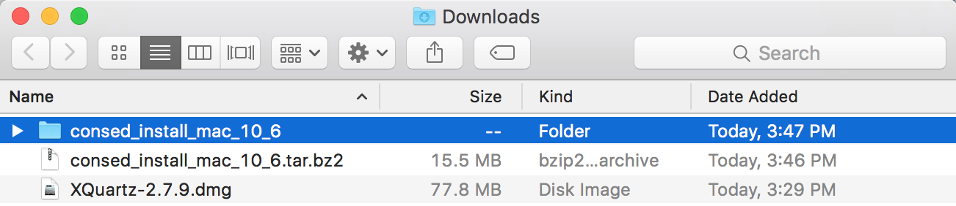

- Open a new Finder window and select “Go” → “Go to Folder” on the main menu bar

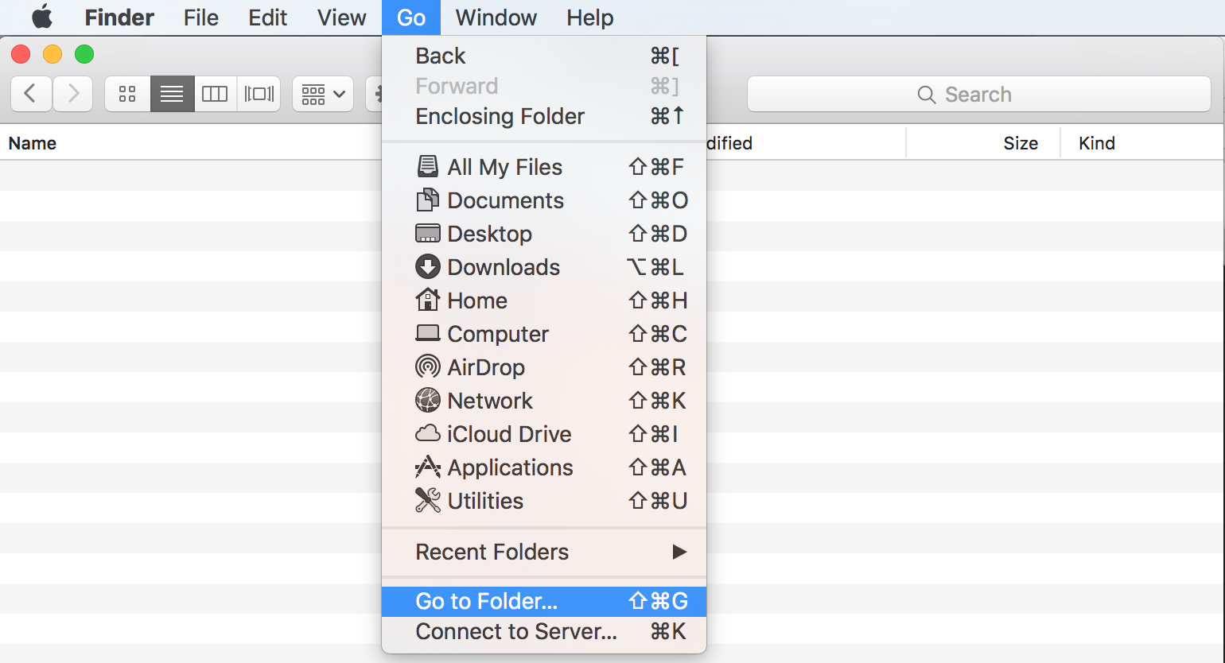

- Copy and paste the following path into the dialog box and then click on the “Go” button

/usr/local

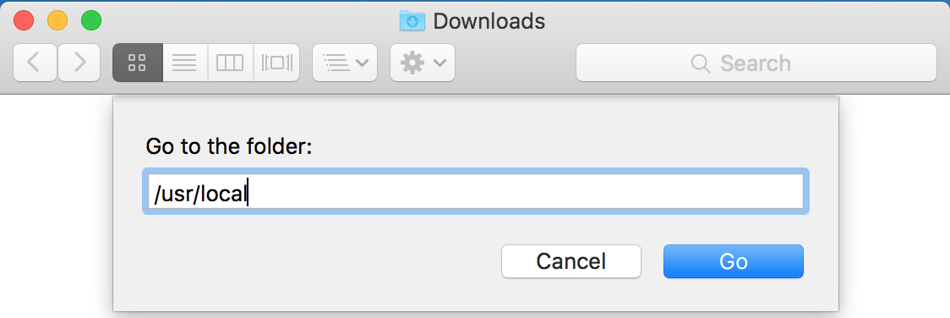

- You should now have two Finder windows open: the first window contains the folder with the Consed installation package and the second window with an empty folder called local.

- Double click on the consed_install_mac_10_6 folder, you should find a folder called genome. Drag the genome folder from the consed_install_mac_10_6 directory to the local folder.

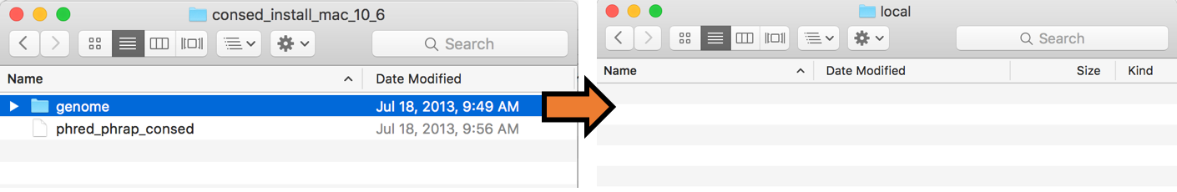

- Because the /usr/local folder is a protected folder in Mac OS X, you will need to click on the Authenticate button and then enter the username and password of your administrator account in order to copy the genome folder into /usr/local

- If all goes well, the genome folder should appear in the /usr/local folder.

- Consed is now installed on your computer. However, in order to allow us to more easily access Consed from the command line, we will setup a shortcut to Consed.

- Select the Finder window for the /usr/local folder and select “Go” → “Go to Folder” in the menu bar again. Copy and paste the following into dialog box and click “Go”

/etc/paths.d

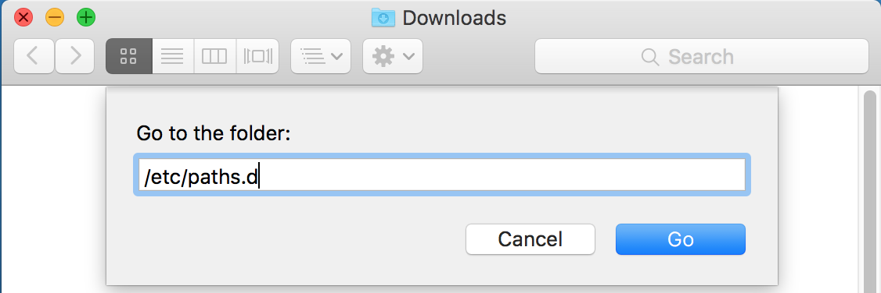

- A folder called paths.d will appear which contains a single file called X11. Select the phred_phrap_consed file in the consed_install_mac_10_6 folder and move it to the paths.d folder

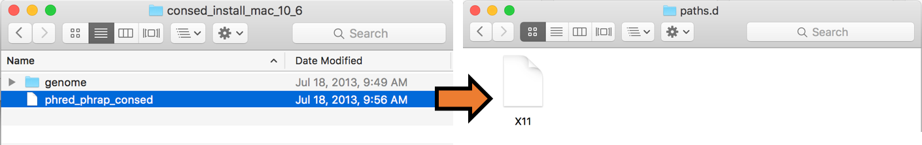

- Like the /usr/local folder, /etc/paths.d is a protected folder in Mac OS X. You will need to click on the Authenticate button and then enter the username and password for your administrator account in order to copy the phred_phrap_consed file into /etc/paths.d

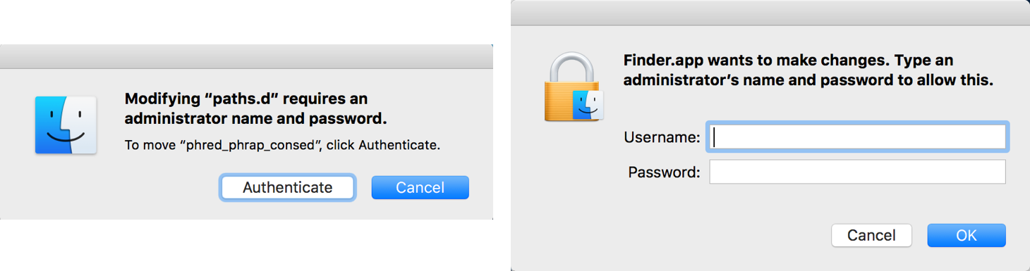

Verify the Consed Installation
The Consed installation is now complete. Next we will download a sequence improvement project from the GEP web site so that we can use it to test our Consed installation.

- Open a web browser and download the sequence improvement package for the Using Consed Graphically tutorial at:
http://gep.wustl.edu/curriculum/course_materials_WU/sequence_improvement/tutorials_and_walkthroughs

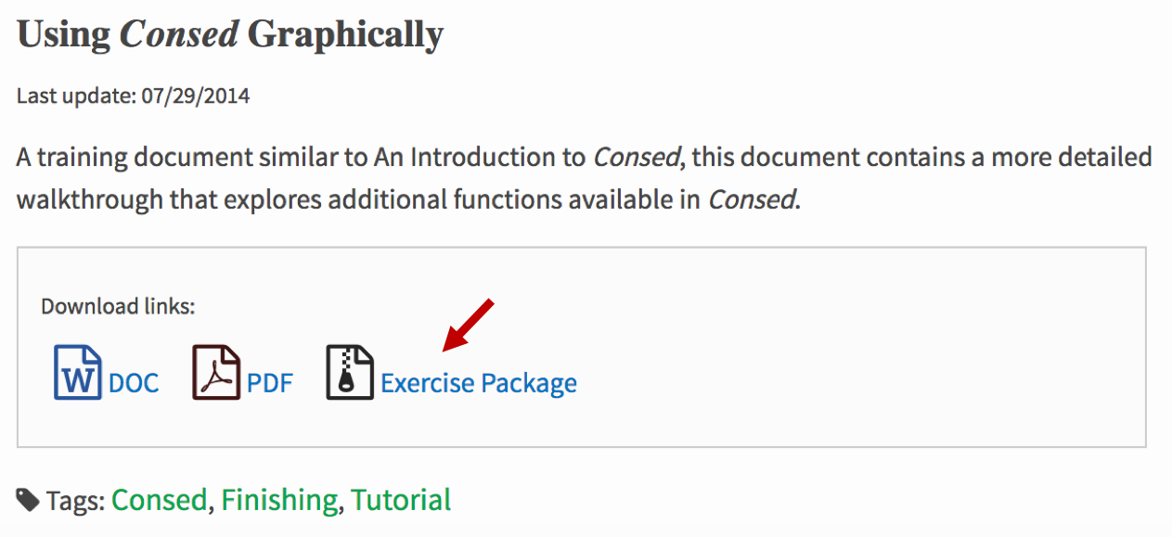

- Once the download is complete, double click on the file to expand the package. Move the folder (called Standard3) to your home directory.
  - The home directory is the same as your account name by default.

- Before we can launch Consed, we need to first launch the Terminal program.
  - Navigate to the Utilities folder (inside the Applications Folder) and double click on the “Terminal” application.
Alternatively, you can simply type “Terminal” into Spotlight search to launch the Terminal application
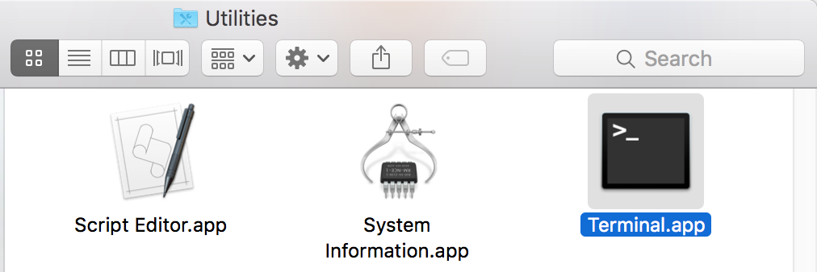

    - You might want to drag the Terminal application into the Dock to make it easier to access this application in the future.

- When you open the Terminal application, a new Terminal window should appear where you can enter commands. Type the following into the Terminal to verify that you can access Consed:

consed –v

This command should report the version of Consed that has been installed (version 25.0 in this case). Note that the “Darwin Version” line might be different because it depends on the version of Mac OS X.

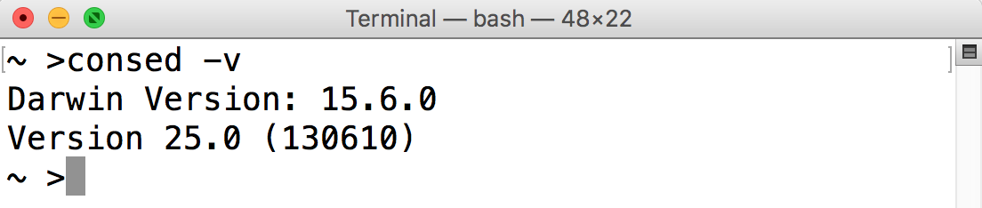

- Next we will try to open a Consed project. Assuming that the Standard3 project is in your home directory (as described above), type the following into the Terminal to open the project:

cd ~/Standard3/edit_dir/
consed &

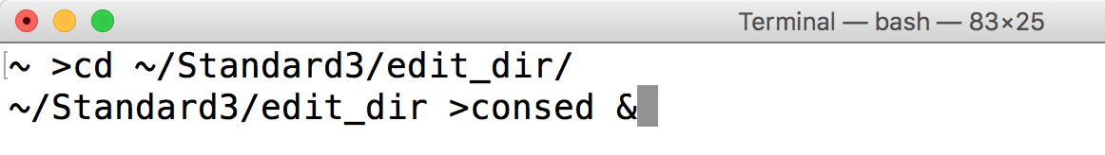

- If all goes well, Consed should launch and we can open the 454Contigs.ace.1 file

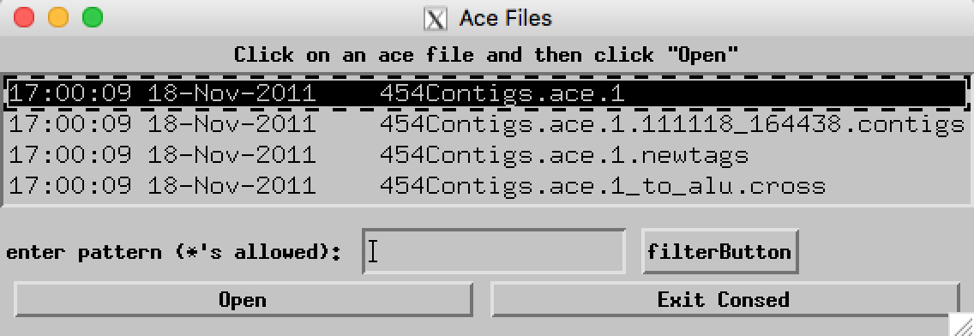

Note that a Software Update dialog may appear when you launch Consed. Click on the “Skip This Version” button because the current version of XQuartz (2.7.11) is incompatible with Consed.

At this point, you should work through the Using Consed Graphically exercise to verify that Consed has been installed correctly. In particular, you should verify that you can open and edit traces, run cross_match in Assembly View, do tear and joins, and run MiniAssembly. Detailed instructions on how to accomplish these tasks are described in the Using Consed Graphically tutorial.

