Pathways Project: Genomic Neighborhood Check For Understanding
Katie M. Sandlin & Sarah A. Justice

Directions: You’ve been assigned to annotate VhaAC39-1 in D. ananassae (Assembly: Sep. 2021 (University of Maryland, ASM1763931v2/DanaRefSeq2)). The first step in the annotation process is to determine whether you have the correct ortholog. Complete the questions below to indicate how you would use genomic neighborhood to establish orthology.

Drosophila melanogaster
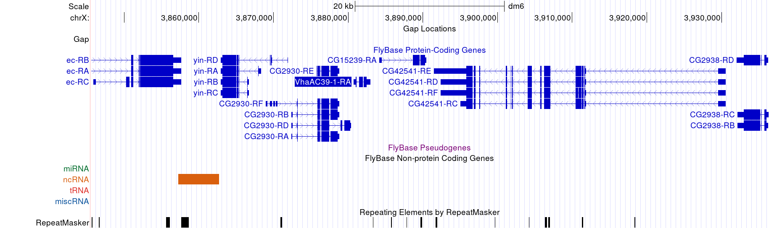

1. What is your target species?

2. What is your reference species?

3. What is your target gene?

4. In 2-3 sentences, describe a genomic neighborhood by using each of the following words: target gene, reference species, target species, nearest upstream neighbor, nearest downstream neighbor, second closest upstream neighbor, and second closest downstream neighbor.

5. Draw a sketch of the genomic neighborhood of your target gene in D. melanogaster (similar to the sketch in Figure 11 of the Pathways Project: Annotation Walkthrough). Be sure your sketch includes the names and/or gene symbols of the surrounding genes and indicates their orientation.

6. Using the instructions in Part 2 of the Pathways Project: Annotation Walkthrough, complete the table below for the tblastn comparison of the D. melanogaster gene to the target species genome.
TABLE 1: Summary of the tblastn search results for the best scaffold match
Range | D. melanogaster |  | Target Species |  | E-Value | Identities (%) | Subject Frame
 | Query  Start | Query  End | Subject  Start | Subject  End
Depending on your results, you may need to add additional rows by clicking in the bottom-right-most cell and pressing tab (or see Microsoft Support). You may also need to duplicate this table (via copy and paste) if you have more than one very good match in your tblastn search.

7. Which evidence track will you use to determine the genomic neighborhood for your target species ortholog (Hint: It isn’t “Spaln Alignment of D. melanogaster Proteins”)?

8. Complete this table using the instructions in Part 3 of the Pathways Project: Annotation Walkthrough.

TABLE 2: blastp search results for the protein sequences of the genomic neighborhood of the target gene in the target species against the D. melanogaster (taxid:7227) reference protein database (refseq_protein)
 |  | 2nd Closest  Upstream | Closest  Upstream | Nested within or Nesting of Target Gene | Target  Gene | Closest Downstream | 2nd Closest Downstream
D. melanogaster | Gene Symbol
 | Strand (+/-)
Target Species | NCBI RefSeq Gene (mRNA) Accession
NCBI RefSeq
Protein Accession
 | Strand (+/-)

9. Using the completed Table in #8 and/or viewing in the GEP UCSC Genome Browser, draw a sketch of the genomic neighborhood of your target gene in your target species (similar to the sketch in Figure 40 of the Pathways Project: Annotation Walkthrough). Be sure your sketch includes the protein accession number of the surrounding genes and indicates their orientation.

10. Imagine that your target gene in D. ananassae was on the opposite DNA strand as you determined above. How would that change your genomic neighborhood sketch? Draw a sketch with the directionality and label which genes are upstream and downstream.

If your target gene is not nested within another gene, or another gene is not nested within your target gene, you can either leave this column blank or put an “X” in each box within the column.

