Transcription Start Sites Project Report

Sample TSS report for onecut

Student name(s): Wilson Leung
Student email(s): student@example.edu
Faculty advisor(s): Sarah C. R. Elgin
College/university: Washington University in St. Louis

Project details
Project name: contig35
Project species: D. biarmipes
Date of submission: 12/26/2023
Number of genes in project: 3

Does this report cover TSS annotations for all of the genes or is it a partial report? Partial report
If this is a partial report, please indicate the region of the project covered by this report:
From base 12,051 to base 21,700

Transcription start sites (TSS) report form
Complete this report form for each gene in your project. Copy and paste this form to create as many copies as needed.

Gene name (e.g., D. biarmipes eyeless): D. biarmipes onecut

Gene symbol (e.g., dbia_ey): dbia_onecut

Name(s) of isoform(s) with unique TSS | List of isoforms with identical TSS
onecut-RA | onecut-RB

Names of the isoforms with unique TSS in D. melanogaster that are absent in this species:
NA

Isoform TSS report
Complete an Isoform TSS report (through page 7) for each unique TSS listed in the table above. If the gene has more than one unique TSS, copy and paste this form to create as many copies as needed.

Gene-isoform name (e.g., dbia_ey-RA): dbia_onecut-RA
Names of the isoforms with the same TSS as this isoform:
dbia_onecut-RB

Type of core promoter in D. melanogaster (see table below):
(Peaked / Intermediate / Broad / Insufficient Evidence)
Peaked
The type of core promoter is defined by the number of TSS annotated by the Celniker group at modENCODE and the number of DHS positions:

Type of core promoter | # annotated TSS | # DHS positions
Peaked | 1 | 0
 | 0 | 1
 | 1 | 1
Intermediate | ≤ 1 | > 1
 | > 1 | ≤ 1
Broad | > 1 | > 1
Insufficient Evidence | 0 | 0

1. Annotate the first transcribed exon
Coordinates of the first transcribed exon based on blastn alignment:
21,599–18,924

Does the blastn alignment cover the entire D. melanogaster first transcribed exon? If not, specify the parts of the D. melanogaster exon that are missing from the blastn alignment.
Yes, the blastn alignment covers the entire length (2647 bp) of the first transcribed exon onecut:3

If the TSS annotation is supported by blastn alignment of the initial transcribed exon against the contig sequence, paste a screenshot of the blastn alignment into the box below:

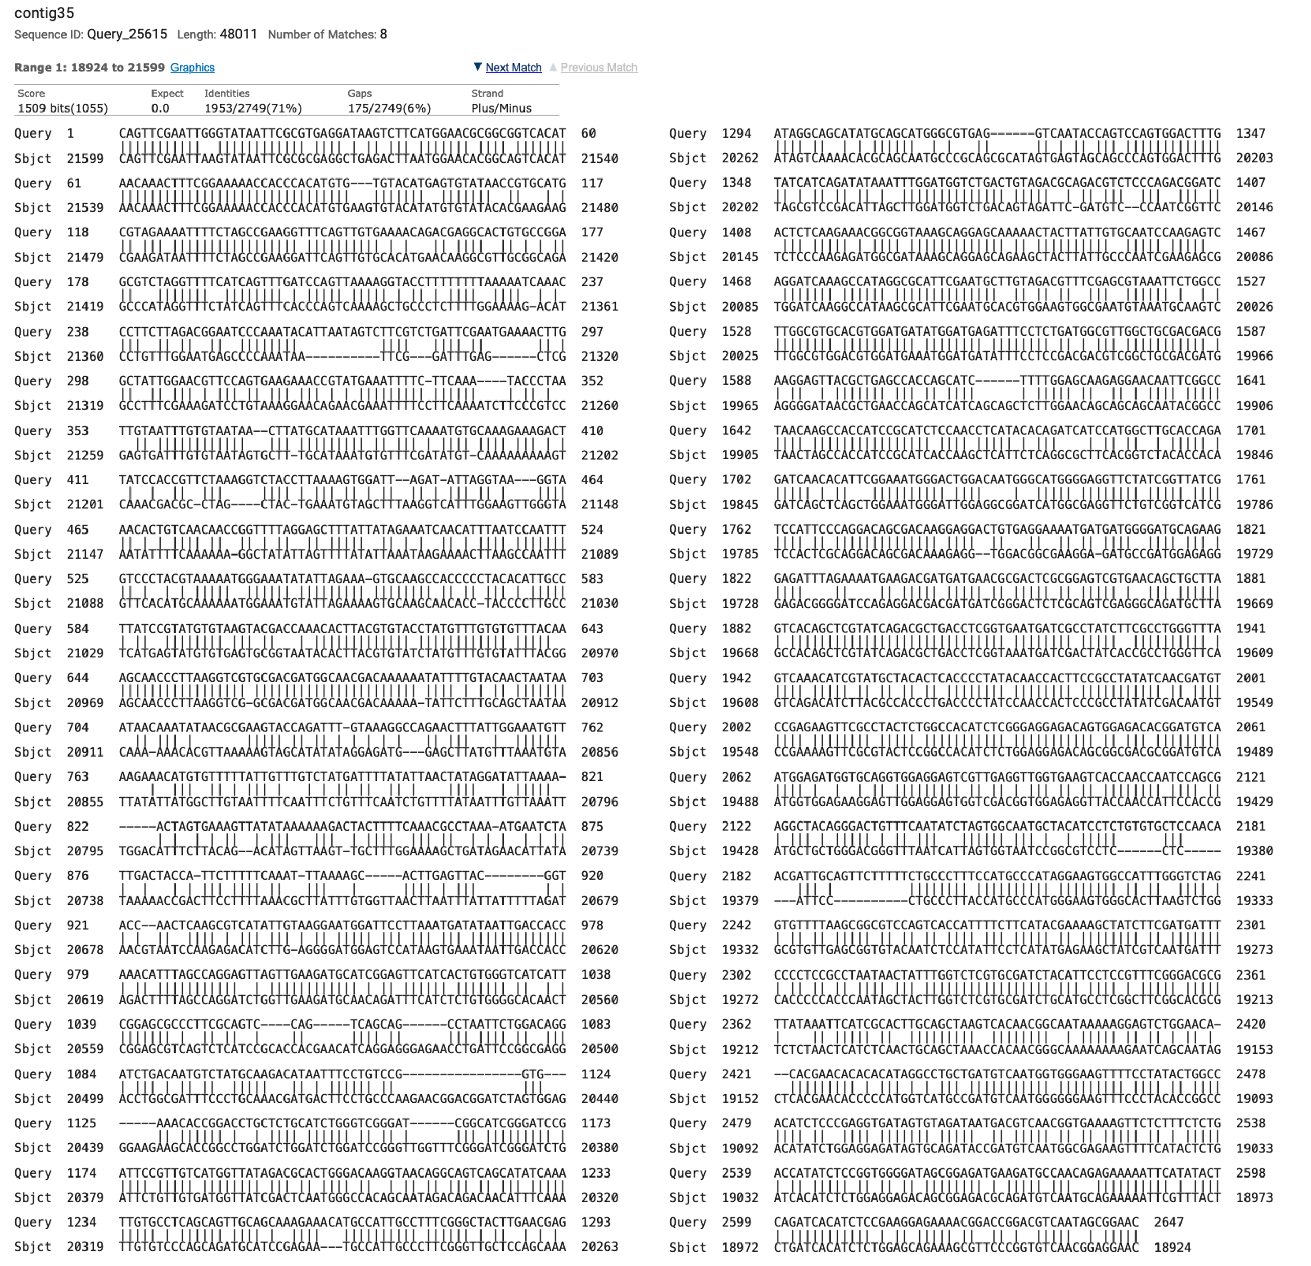

2. Turn on RNA-Seq evidence tracks
If the TSS annotation is supported by RNA-Seq read coverage or splice junction predictions (e.g., TopHat, regtools), paste a Genome Browser screenshot of the region surrounding the putative TSS (± 300 bp) with the following evidence tracks:

- RNA-Seq Alignment Summary or RNA-Seq Coverage
- RNA-Seq TopHat or Splice Junctions

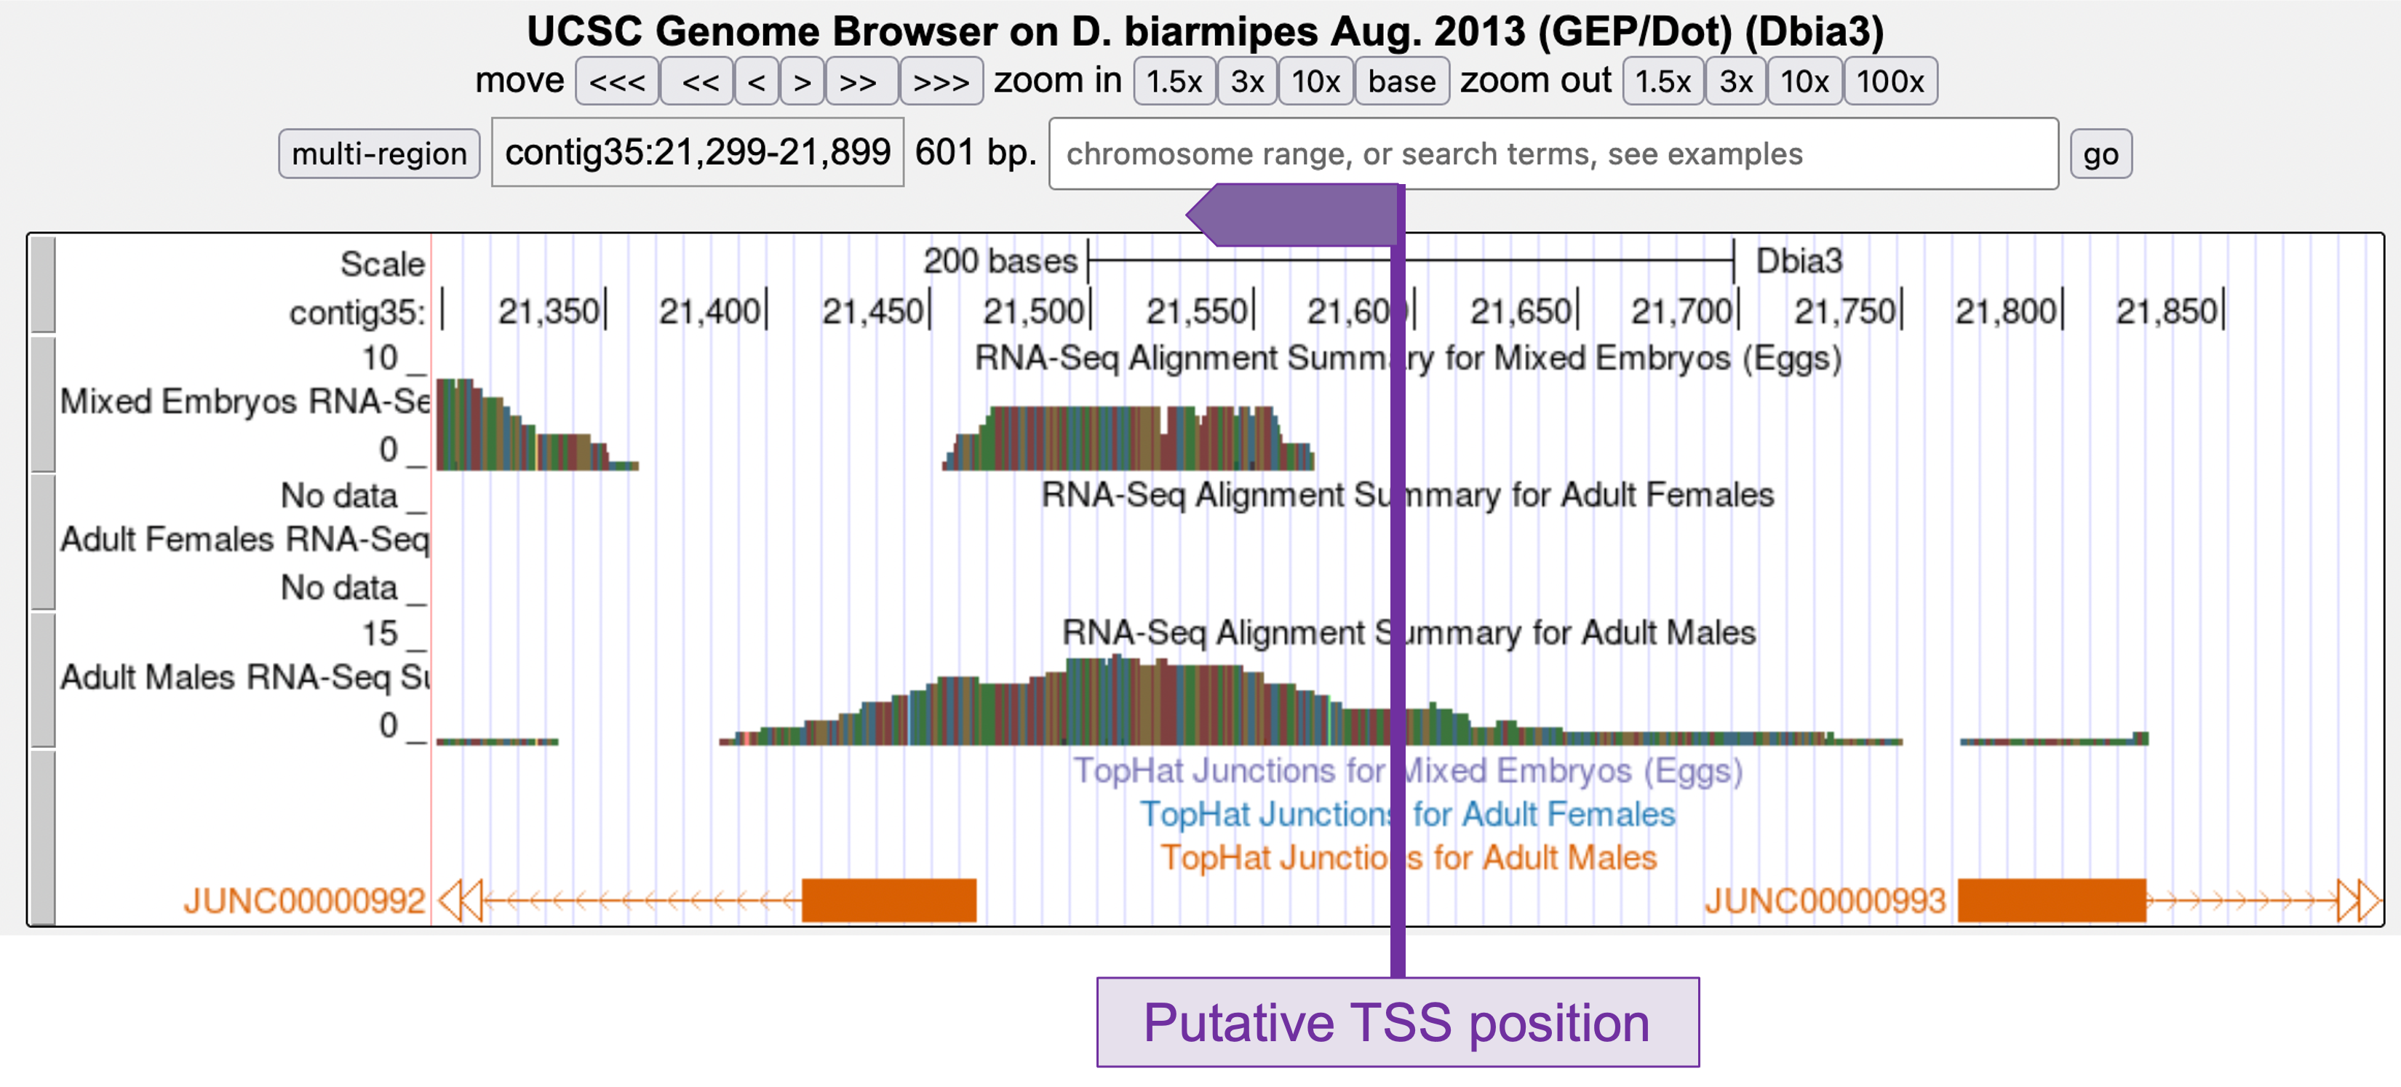
If the RNA-Seq evidence tracks indicate the TSS position, list it here: NA (see explanation below)
If the RNA-Seq evidence tracks indicate a TSS search region, list it here: contig35:21,599–21,750

3. Turn on comparative genomics tracks
If the TSS annotation is supported by sequence conservation with other Drosophila species, paste a screenshot of the multiple sequence alignment (e.g., from Clustal Omega, ROAST) into the box below:

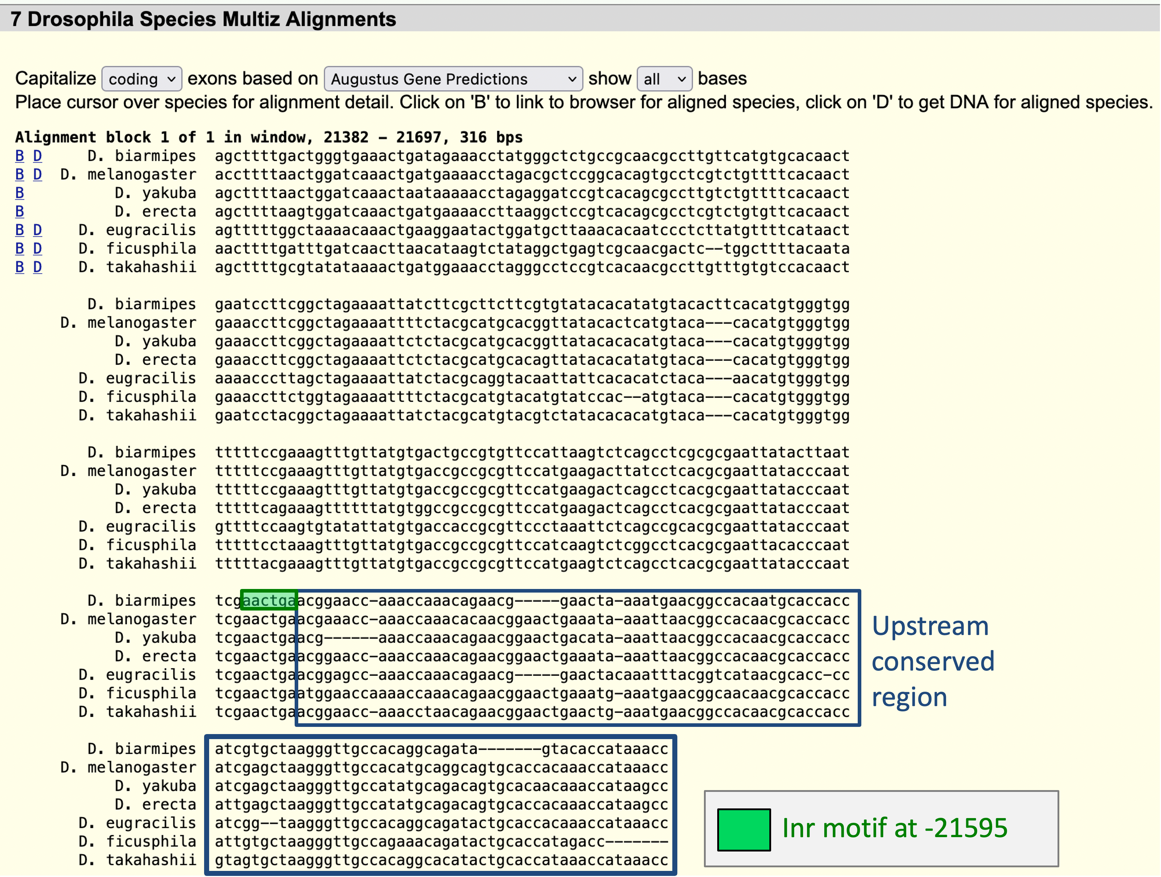

4. Define the TSS search region(s)

Note:
If the blastn alignment to the initial transcribed exon satisfies the criteria listed on page 8 of Module TSS4 (i.e., a long match with low E-value, requires extrapolation of less than 150 bp to the estimated TSS position, alignment is in concordance with other evidence tracks), then you can define the TSS search region as +/- 300 bp from the initial 5’ nucleotide. For example, if the estimated TSS position is located at position 1500, then the narrow TSS search region would be placed at 1200-1800.

If you cannot estimate the TSS position based on the blastn alignment to the initial transcribed exon, then you can define the TSS search region(s) based on the experimental data (e.g., RNA-Seq, RNA PolII ChIP-Seq) and the conservation track for the target species. If part of the TSS search region is only weakly supported by the available evidence, then please specify both a wide and a narrow search region. For example, if the region at 1500-2000 shows high RNA-Seq read coverage but there is very low RNA-Seq coverage from 1000-1499, then you will report “1000-2000” as the wide search region and “1500-2000” as the narrow search region.

Enter “Insufficient evidence” if the narrow search region cannot be determined based on the available evidence.

Coordinates of the narrow TSS search region:

21,599–21,750

Coordinates of the wide TSS search region:
(Enter “NA” if the narrow TSS search region is defined based on the blastn alignment to the initial transcribed exon. Enter “Insufficient evidence” if a wide search region cannot be defined based on the available evidence)

Insufficient evidence

Describe the evidence used to define the TSS search region(s) (e.g., RNA-Seq and Conservation tracks in this species, RAMPAGE data from D. melanogaster):

The TSS search region is defined based on RNA PolII enrichment, RNA-Seq read coverage, sequence conservation among seven Drosophila species, and the Inr motif at 21,630 (see the explanations in section 6 below).

5. Search for core promoter motifs
The consensus sequences for the Drosophila core promoter motifs are available at https://gander.wustl.edu/~wilson/core_promoter_motifs.html

Use the "Short Match" functionality in the GEP UCSC Genome Browser to search for each of the core promoter motifs listed below in the region surrounding the TSS (± 300 bp) in your project and in the D. melanogaster ortholog.

For TSS annotations where you can only define a TSS search region (and not a single coordinate), you should report all motif instances within the narrow TSS search region. If you did not report a narrow TSS search region due to insufficient evidence, report the motif instances in the wide TSS search region.

Coordinates of the motif search region
Your project (e.g., contig10:1500-2000): contig35:21,299-21,899
Orthologous region in D. melanogaster: chr4:607,349-607,949

Record the orientation and the start coordinate (e.g., +10000) of each motif match below. (Enter "NA" if there are no motif instances within the search region.)
Note: Highlight (in yellow) the motif instances that support the TSS annotation above.

Core promoter motif | Your project | D. melanogaster
BRE^{u} | NA | NA
TATA Box | NA | NA
BRE^{d} | -21409, -21494, -21606, -21611,  -21640, -21650, -21686, -21695,  -21818 | -607557, -607635, -607656,  -607661, -607663, -607666,  -607695, -607705, -607745,  -607748, -607757
Inr | -21399, -21448, -21595, -21630,  -21883 | -607452, -607501, -607645,  -607675
MTE | NA | NA
DPE | -21361, -21446, -21809 | -607499, -607831, -607905
Ohler_motif1 | NA | NA
DRE | NA | NA
Ohler_motif5 | NA | NA
Ohler_motif6 | NA | NA
Ohler_motif7 | NA | NA
Ohler_motif8 | NA | NA

6. Summarize all of the evidence that supports the TSS annotation postulated above.

Coordinate(s) of the TSS position(s):
Based on blastn alignment: 21,599
Based on core promoter motifs (e.g., Inr): 21,598
Based on other evidence (please specify): NA
Note: If the blastn alignment for the initial transcribed exon is a partial alignment, you can extrapolate the TSS position based on the number of nucleotides that are missing from the beginning of the exon. (Enter “Insufficient evidence” if you cannot determine the TSS position based on the available evidence.)

Were you able to define a TSS position based on the available evidence? Yes; at 21,599

If so, indicate whether the evidence listed below support the TSS position.
If not, indicate whether the evidence listed below support the TSS search region(s).

Evidence type | Support | Refute | Neither
blastn alignment of the initial exon from D. melanogaster
RNA PolII ChIP-Seq
RNA-Seq coverage and splice junctions
Core promoter motifs
Sequence conservation with other Drosophila species (e.g., “Conservation” track on the Genome Browser)
RefSeq Genes, N-SCAN PASA-EST, and Augustus TSS predictions
Other (please specify)
TSS identified by the RAMPAGE datasets in D. melanogaster
Note: The evidence type refutes the TSS annotation only if it suggests an alternate TSS position. For example, the presence of RNA-Seq read coverage upstream of the annotated TSS indicates that the TSS is located further upstream and it would be considered to be evidence against (i.e., Refute) the annotated TSS. In contrast, the lack of RNA-Seq read coverage is a negative result and it neither supports nor refutes the TSS annotation (i.e., Neither).

Provide an explanation if the TSS annotation is inconsistent with at least one of the evidence types specified above:

The annotation of the TSS position for the D. biarmipes onecut gene is based on minimizing the change in the size of the initial transcribed exon compared to the D. melanogaster ortholog (i.e., parsimony). The blastn alignment of the initial transcribed exon of the A isoform of onecut (onecut:3) from D. melanogaster against the genomic sequence of D. biarmipes contig35 shows a full-length alignment and the exon is highly conserved (with an E-value of 0.0 and a sequence identity of 71%; see screenshot above). The blastn alignment placed the TSS of onecut at 21,599. There is also an Inr motif at 21,595–21,600. Because the Inr motif is found at -2 of the TSS, the Inr motif would place the TSS of onecut at 21,598.

Examination of the Combined RAMPAGE TSS datasets for D. melanogaster suggest there are two strong TSS in onecut. The TSS at 607,649 is consistent with the D. melanogaster FlyBase annotations for the A and B isoforms of onecut while the TSS at 607,648 is consistent with the Inr motif. Both TSS have high RAMPAGE read density but the TSS at 607,648 is stronger than the TSS at 607,649. Hence the TSS of onecut for D. biarmipes is placed at 21,599 based on parsimony with D. melanogaster.

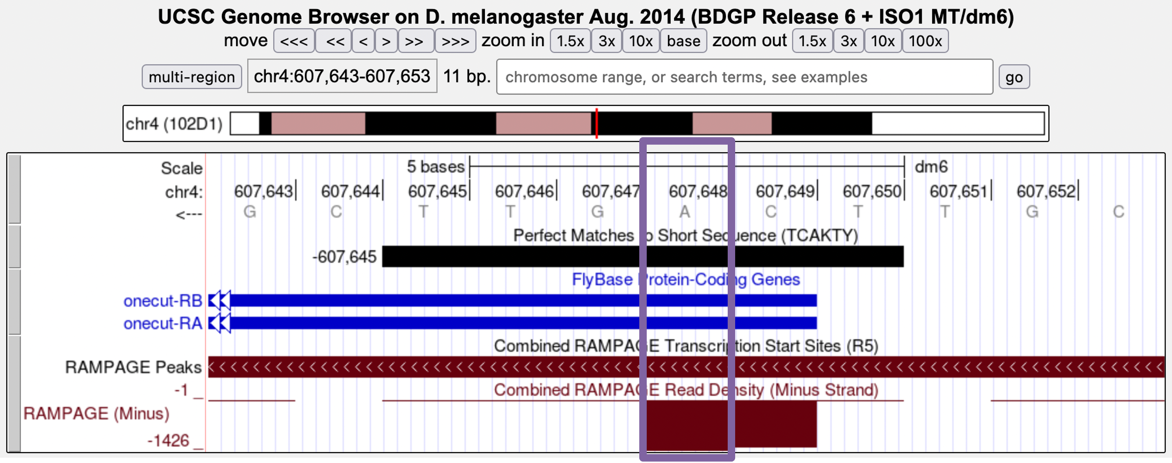

Examination of the region surrounding the blastn alignment to exon onecut:3 (i.e., 21,599–18,924) shows that the available RNA-Seq data generally supports the proposed TSS position at 21,599. For example, the TopHat junctions in adult females and adult males (JUNC00000541 and JUNC00000991, respectively) are consistent with the splice junction between exons onecut:1 and onecut:2 in the B isoform of onecut.

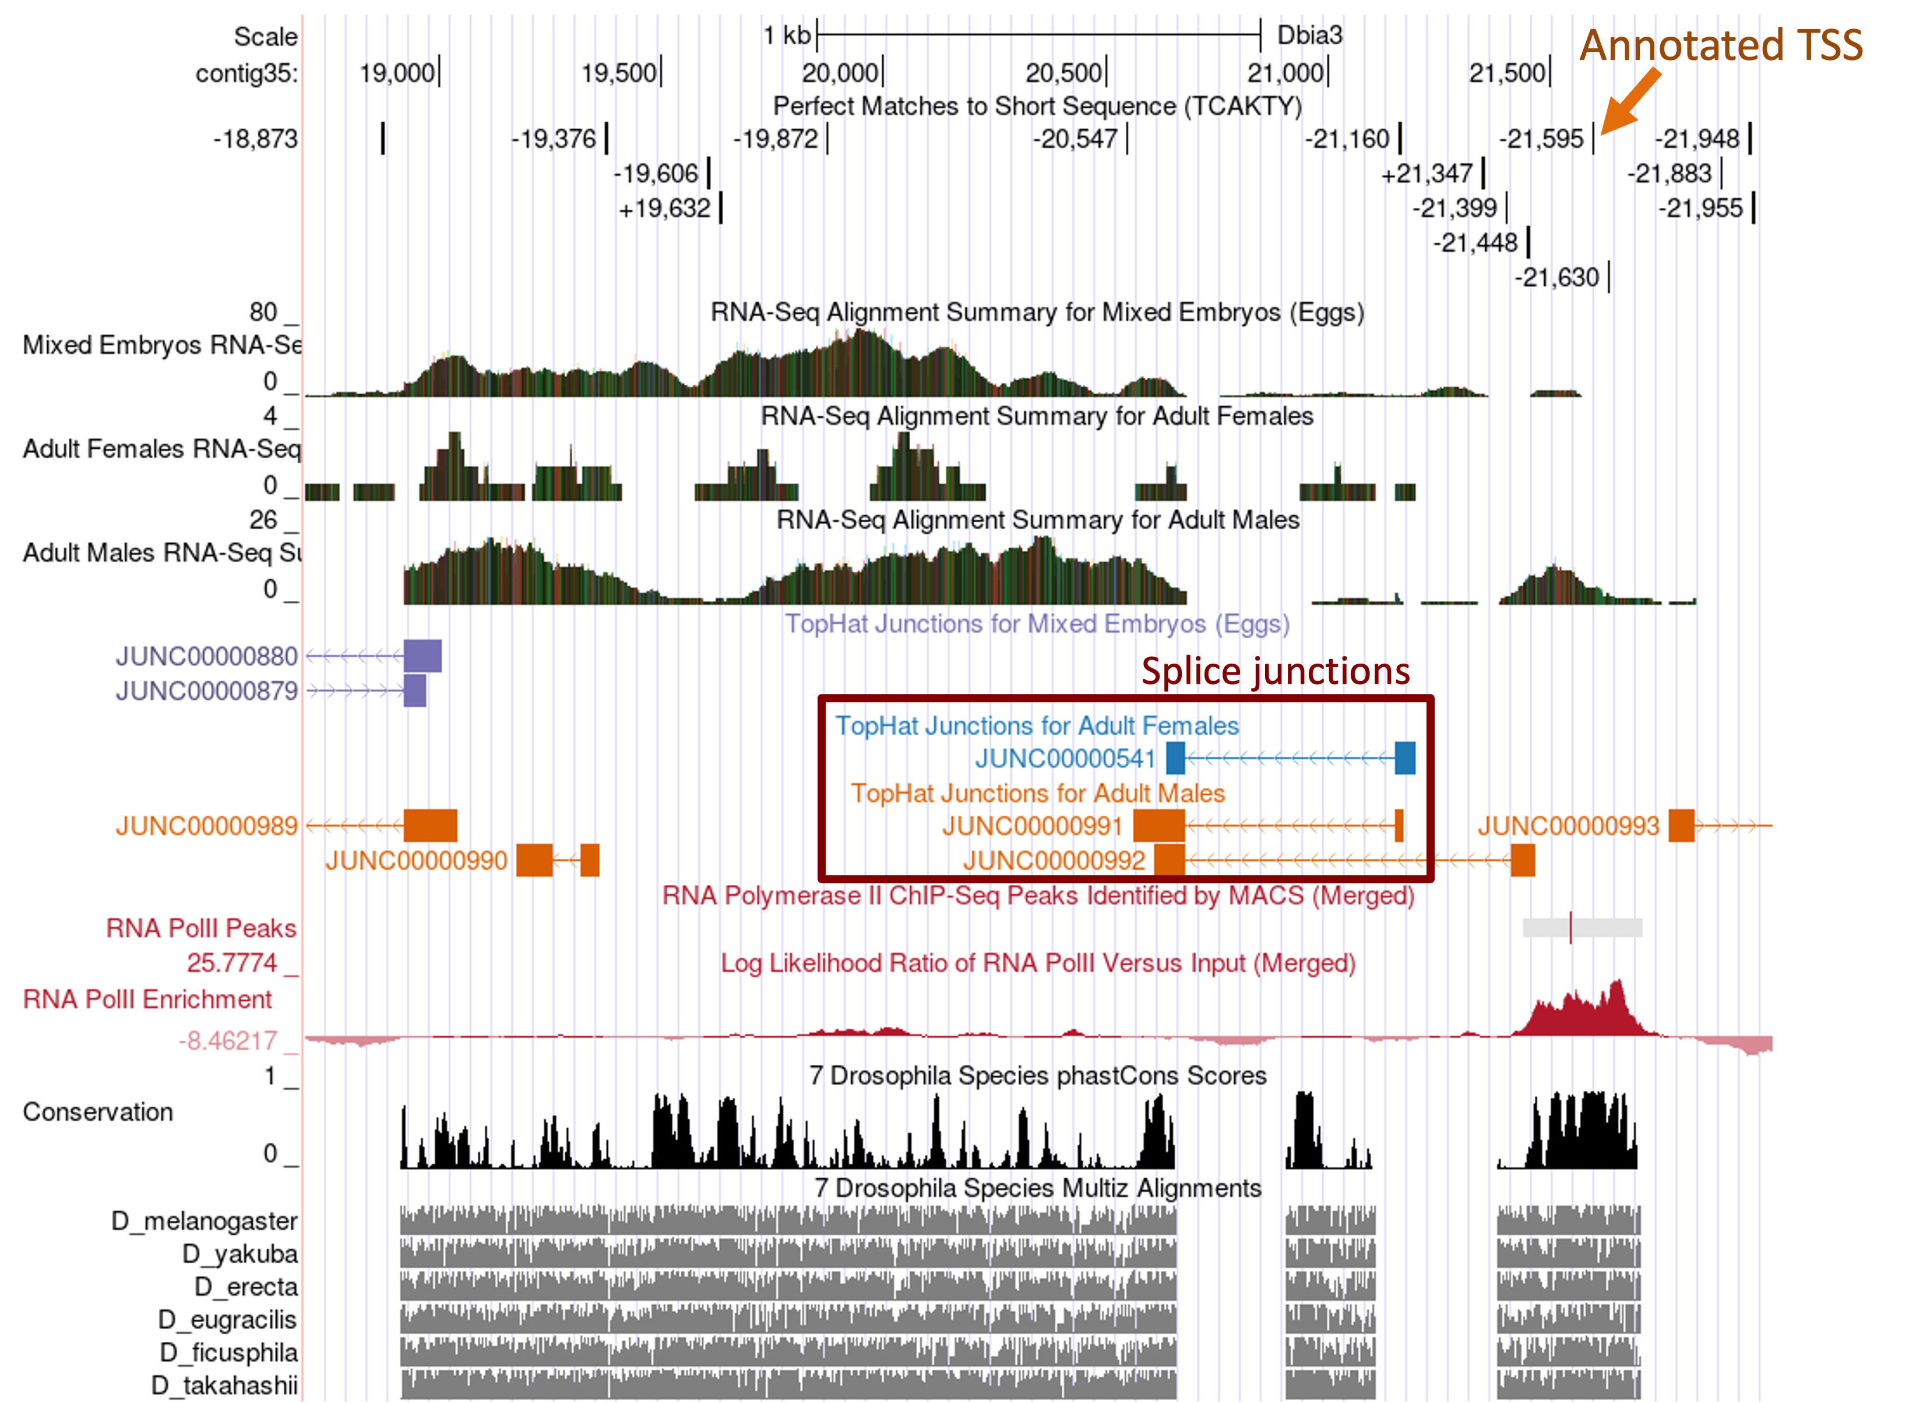

While the RNA-Seq evidence is generally in congruence with the proposed TSS position, the RNA-Seq alignment summary from the adult males sample shows additional RNA-Seq read coverage upstream (i.e., further to the right) of the annotated TSS.

Similarly, the "RNA PolII Peaks" and the "RNA PolII Enrichment" tracks indicate the presence of RNA PolII upstream of the annotated TSS at 21,599. This region also has an Inr motif at 21,630. According to the "Conservation" and the "Most Conserved" tracks, part of this upstream region (21,600–21,697) is highly conserved with the orthologous regions from six Drosophila species (D. melanogaster, D. yakuba, D. erecta, D. ficusphila, D. eugracilis, and D. takahashii). Collectively, the available evidence suggests that the TSS of onecut might be located further upstream of the proposed TSS for onecut in contig35.

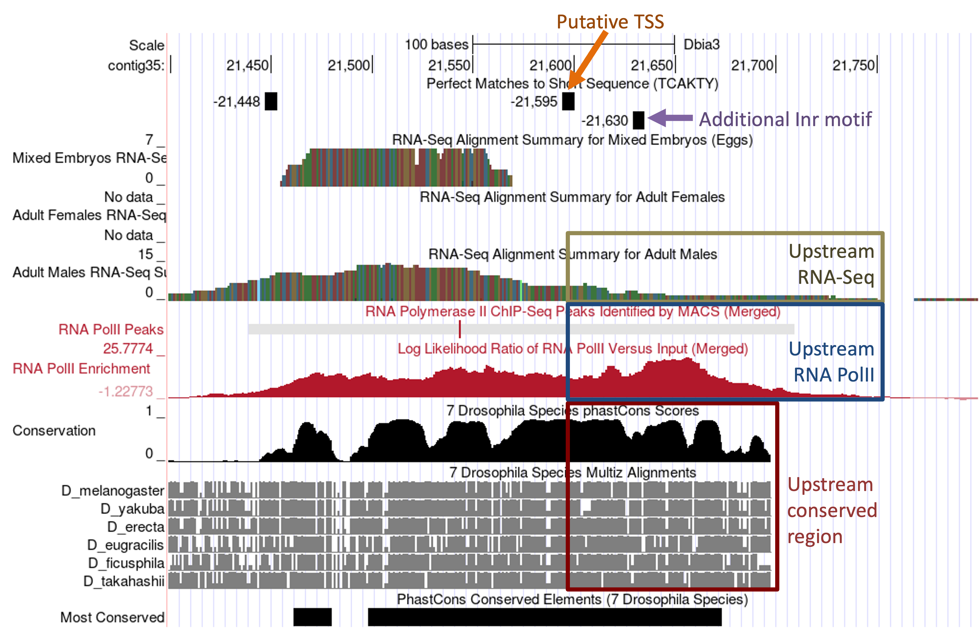

Examination of the RefSeq genes, N-SCAN, and Augustus gene predictions in the D. biarmipes April 2013 (BCM-HGSC/Dbia_2.0) assembly shows that each tool assigned different position(s) as the TSSs for onecut (labeled A–D in the figure below). Due to these inconsistencies and the high error rate associated with TSS predictions, these TSS predictions were not used to define the TSS position or the TSS search region for the onecut-RA ortholog in D. biarmipes.

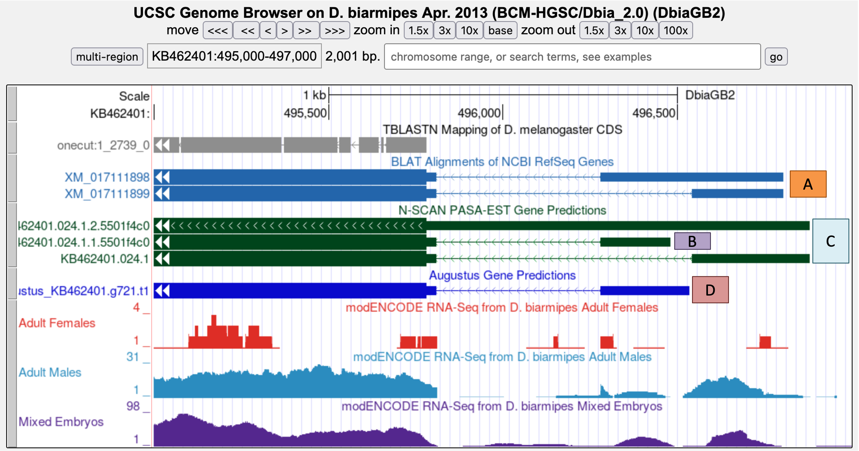

Collectively, the narrow TSS search region for onecut-RA is defined at contig35:21,599–21,750 to account for the RNA-Seq read coverage, RNA PolII ChIP-Seq data, conservation among seven Drosophila species, and the location of the additional Inr motif.

