Consed Installation Instructions for

Mac OS X

Installing X11
- Because Consed relies on an application called X11, you will need to verify that X11 is installed on your Mac prior to installing Consed.

  - Open a Finder window and go to the Applications folder and then double click on the Utilities folder

  - You should find the X11 application inside this folder. Double click on X11 icon to launch the X11 program

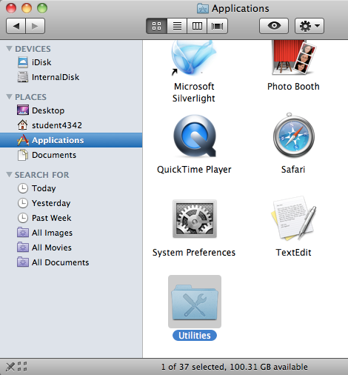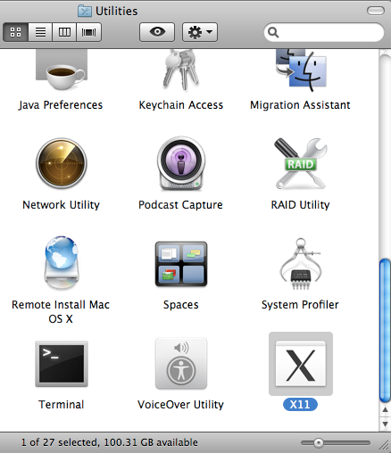

- The X11 application is installed on Mac OS 10.5, 10.6, and 10.7 by default. In these versions, an xterm will appear and you can skip the rest of this section and continue with the Installing Consed section (see page 3).

- On Mac OS 10.8, you will see a dialog box with instructions on how to install X11.

- Installing X11 on Mac OS 10.8

  - Click on the “Install” button on the X11 dialog box. This will open a web browser and navigate to the Apple Knowledge Base article on how to install X11 on Mac OS 10.8 (http://support.apple.com/kb/HT5293)

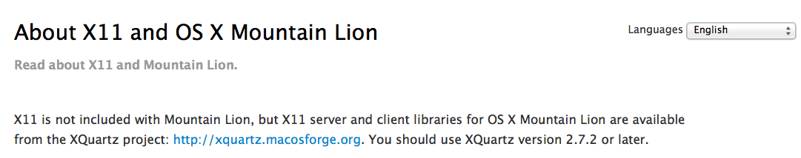

  - Click on the XQuartz project link (http://xquartz.macosforge.org/)

  - Click on the link to the most recent release (i.e. XQuartz-2.7.4.dmg) of XQuartz under the “Quick Download” section

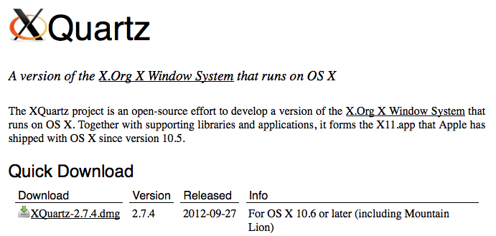

  - Navigate to the directory where you have saved the package
    - By default, most web browsers will save the file in your Downloads folder or on your Desktop

    - Note that some web browsers (e.g. Safari) will mount the disk image automatically after the download is complete

  - If the disk image did not mount automatically, double-click on the XQuartz-2.7.4.dmg file. A new drive called XQuartz-2.7.4 will appear which contains the installation package XQuartz.pkg

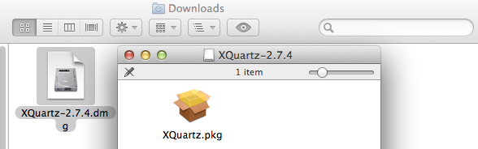

  - Double click on the XQuartz.pkg package to launch the installer. Follow the instructions to install X11.

Note that you will need to enter the credentials for your administrator’s account to install the package

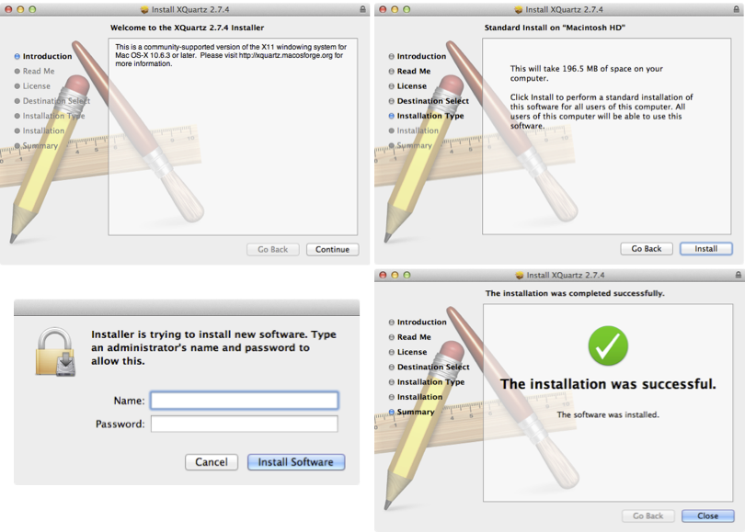

  - Restart your computer once the XQuartz application has been installed successfully

Installing Consed

- Open a web browser and download the Consed installation package at:
http://gander.wustl.edu/~chris/consed_osx_package/gep06/consed_25_install_mac_10_6.tar.bz2

- Navigate to the directory where you have saved the package

  - By default, most web browsers will save the file in your Downloads folder or on your Desktop

- Double click on this file to expand the Consed installation package
  - A new folder called consed_install_mac_10_6 will appear

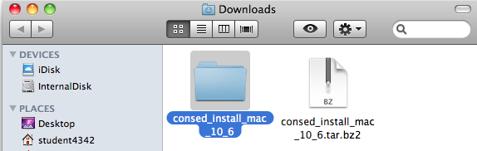

- Open a new Finder window and select “Go” -> “Go to Folder” on the main menu bar

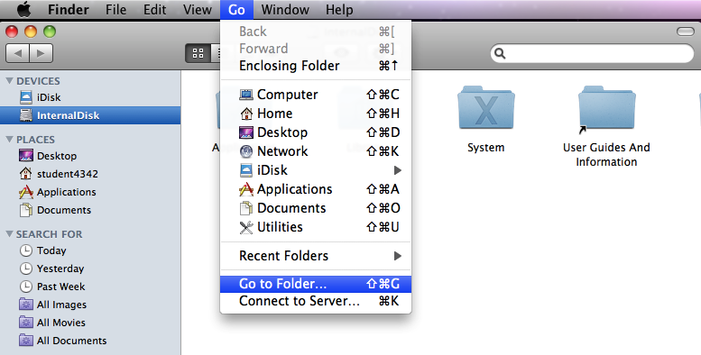

- Copy and paste the following path into the dialog box and then click on the “Go” button

/usr/local

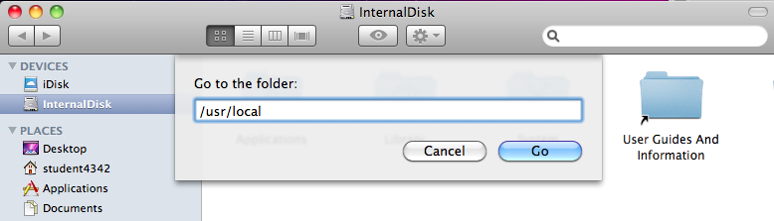

- You should now have two Finder windows open: the first window contains the folder with the Consed installation package and the second window with an empty folder called local.

- Double click on the consed_install_mac_10_6 folder, you should find a folder called genome. Drag the genome folder from the consed_install_mac_10_6 directory to the local folder.

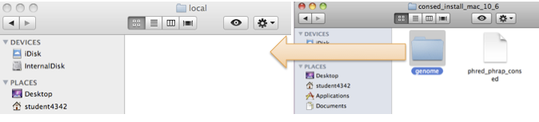

- Because the /usr/local folder is a protected folder in Mac OS X, you will need to click on the Authenticate button and then enter the username and password of your administrator account in order to copy the genome folder into /usr/local

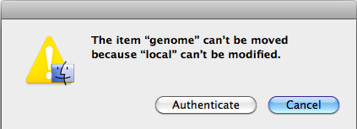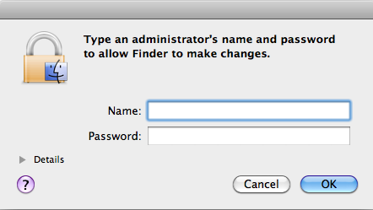

- If all goes well, the genome folder should appear in the /usr/local folder.

- Consed is now installed on your computer. However, in order to allow us to more easily access Consed from the command line, we will setup a shortcut to Consed.

- Select the Finder window for the /usr/local folder and select “Go” -> “Go to Folder” in the menu bar again. Copy and paste the following into dialog box and click “Go”

/etc/paths.d

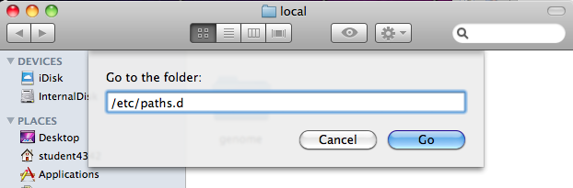

- A folder called paths.d will appear which contains a single file called X11. Select the phred_phrap_consed file in the consed_install_mac_10_6 folder and move it to the paths.d folder
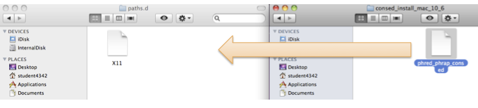

- Like the /usr/local folder, /etc/paths.d is a protected folder in Mac OS X. You will need to click on the Authenticate button and then enter the username and password for your administrator account in order to copy the phred_phrap_consed file into /etc/paths.d

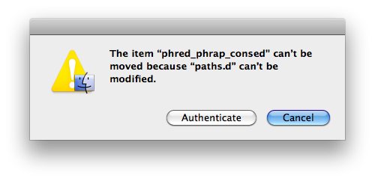

Verify the Consed Installation
The Consed installation is now complete. Next we will download a sequence improvement project from the GEP web site so that we can use it to test our Consed installation.

- Open a web browser and download the sequence improvement package for the Using Consed Graphically tutorial at:
http://gep.wustl.edu/curriculum/course_materials_WU/sequence_improvement/tutorials_and_walkthroughs

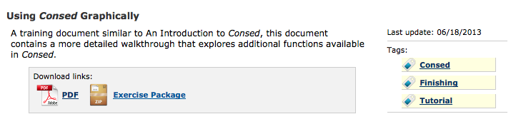

- Once the download is complete, double click on the file to expand the package. Move the folder (called Standard3) to your home directory.
  - The home directory is the same as your account name by default.
  - The home directory is called student4342 in this tutorial.

- Before we can launch Consed, we need to first launch the X11 program.
  - Navigate to the Utilities folder and double click on the X11 application (as shown on page 1).

    - You might want to drag the X11 application into the Dock to enable easier access to this application in the future.

- When you open X11, a new xterm should appear. Type the following into the xterm to verify that you can access Consed:

consed –v

This command should report the version of Consed that has been installed (version 25.0 in this case). Note that the “Darwin Version” line will be different depending on your version of Mac OS X.

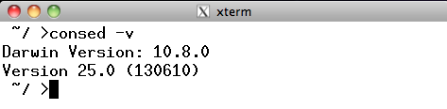

- Next we will try to open a Consed project. Assuming that the Standard3 project is in your home directory (as described above), type the following into the xterm to open the project:

cd Standard3/edit_dir/
consed &

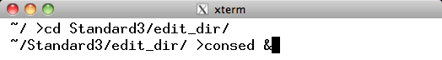

- If all goes well, Consed should launch and we can open the 454Contigs.ace.1 file

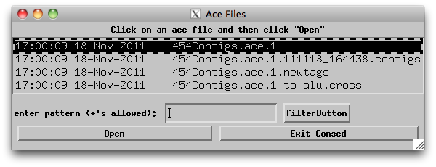

At this point, I will recommend going over the entire Using Consed Graphically exercise to verify that Consed has been installed correctly. In particular, I would verify that you can open and edit traces, run cross_match in Assembly View, do tear and joins and run MiniAssembly. Detailed instructions on how to accomplish these tasks are described in the Using Consed Graphically tutorial.

