Drosophila Pathways Project: Annotation Walkthrough
Katie Sandlin*, Wilson Leung, & Laura Reed†
*contact regarding feedback/questions/concerns about this curriculum kmsandlin@ua.edu
† project leader lreed1@ua.edu

Prerequisites
- Understanding Eukaryotic Genes (modules 1, 4, and 6)
- RNA-Seq Primer
- An Introduction to NCBI BLAST

Tools
- All links for this walkthrough can be found on the Drosophila Pathways Project page of the GEP website (gep.wustl.edu). Links for each tool are also listed below:
  - GEP UCSC Genome Browser Gateway
  - Gene Record Finder
  - Genome Assemblies for the Drosophila Pathways Project
  - NCBI BLAST
  - Gene Model Checker for Whole Genome Assemblies
  - Annotation Files Merger for Whole Genome Assemblies

Resources
- Links for these resources can be found on the Drosophila Pathways Project page of the GEP website (gep.wustl.edu).
- Annotation Notebook
- Annotation Report Form

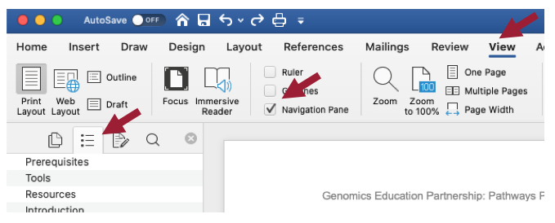
To help you navigate this walkthrough, follow these steps to open the Navigation Pane:
- Click “View” in the toolbar ribbon.
- Check the box next to “Navigation Pane.”
- Click the icon in the sidebar that appears.

Note: Your version of Word may be different than the one shown above. See this link for more details.

Introduction

The Pathways Project is focused on annotating genes found in well characterized signaling and metabolic pathways across the Drosophila genus. The current focus is on the Insulin Signaling pathway which is well conserved across animals and critical to growth and metabolic homeostasis. The long-term goal of the Pathways Project is to analyze how the regulatory regions of genes evolve in the context of their positions within a network.

This walkthrough illustrates how to apply the GEP annotation strategy for the Pathways Project to construct a gene model for the Ras homolog enriched in brain (Rheb) gene in the Drosophila yakuba [May 2011 (WUGSC dyak_caf1/DyakCAF1)] assembly. This walkthrough focuses on annotation of the coding regions so we will not annotate the untranslated regions (UTRs) or the transcription start site (TSS).

It is important to note that the Rheb gene in D. yakuba is relatively straightforward in comparison to what your own project might be. Some of the steps we will follow in this walkthrough might appear to be excessive, but keep in mind that you will potentially have a more complex project, so it is important to follow this protocol as we have tried to equip you with most of what you will need should you encounter complexities.

We recommend you follow the parts in the order they are presented, and then refer back to particular parts when needed for your own project. Note that the figures have been configured to fit this document while still maintaining readability; therefore, your screen may differ slightly. Commas have been included with all coordinates to improve readability, but you do not have to enter them in the Genome Browser (navigation will work the same with or without commas). Throughout the walkthrough, text boxes with icons are you used to provide the following:

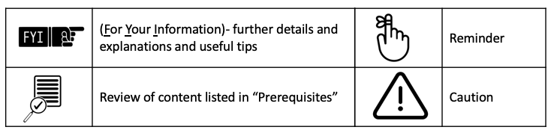

In this walkthrough, we will:
- Part 1: Examine the genomic neighborhood surrounding the gene of interest in D. melanogaster
- Part 2: Identify the genomic location of the ortholog in D. yakuba
- Part 3: Examine the genomic neighborhood of the putative ortholog in D. yakuba
- Part 4: Determine the gene structure in D. melanogaster
- Part 5: Determine the approximate location of the coding exons (CDS’s) in D. yakuba
- Part 6: Refine coordinates of coding exons (CDS’s)
- Part 7: Verify gene model
- Appendix:
  - A. Investigate the other tblastn alignments to D. yakuba chr3R

Part 1: Examine the genomic neighborhood surrounding the gene of interest in D. melanogaster

- Navigate to the GEP UCSC Genome Browser Gateway Page.
- Click “D. melanogaster” in the “REPRESENTED SPECIES” table.
- Select “Aug. 2014 (BDGP Release 6 + ISO1 MT/dm6)” under the “D. melanogaster Assembly” field.
- Enter “Rheb” under the “Position/Search Term” field.
- Click the “Go” button (Figure 1).

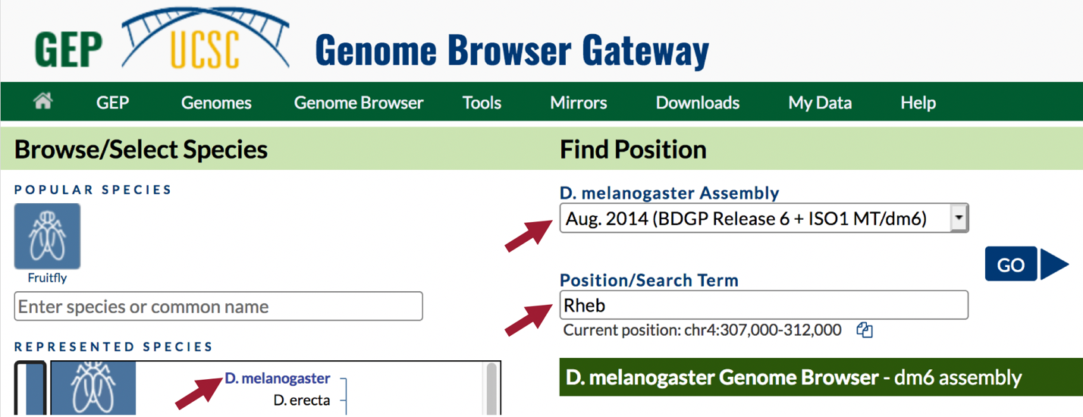
Figure 1 Navigate to the Rheb gene in the D. melanogaster Aug. 2014 (BDGP Release 6 + ISO1 MT/dm6) assembly.

- On the following page, “FlyBase Protein-Coding Genes,” click “Rheb-RA at chr3R:5568921-5570491” (Figure 2).

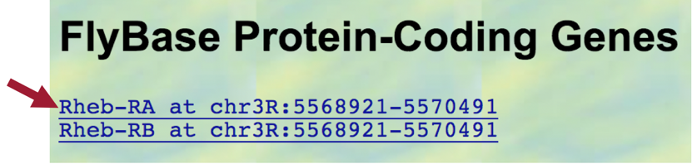
Figure 2 Navigate to Rheb-RA on the right arm of chromosome 3 (chr3R) in D. melanogaster.

- Because the Genome Browser remembers our previous track display settings, scroll down to the list of buttons below the Genome Browser image and then click on the “hide all” button to hide all of the evidence tracks (Figure 3).

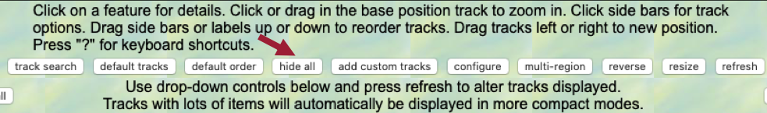
Figure 3 Click on the “hide all” button to hide all the evidence tracks.
- Under the “Genes and Gene Prediction Tracks,” change the “FlyBase Genes” track to “pack.”
- Click the “refresh” button (Figure 4).

Figure 4 Change the display mode for the “FlyBase Genes” to “pack” to examine the gene structure for Rheb.

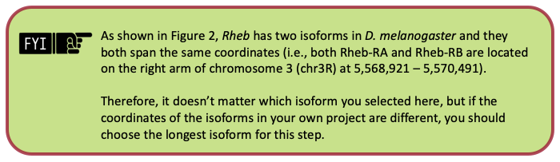

In the “FlyBase Protein-Coding Genes” track, we should now see the gene structure for the two isoforms of the Rheb gene (i.e., Rheb-RB and Rheb-RA) (Figure 5).

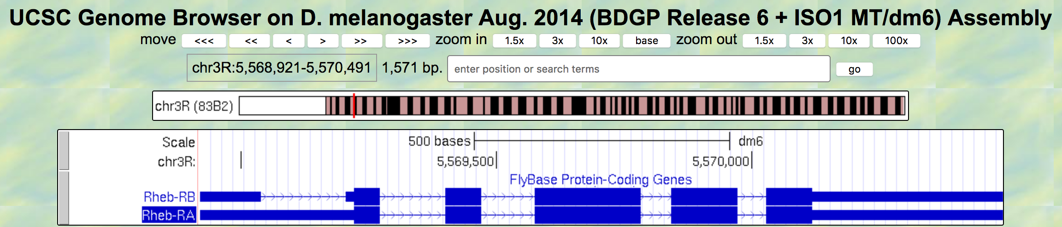
Figure 5 There are two isoforms of Rheb in D. melanogaster (Rheb-RA and Rheb-RB). The differences between the two isoforms are at the 5’ untranslated regions (5’ UTR).

- Zoom out until you can see two genes on either side of Rheb.

We are now viewing the genomic neighborhood of the Rheb gene in D. melanogaster (i.e., region of the right arm of chromosome 3 (chr3R) containing the Rheb gene and adjacent upstream and downstream genes) (Figure 6).
- The two nearest upstream genes to Rheb are CG2931 and CG12746.
- The two nearest downstream genes to Rheb are CRMP and CG2926.
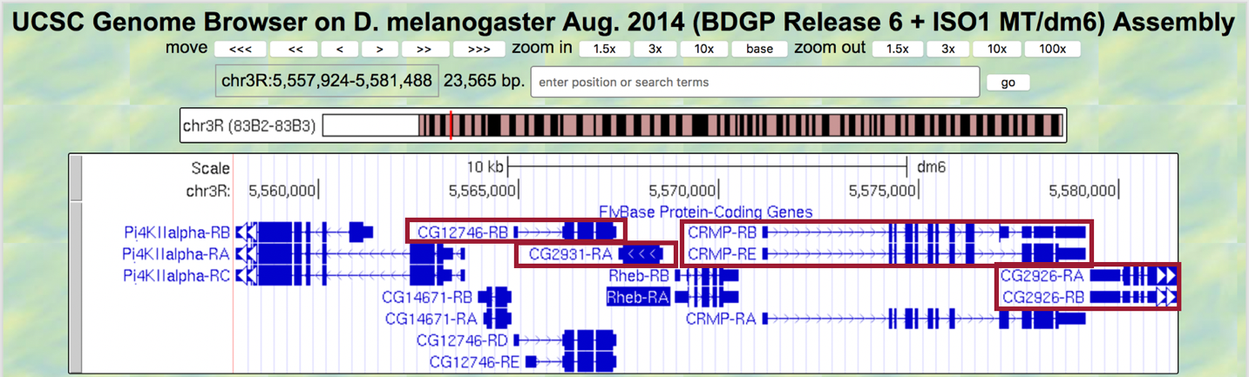
Figure 6 The genes CG12746 and CG2931 are located upstream of Rheb. The genes CRMP and CG2926 are located downstream of Rheb.

At this point in your own project, you should draw a sketch of the genomic neighborhood of your assigned gene (an example for Rheb is shown in Figure 7). In order to do so, we must identify the direction of transcription for each gene by zooming in on an intron of each gene.

- Start by zooming into an intron of Rheb.
- In your genomic neighborhood sketch, be sure to draw an arrow in the correct direction for Rheb.

- Repeat this process for the neighboring genes (i.e., zoom into an intron of each of the four neighboring genes and draw arrows in the correct directions on your sketch).
- Note: If a gene only has one exon, and therefore no introns, zoom into the exon to identify the direction of transcription.

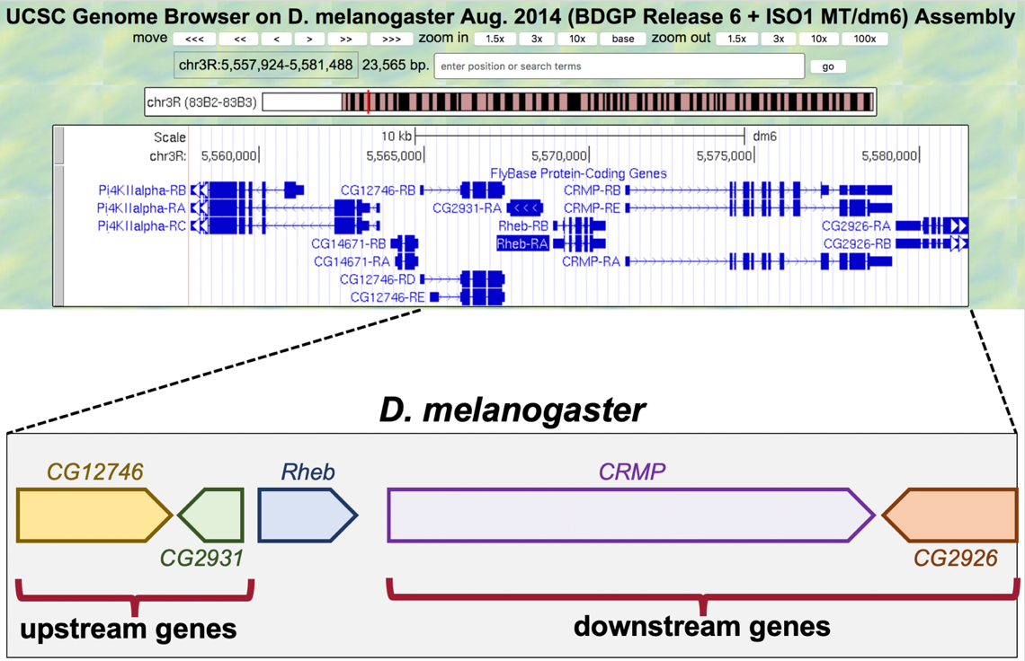
Figure 7 Sketch of the genomic neighborhood of Rheb in D. melanogaster. Since the direction of the arrows within their introns point to the right, CG12746 and CRMP are on the positive strand. CG2931 and CG2926 are on the negative strand since the direction of the arrows within their introns point to the left.
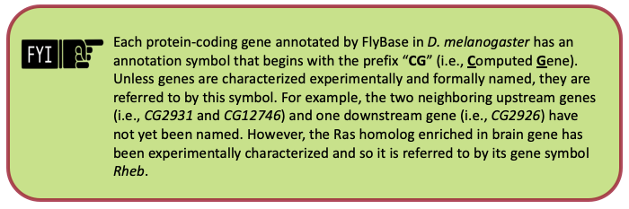

Part 2: Identify the genomic location of the ortholog in D. yakuba

Now that we’ve examined the genomic neighborhood of Rheb in D. melanogaster, we need to identify the location of Rheb in D. yakuba.

Part 2.1: Retrieve the protein sequence for Rheb-PA

- In the “FlyBase Protein-Coding Genes” track shown in the Genome Browser image, click “Rheb-RA” (Figure 8).

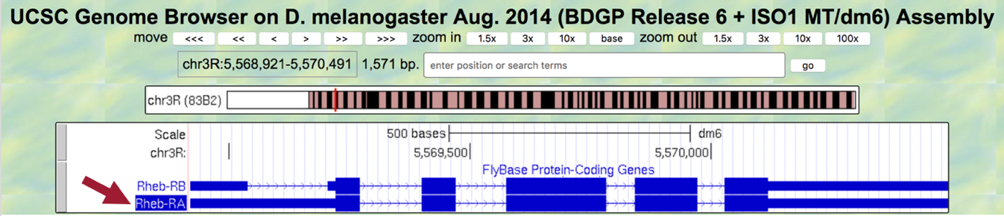
Figure 8 Click on “Rheb-RA” to view details regarding this protein-coding gene that was annotated by FlyBase.

- Under the “Links to sequence” heading, click the “Translated Protein” link (Figure 9, left).

We are now viewing the sequence for the 182 amino acids in the translated protein of Rheb-RA in D. melanogaster (Figure 9, right).

- Copy the entire sequence (excluding the header) so we can use it in our tblastn search.
- Note: This same information could also be found on the gene page for Rheb on FlyBase.
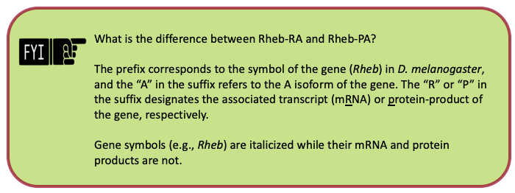
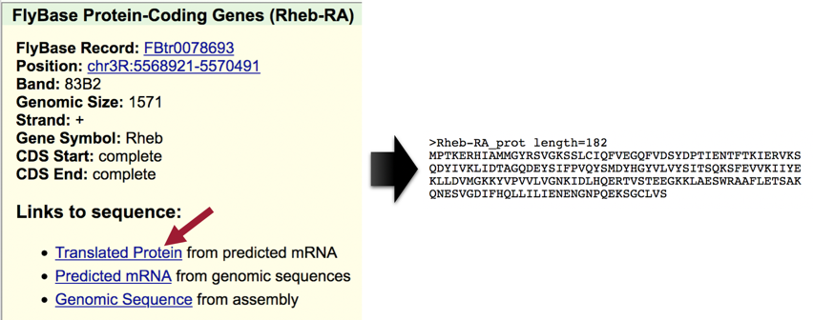
Figure 9 Click the “Translated Protein” link for the Rheb-RA feature to obtain the sequence of the translated protein.

Part 2.2: Perform a BLAST search of Rheb-PA against the D. yakuba genome assembly
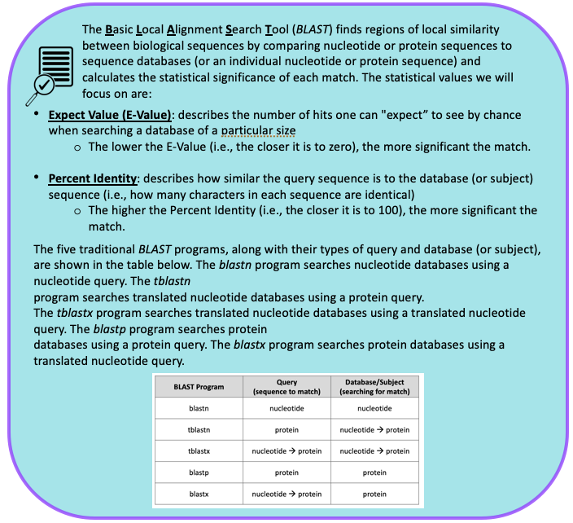
See An Introduction to NCBI BLAST for additional details.

In Part 2.1, we retrieved the protein sequence for Rheb-PA in D. melanogaster. Now we need to perform a BLAST search of Rheb-PA against the D. yakuba genome assembly.

Since we are looking for the orthologous region of Rheb in D. yakuba, we want BLAST to search the entire genome of D. yakuba to identify regions of local similarity with the protein sequence of Rheb in D. melanogaster we obtained in Part 2.1. In other words, we need to BLAST our Rheb protein sequence from D. melanogaster against the entire genome of D. yakuba to narrow down the possible regions where Rheb could be located in D. yakuba.
We can use either tblastn or blastx to perform this search (depending on whether we treat the Rheb-PA sequence as the query or the subject sequence, respectively). In this walkthrough, we will use the tblastn program to search the translated nucleotide database of our target species, D. yakuba, using the protein sequence of Rheb in D. melanogaster as our query.
- Query: sequence we are looking to match (protein sequence of Rheb in D. melanogaster)
- Database: collection of sequences we are searching for matches (BLAST will translate entire genome of D. yakuba)

- Navigate to the Genome Assemblies for the Drosophila Pathways Project page.
- Click the “Genome BLAST” link for D. yakuba (Figure 10).
  - Note: Here we are selecting the D. yakuba genome database to search.

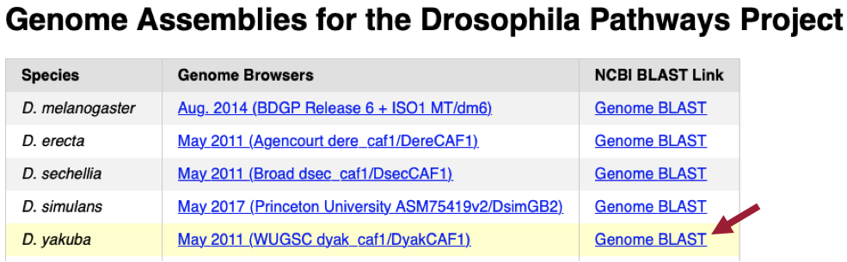
Figure 10 Click on the “Genome BLAST” link under the “NCBI BLAST Link” column for the D. yakuba row.

- Make sure the “tblastn” tab is selected (Figure 11).
- Paste the Rheb-PA sequence (excluding the header) we copied from Part 2.1 into the “Enter Query Sequence” text box.
- Enter “Rheb-PA” into the “Job Title” text box.
- Make sure the check box next to “Show results in a new window” is selected.
- Click the “BLAST” button.
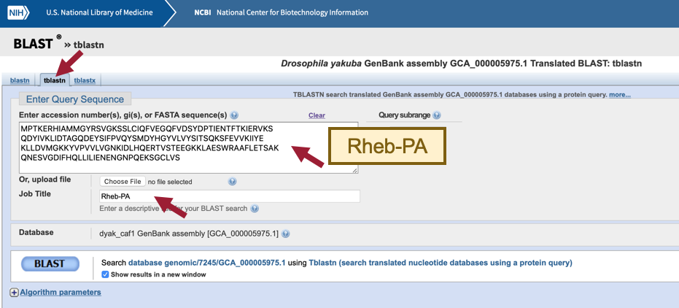
Figure 11 Configure tblastn to compare the D. melanogaster protein Rheb-PA against the D. yakuba whole genome assembly.
When performing a search, BLAST may return any number of matches (often referred to as “hits”) for regions of local similarity between our query sequence and database; however, each hit is not necessarily statistically significant. BLAST provides statistical scores to help us determine which alignments between the two sequences are statistically significant and which are spurious (i.e., likely occurred by chance alone and, therefore, are not evidence of real biological conservation). If BLAST returns multiple good hits (i.e., more than one match with a low E-value and a high sequence identity), we will need to investigate them all further to determine if we have the best ortholog.

Our tblastn search found seven regions within the D. yakuba genome that show similarities with the protein sequence of Rheb in D. melanogaster (Figure 12); however, only one of these is a good hit (Drosophila yakuba strain Tai18E2 chromosome 3R, whole genome shotgun sequence; sequence identity of 97.14% and an E-value of 2e-78). The second hit has a much higher E-value (8e-37) and much lower percent identity (43.75%), and this pattern of increasingly lower quality matches continues throughout the other five matches as well. Therefore, we will continue our analysis based on the hypothesis that the putative ortholog of Rheb-PA in D. yakuba is located somewhere on the right arm of chromosome 3 (chromosome 3R; chr3R).

Notice that each of the genome regions of our seven hits has a unique Accession number. The Accession number for our best hit, which is on chromosome 3R (chr3R), is CM000160.2 (Figure 12).

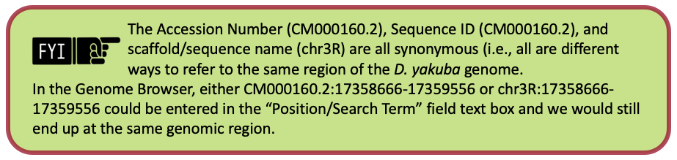

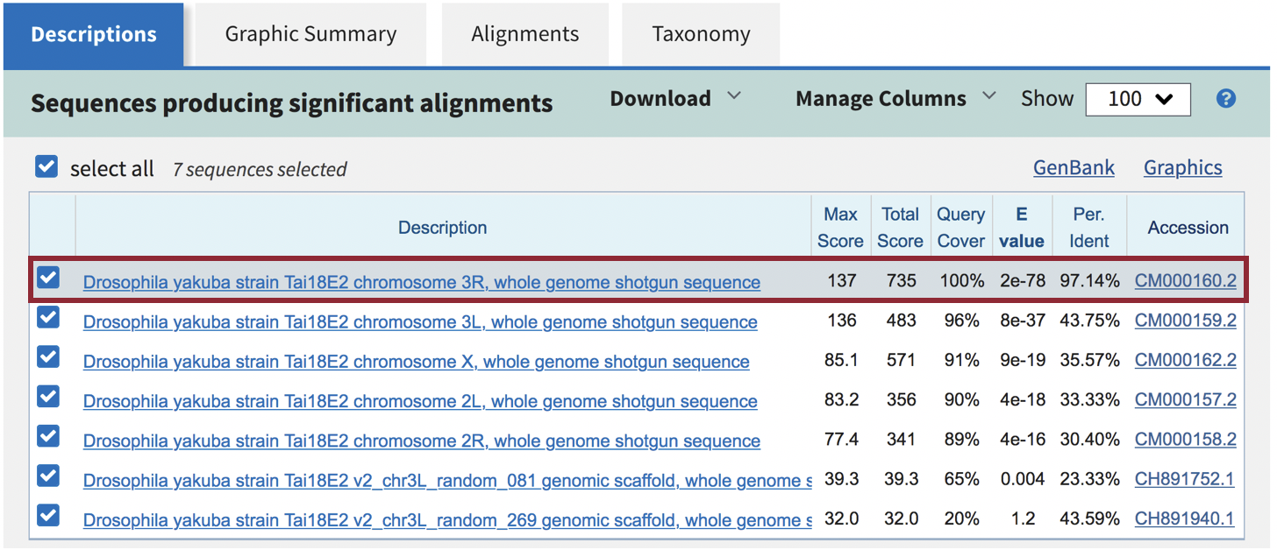
Figure 12 The best tblastn match to Rheb-PA is located on chromosome 3R (chr3R; accession number: CM000160.2) with an E-value of 2e-78 and a sequence identity of 97.14%. The next best match is located on the left arm of chromosome 3 (chromosome 3L), and it has much higher E-value (8e-37) and much lower percent identity (43.75%). The other five matches are to regions on chromosome X, 2L, 2R, and 3L.

Part 2.3: Summarize the tblastn results for Rheb-PA on D. yakuba chr3R

- Under the “Descriptions” tab, uncheck the box next to “select all” (Figure 13).
- Click the “Drosophila yakuba strain Tai18E2 chromosome 3R, whole genome shotgun sequence” link in the “Description” column to navigate to the alignment (Figure 13).

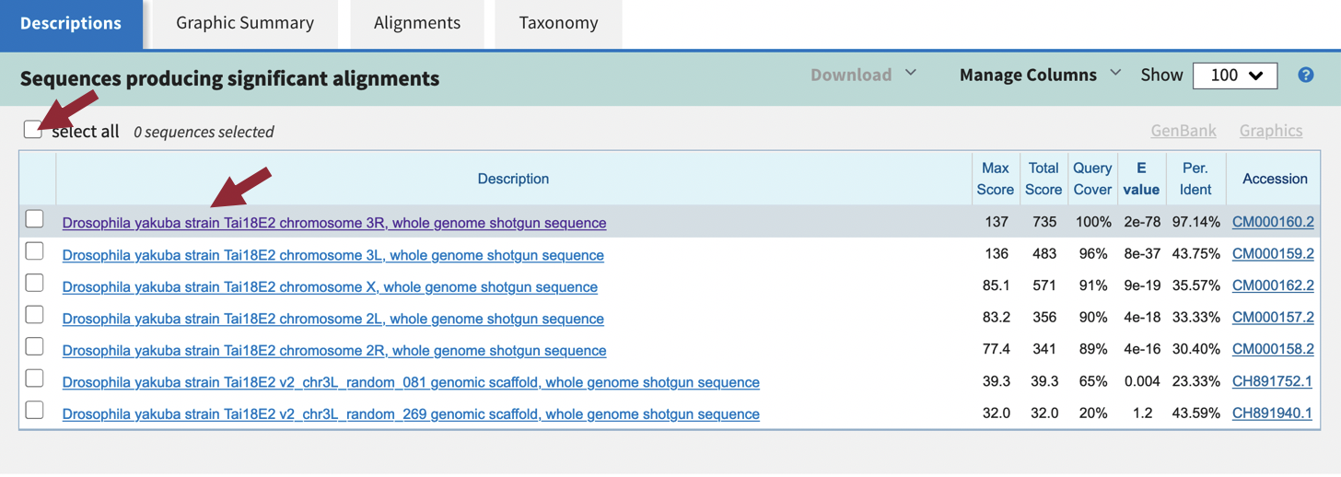
Figure 13 Uncheck “select all” and then click the link for the best match to navigate to the alignment.

- In the blue toolbar for the BLAST hit, select the “Subject start position” option from the drop-down menu of the “Sort by” field to order the matches based on the start coordinates on D. yakuba chr3R in ascending order (Figure 14).
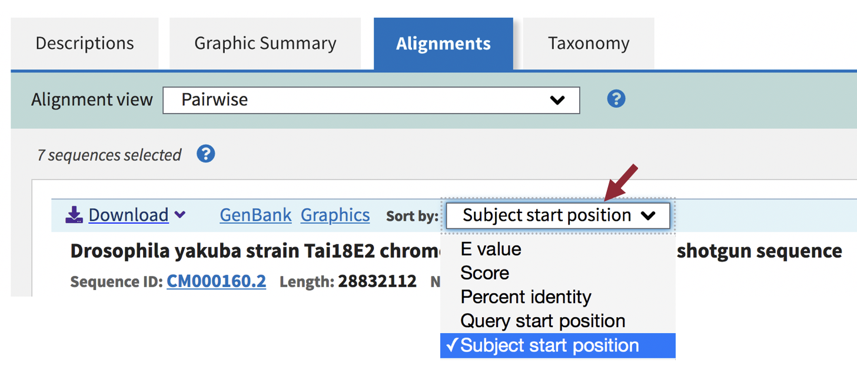
Figure 14 In the blue toolbar for the BLAST hit, select the “Subject start position” option from the drop-down menu of the “Sort by” field to order the matches based on the start coordinates on D. yakuba chr3R in ascending order.
We should now see 12 ranges listed in ascending order. Each range corresponds to a contiguous portion of the subject sequence that shows significant sequence similarity (i.e., matches) with a portion of the query sequence. Here, the 12 ranges show matches between Rheb-PA in D. melanogaster and a range of coordinates from chromosome 3R in D. yakuba. For example, Range 1 shows a match between Rheb-PA in D. melanogaster (55 – 163) and coordinates 5,727,469 – 5,727,792 of chromosome 3R in D. yakuba when translated in frame +1. Range 1 has an E-Value of 2e-10 and a sequence identity of 36% (Figure 15).
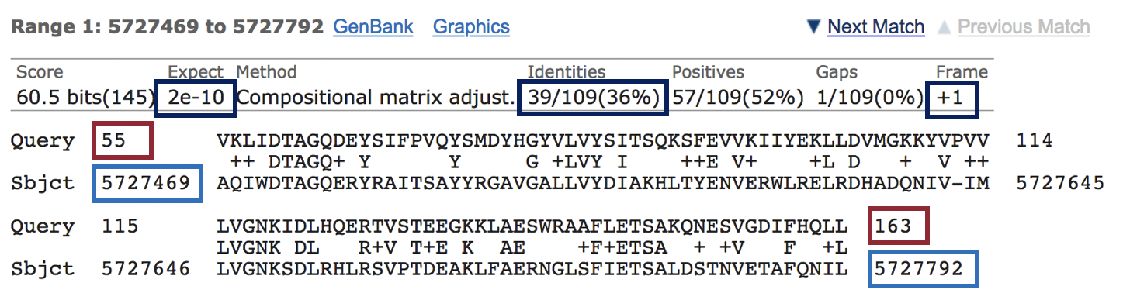
Figure 15 The query coordinates (55 – 163) and subject coordinates (5,727,469 – 5,727,792) are shown in red and blue, respectively.

Since chromosome 3R in D. yakuba is 28,832,112 bp long, it is likely we will have some ranges (i.e., alignment matches) that do not correspond to our ortholog; therefore, we need to examine each match more closely.

Remember that we are looking for matches with low E-values and high sequence identities, and there are five matches (ranges 7-11) that fit these criteria (E-value of 2e-78 and sequence identities that range from 83.3% to 97.1%). These five alignment matches are also collinear and appear on the same strand of DNA (+ Frame) (Figure 16).

The best collinear set of alignments to Rheb-PA is located at 17,358,666 – 17,359,556 on chr3R of the D. yakuba genome assembly and the five alignment matches cover all 182 amino acids of Rheb-PA (Figure 16). Therefore, we will continue our analysis based on the hypothesis that the putative ortholog of Rheb-PA is located at approximately 17,358,666-17,359,556 on chr3R of the D. yakuba genome assembly. See Appendix A for details on investigating the other tblastn alignments to D. yakuba chr3R.
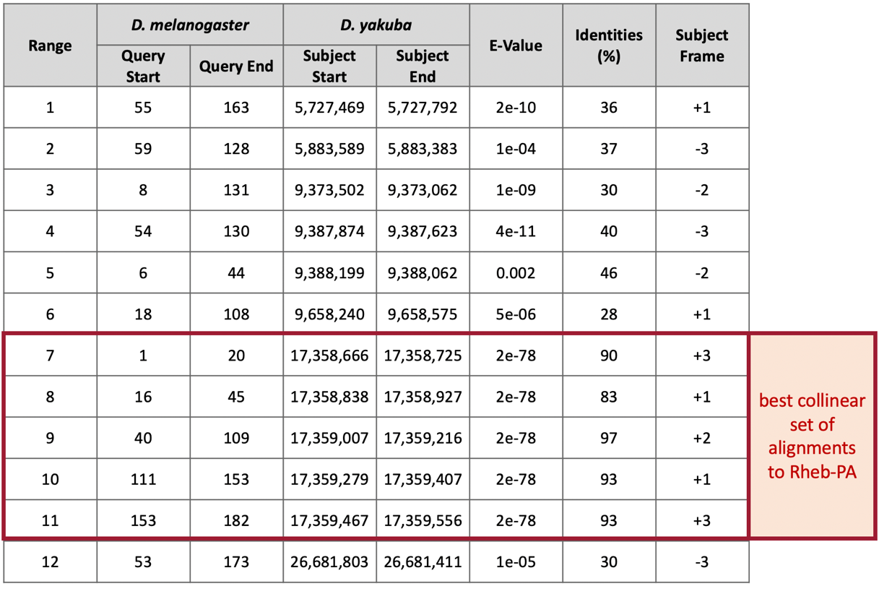
Figure 16 Summary of the tblastn search results for the 12 matches to Rheb-PA within chromosome 3R of D. yakuba. The best collinear set of alignments to Rheb-PA is located at 17,358,666-17,359,556.

Part 3: Examine the genomic neighborhood of the putative ortholog in D. yakuba

In Part 1, we sketched the genomic neighborhood of Rheb in D. melanogaster. Here we will examine the genomic neighborhood of Rheb in D. yakuba and then compare the order and orientation of these genes to what we found in D. melanogaster.

Based on parsimony, the genes surrounding Rheb in D. yakuba should be identical or very similar in function to the genes in the genomic neighborhood of Rheb in D. melanogaster. Additionally, the neighboring genes should also match in orientation (look at the direction of transcription of the neighboring genes; this is called synteny). Since Rheb is on the positive strand in D. melanogaster (i.e., transcribed left to right) and since CG2926 is on the negative strand in D. melanogaster (i.e., transcribed right to left), these two genes should also be on different strands (i.e., transcribed in different directions) in D. yakuba.

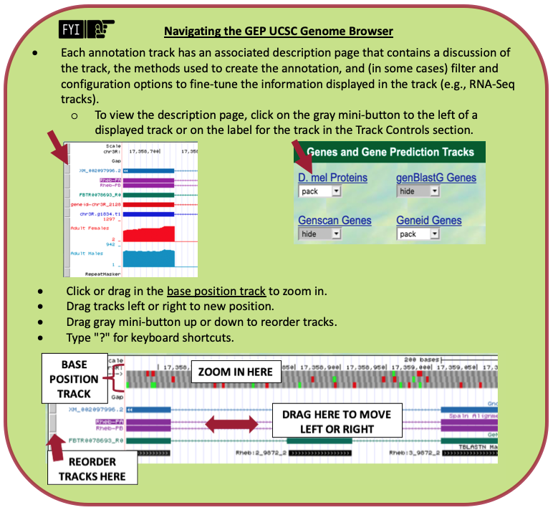

Part 3.1: Examine the evidence for a protein-coding gene in the D. yakuba region surrounding the tblastn alignment

- Navigate to the GEP UCSC Genome Browser Gateway Page.
- Click “D. yakuba” in the “REPRESENTED SPECIES” table.
- Confirm that “May 2011 (WUGSC dyak_caf1/DyakCAF1)” is selected under the “D. yakuba Assembly” field.
- In Part 2, we determined the putative ortholog of Rheb-PA is located at approximately 17,358,666 – 17,359,556 on chr3R of the D. yakuba genome assembly. Enter “chr3R:17,358,666-17,359,556” under the “Position/Search Term” field to examine this region.
- Click the “Go” button (Figure 17).

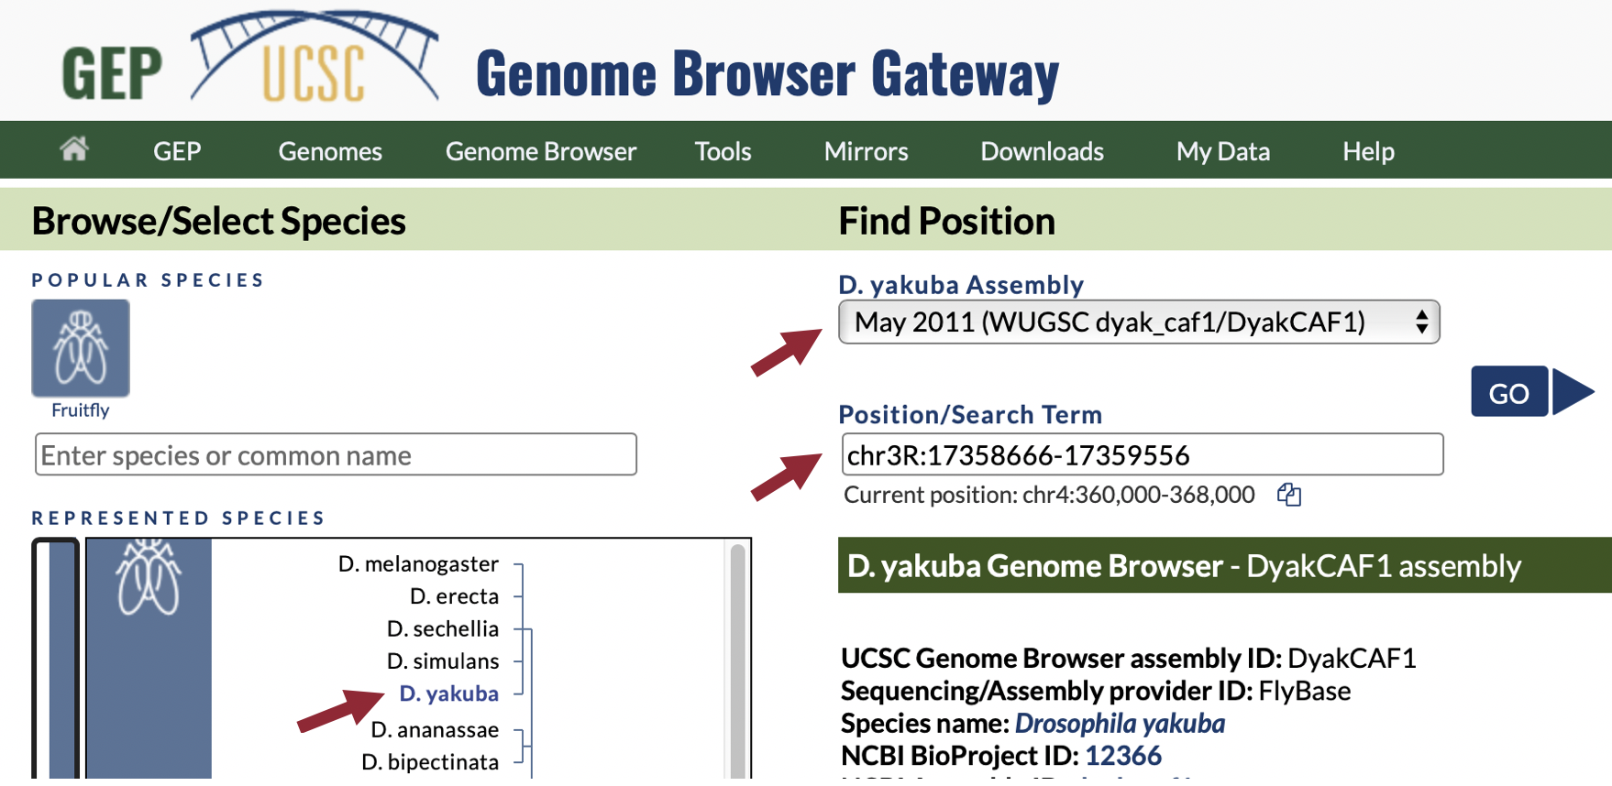
Figure 17 Navigate to the region surrounding the best collinear set of alignments to the D. melanogaster Rheb-PA protein in the D. yakuba May 2011 (WUGSC dyak_caf1/DyakCAF1) assembly (i.e., chr3R:17,358,666-17,359,556).

- In the list of buttons below the Genome Browser image, click “hide all” to hide all of the evidence tracks.
- Click the “default tracks” button to the left of “hide all” (Figure 18).
- Zoom out 3x.

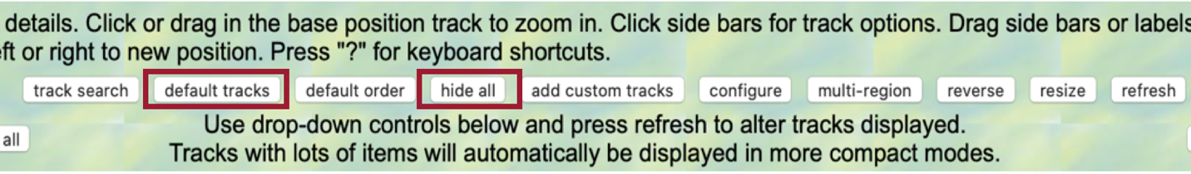
Figure 18 Click “hide all” and then “default tracks.”

In the Genome Browser image, we should now see the following tracks (Figure 19):
- Spaln Alignment of D. melanogaster Proteins
  - NOTE: In the Genome Browser image, the D. mel Proteins track is referred to as “Spaln Alignment of D. melanogaster Proteins,” but don’t let this confuse you. It is not important to know the precise details of the Spaln Alignment algorithm, just know it’s similar to blastx.
- Gene Prediction Tracks:
  - Gnomon Gene Annotations
  - GeMoMa Gene Predictions
  - Geneid Gene Predictions
  - Augustus Gene Predictions
- modENCODE RNA-Seq from Adult Females
- modENCODE RNA-Seq from Adult Males

We will delve into each of the above tracks in Part 6, but for now, we will use these tracks to provide additional evidence for our hypothesis that the putative ortholog of Rheb-PA is located at approximately 17,358,666-17,359,556 on chr3R of the D. yakuba genome assembly.

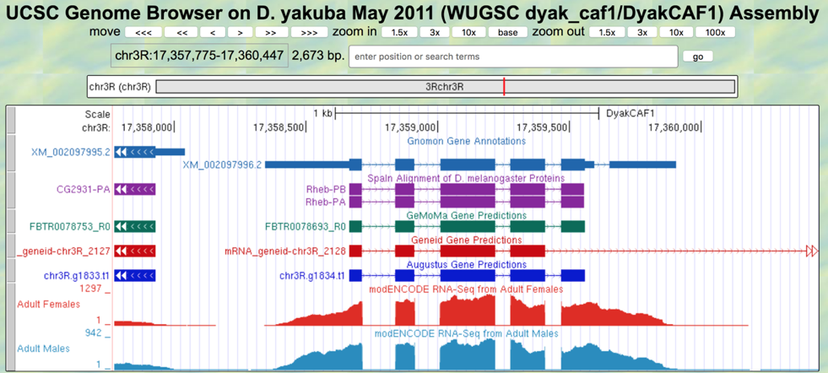
Figure 19 Based on the Spaln protein alignments to both isoforms of Rheb, gene predictions from multiple gene predictors (i.e., Gnomon, GeMoMa, Geneid, and Augustus), as well as RNA-Seq data from samples of adult females and males, the D. yakuba region at chr3R:17,358,666-17,359,556 likely contains a protein-coding gene.

Part 3.2: Use synteny to gather additional evidence for the ortholog assignment
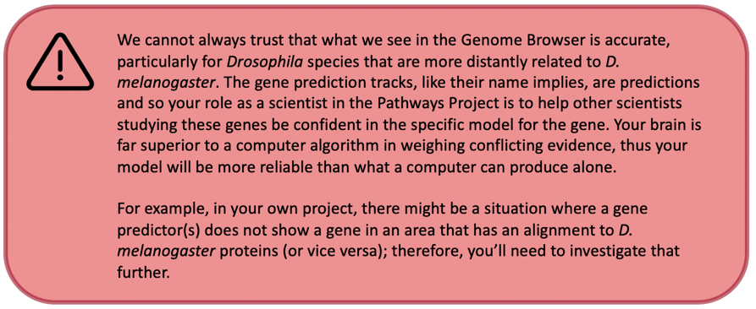
- Zoom out another 3x (you should now be viewing chr3R:17,355,102-17,363,120).
- In the “Gnomon Gene Annotations” track shown in the Genome Browser image, click “XM_002097995.2” (Figure 20).

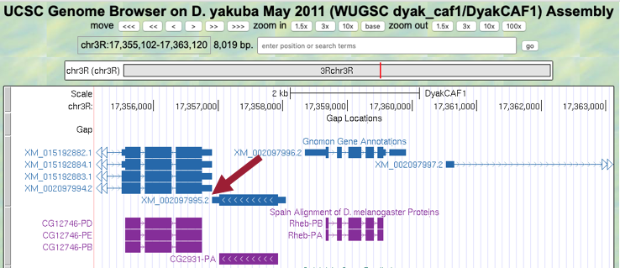
Figure 20 Click the Gnomon Gene Annotations track for the nearest upstream neighbor.

Notice the position of XM_002097995.2 is “chr3R:17,356,905-17,358,043” (Figure 21).

- Under the “Links to sequence” heading, click the “Translated Protein” link (Figure 21, left).

We are now viewing the protein sequence of the 305 amino acids of the nearest predicted upstream neighbor to Rheb-PA in D. yakuba (Figure 21, right).

- Copy the entire sequence (including the header) so we can use it in our blastp search.

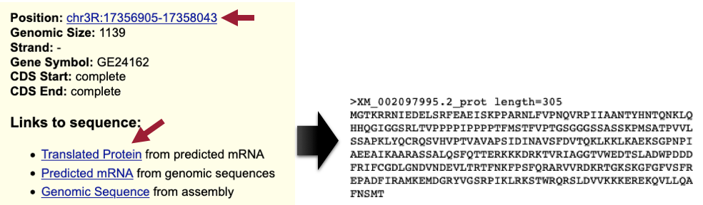
Figure 21 Click the “Translated Protein” link for the Gnomon Gene Annotation feature (XM_002097995.2) to obtain the sequence of the translated protein and then copy the entire sequence (including the header).

- Navigate to NCBI BLAST.
- Click the “Protein BLAST” button (Figure 22).
- Note: This is a blastp search (Part 2.2, review box).
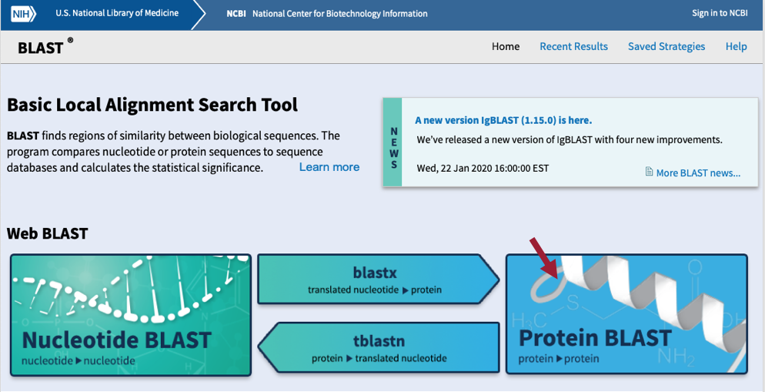
Figure 22 Navigate to the NCBI BLAST website and then click the Protein BLAST button.
- Paste the XM_002097995.2 sequence (including the header) we copied from the Genome Browser into the “Enter Query Sequence” text box (Figure 23).
- Click within the “Job Title” text box and it should automatically populate with the sequence header.
- Under “Choose Search Set,” select “Reference proteins (refseq_protein)” as the “Database” to search.
- In the “Organism” text box, enter “Drosophila melanogaster (taxid:7227).”
- Make sure the check box next to “Show results in a new window” is selected.
- Click the “BLAST” button.
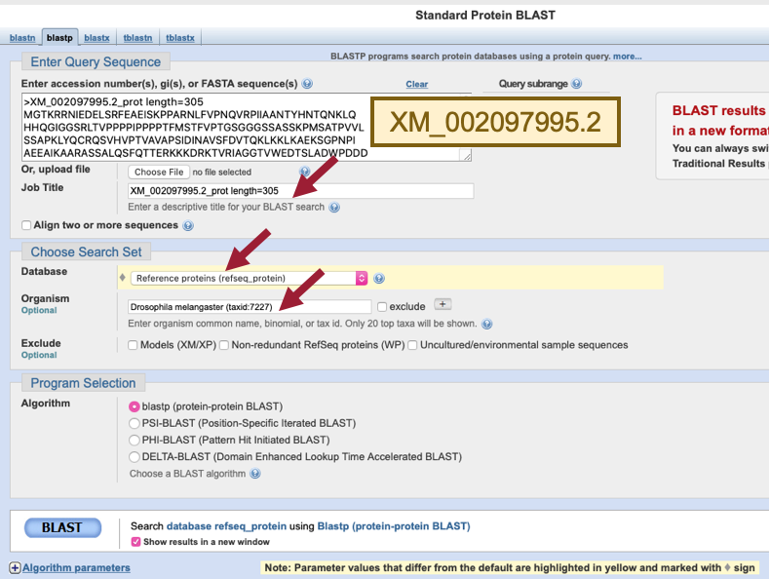
Figure 23 Configure blastp to compare the protein sequence of the nearest predicted upstream neighbor to Rheb-PA (XM_002097995.2) in D. yakuba against the D. melanogaster reference protein database.
Our blastp search found 84 proteins within the D. melanogaster reference protein database that show similarities with the protein sequence of the nearest predicted upstream neighbor (XM_002097995.2) of Rheb-PA in D. yakuba; however, only one of these is a good hit (uncharacterized protein Dmel_CG2931 [Drosophila melanogaster]; sequence identity of 96.72% and an E-value of 0). The remaining hits had much higher E-values (2e-13 to 2.6) and much lower percent identities (50% to 21.57%). Therefore, we can conclude that CG2931 is the nearest upstream neighbor of Rheb in both D. yakuba and D. melanogaster. Furthermore, CG2931 is located at approximately chr3R:17,356,905-17,358,043 in D. yakuba (Figure 24).

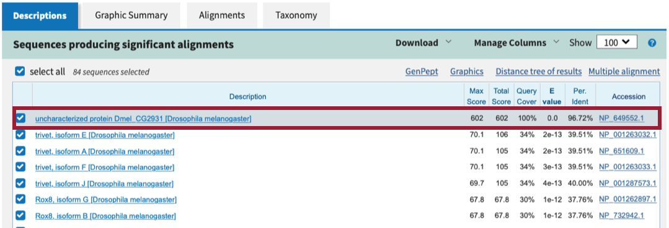
Figure 24 The best blastp match to the nearest predicted upstream neighbor (XM_002097995.2) of Rheb-PA in D. yakuba is uncharacterized protein Dmel_CG2931 [Drosophila melanogaster] with an E-value of 0.0 and a sequence identity of 96.72%. All other matches have much higher E-values (2e-13 to 2.6) and much lower percent identities (50% to 21.57%).

Now we need to repeat the blastp search for the other upstream neighboring gene (i.e., XM_002097994.2) and both downstream neighbors (i.e., XM_002097997.2 and XM_002097998.2) (Figure 25).
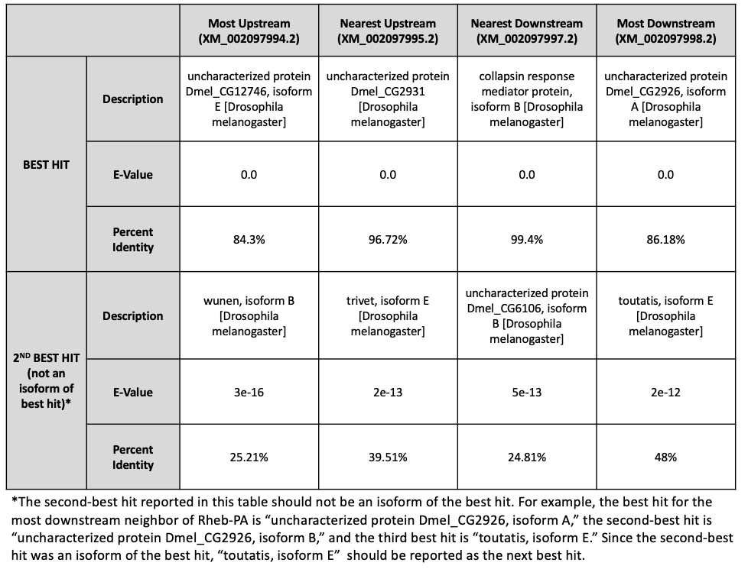
Figure 25 Summary of the blastp search results for the protein sequences of the two nearest predicted upstream and downstream neighbors to Rheb-PA in D. yakuba against the D. melanogaster reference protein database.
At this point in your own project, you should draw a sketch of the genomic neighborhood of your assigned gene in your target species (an example for Rheb in D. yakuba is shown in Figure 27). In order to do so, we need to repeat the process we followed in Part 1 for each of the neighboring genes in D. yakuba identified in our blastp search (i.e., zoom into an intron of each of the four neighboring genes and draw arrows in the correct directions on your sketch) (Figure 25).

- Zoom out far enough to examine the genomic region surrounding the putative Rheb ortholog.
- Use the strategy described in Steps 10 – 12 of Part 1 to determine the orientations of the two genes upstream and downstream of the putative Rheb ortholog (Figure 26).
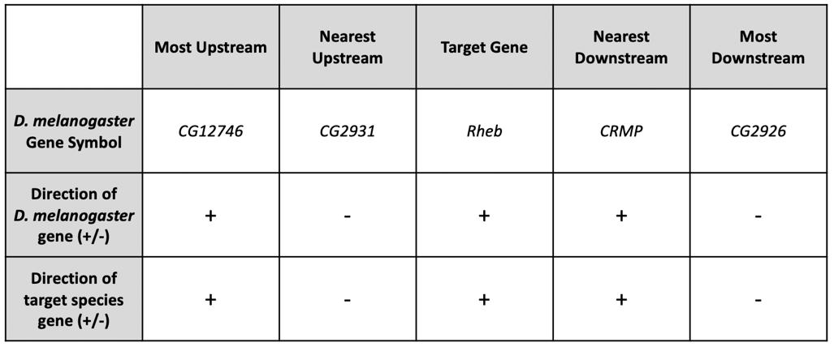
Figure 26 The putative orthologs of CG12746 and CG2931 are located upstream of Rheb, and the putative orthologs of CRMP and CG2926 are located downstream of Rheb in the D. yakuba chr3R scaffold, and each gene is on the +, -, +, and - strands, respectively.
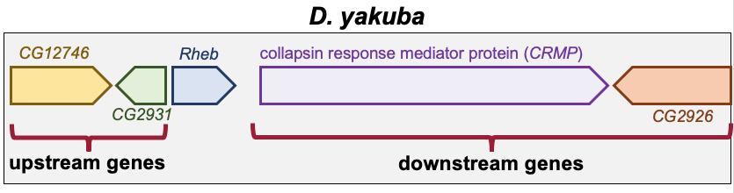
Figure 27 Sketch of the genomic neighborhood of Rheb in D. yakuba.

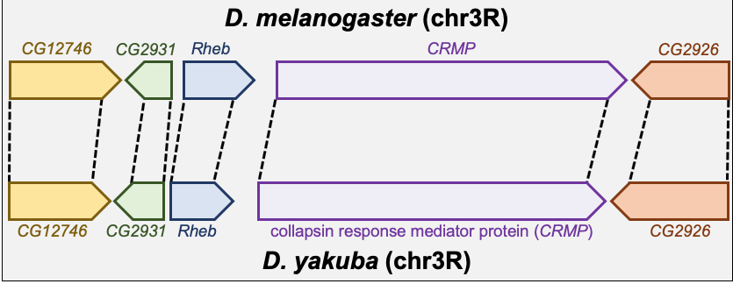
Figure 28 Comparison of the relative order and orientation of the genomic neighborhoods of Rheb in D. melanogaster (top) and D. yakuba (bottom).
If the genomic neighborhood looks similar between Rheb in D. melanogaster and the putative ortholog in D. yakuba, we can be confident we have found the true ortholog. However, if any of the information is inconsistent with this being a syntenic region, we should inspect our other hits in the tblastn search to see if a different genomic region is a better match overall.

Examination of the genomic regions surrounding the Rheb gene in D. melanogaster (Figure 28; top) and the putative Rheb ortholog in D. yakuba (Figure 28; bottom) shows that the relative gene order (i.e., CG12746, CG2931, Rheb, CRMP, and CG2926) and orientations (+, -, +, + , -) are the same in the two species. Hence the synteny analysis supports the assignment of the D. yakuba feature at chr3R:17,358,666-17,359,556 as an ortholog of Rheb.
- Note: If your target species’ assembly happened to have been numbered from the opposite end of the relevant scaffold, the orientation (+ or – strand) of the orthologs could be the opposite (i.e., -, +, -, -, +) of what you see in D. melanogaster but still be syntenic.

Part 4: Determine the gene structure in D. melanogaster

In Part 4 we will use the Gene Record Finder, which is a web tool that enables us to quickly identify a unique set of exons for a given gene and to retrieve their Coding DNA Sequences (CDS’s), also referred to as coding exons.

The Gene Record Finder will also provide details, such as number of isoforms, exon-intron structure and their coordinates, and transcript and protein information of the gene in question (in this case Rheb). It is important to remember that the details provided by the Gene Record Finder are for the gene in the reference organism, D. melanogaster. We will use the details from Rheb in D. melanogaster to assist us with creating a gene model for Rheb in D. yakuba.
Before we can construct the orthologous gene model, we need to ascertain the gene structure (e.g., number of isoforms and CDS’s) of the D. melanogaster Rheb gene using the Gene Record Finder.

- Open a new tab and navigate to the Gene Record Finder.
- Enter “Rheb” into the text box.
- Click the “Find Record” button (Figure 29).
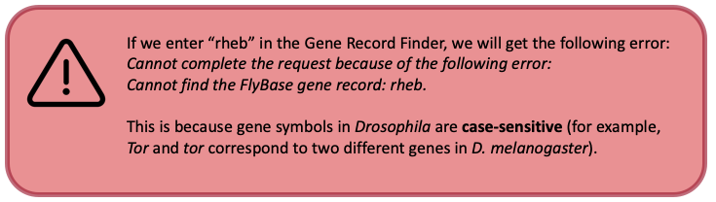

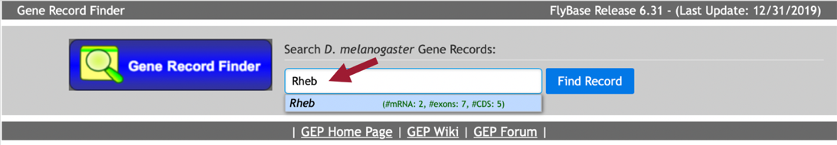
Figure 29 Use the Gene Record Finder to retrieve the gene record for the Rheb gene in D. melanogaster.
The Gene Record Finder shows that Rheb has two isoforms (A and B) in D. melanogaster. The CDS usage map (under the “Polypeptide Details” tab) shows that both isoforms have the same set of coding exons (CDS’s) (i.e., 1_9861_0, 2_9861_2, 3_9861_2, 4_9861_1, and 5_9861_0). (The coding exons are ordered from 5' to 3' from left to right in the CDS usage map.) Hence the differences between these two isoforms are limited to the untranslated regions (UTRs). A graphical overview of the two isoforms is shown in the “mRNA Details” panel (Figure 30).
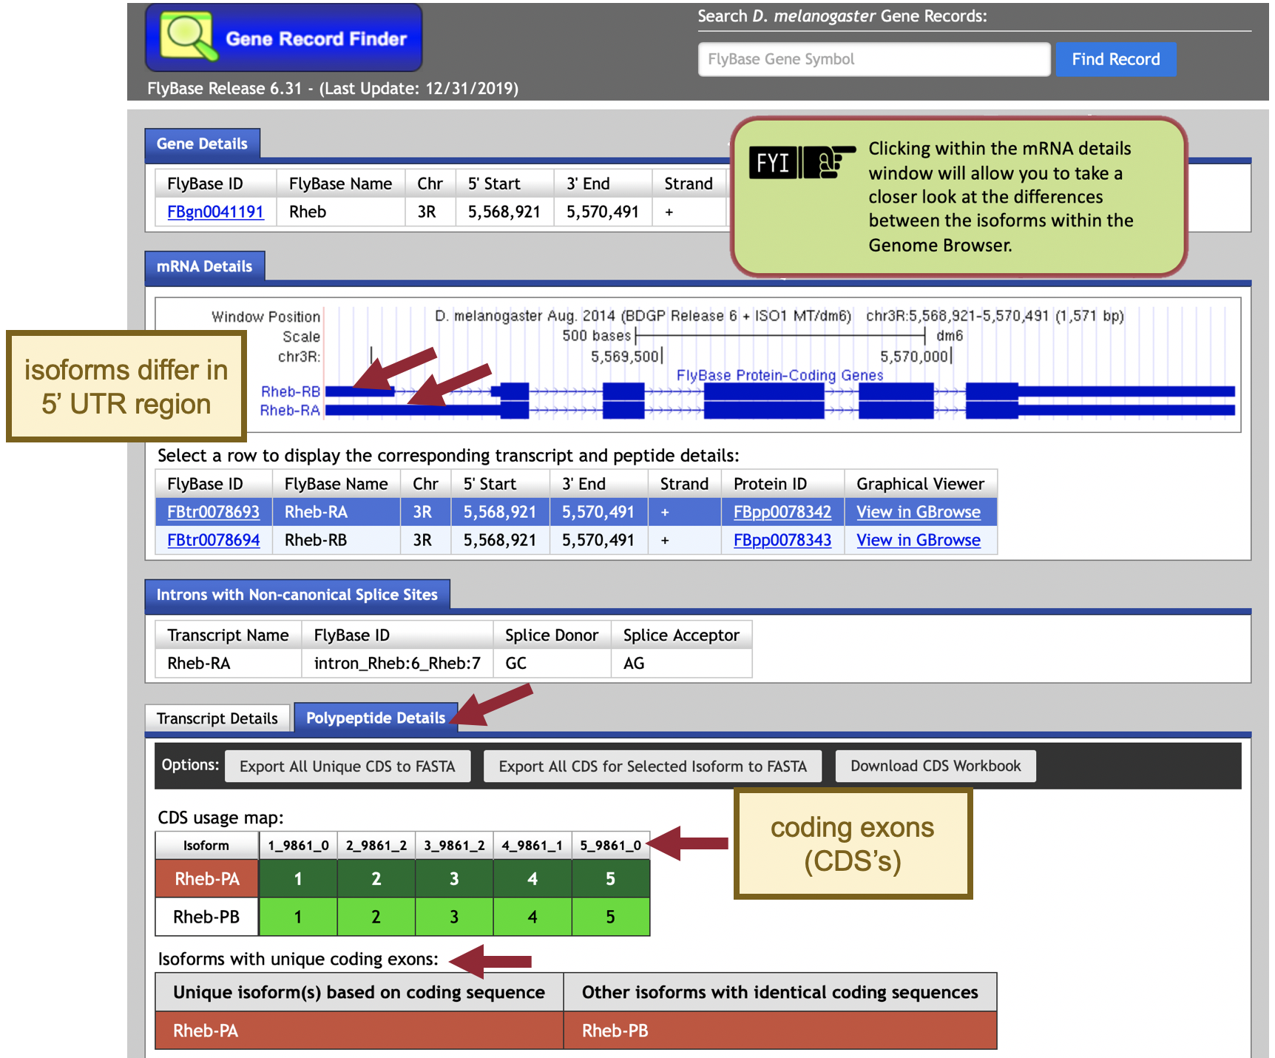
Figure 30 The “mRNA Details” panel of the Gene Record Finder shows that the Rheb gene has two isoforms in D. melanogaster (i.e., Rheb-RA and Rheb-RB). Under the “Polypeptide Details” tab, the “CDS usage map” indicates that both isoforms have five coding exons (CDS’s), and the “Isoforms with unique coding exons” section shows that both isoforms have identical coding sequences.

Based on parsimony (i.e., minimizing the number of changes compared to D. melanogaster), we expect to find both the A and B isoforms of Rheb in our D. yakuba genome sequence. For this walkthrough, we will only focus on the annotation of the coding exons (CDS’s), which do not include the UTRs. Consequently, we only need to determine the coordinates of the five coding exons (CDS’s) for one of the isoforms (e.g., isoform A) because the set of coding exons for both the A and B isoforms are the same (Figure 30).

Part 5: Determine the approximate location of the coding exons (CDS’s) in D. yakuba

The initial tblastn search we performed in Part 2 helped define the search region for the putative ortholog within the genomic scaffold of the target genome, D. yakuba. The approximate coordinates of each CDS can now be determined by aligning each CDS of the gene in D. melanogaster against this search region of the target genome.

The next step in our analysis is to determine the approximate coordinates of each coding exon (CDS) of Rheb-PA in D. yakuba. Because the BLAST algorithm does not take the positions of potential splice sites within a complete protein sequence into account when it generates the alignment, BLAST often extends the alignment beyond the coding exon boundary and into the intron. To ameliorate this issue, the GEP annotation protocol recommends mapping each coding exon separately to determine their approximate locations and then further refine the exon boundaries by searching for compatible splice donor and acceptor sites through visual inspection using the Genome Browser.

In addition to comparing a query sequence against a collection of subject sequences in a database (e.g., Part 2 of this walkthrough), the NCBI BLAST web service also allows us to compare two or more sequences against each other (using the program bl2seq (BLAST 2 sequences)).

In order to map the amino acid sequences of each D. melanogaster CDS against the D. yakuba scaffold, we must translate the entire D. yakuba scaffold sequence in all six reading frames (i.e., three reading frames in the plus and minus strands, respectively) and then compare each conceptual translation against each CDS sequence from D. melanogaster. This means that we can use either tblastn or blastx to perform this search (depending on whether we treat the CDS sequence as the query or the subject sequence, respectively).

In this walkthrough, we will perform five tblastn searches— using each D. melanogaster Rheb CDS sequence as the query and the D. yakuba Accession Number (CM000160.2) we identified for the chr3R scaffold in Part 2.2 as the database (subject) sequence.
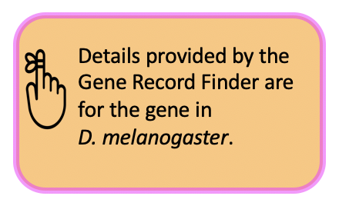
- Navigate to the Gene Record Finder.
- Enter “Rheb” into the text box.
- Click the “Find Record” button.

Scroll down to the CDS usage map (under the “Polypeptide Details” tab). Since Rheb has 5 coding exons (CDS’s), we will need to run five different tblastn searches, one for each of our CDS’s. Let’s start with CDS-1.

- To view the protein sequence for CDS-1, select row 1 (FlyBase ID: 1_9861_0).
- Copy the entire sequence (including the header) shown in the pop-up window (Figure 31).
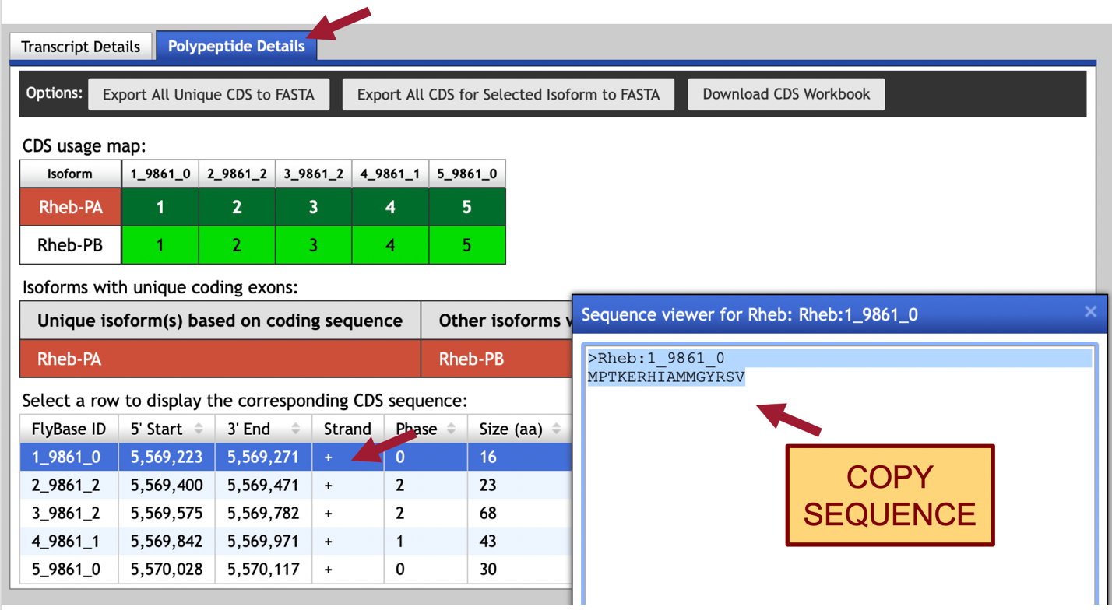
Figure 31 Use the Gene Record Finder to retrieve the amino acid sequence for CDS-1 (FlyBase ID: 1_9861_0). To obtain the sequence for CDS-1, select row 1 (left) and then copy entire sequence (including header) shown in pop-up window (right).
- To setup the tblastn search, navigate to the NCBI BLAST website.
- Click the “tblastn” image under the “Web BLAST” section (Figure 32).
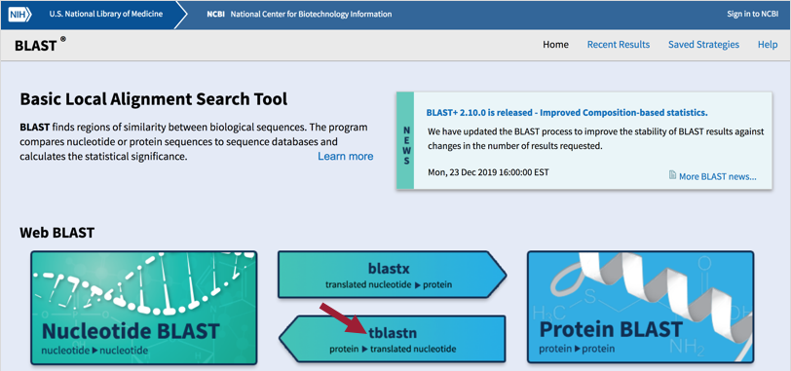
Figure 32 Navigate to the NCBI BLAST website and then click the “tblastn” image.

- Select the “Align two or more sequences” checkbox (Figure 33).
- Paste the sequence for CDS-1 into the “Enter Query Sequence” text box.
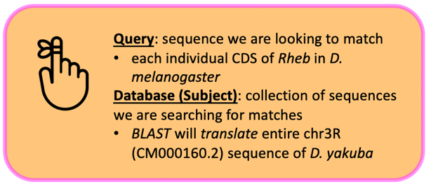
- Click within the “Job Title” text box and it should automatically populate with the sequence header.
- In the “Enter Subject Sequence” text box, enter the Accession Number for the chr3R sequence “CM000160.2” we identified in Part 2.2.
- Based on our analysis in Part 2.3, limit the “Subject subrange” by entering from “17300000” to “17400000.”
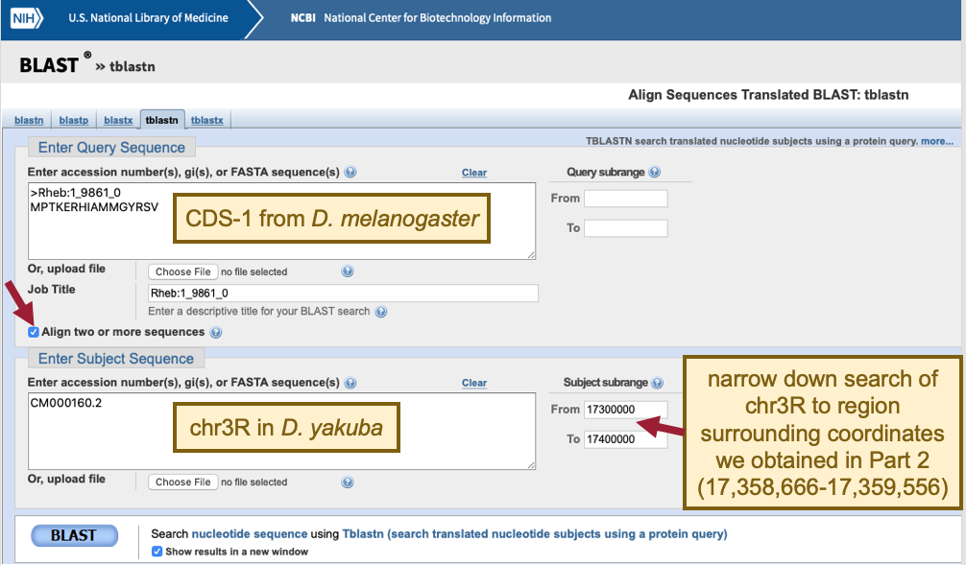
Figure 33 Configure tblastn to compare the D. melanogaster CDS-1 (query) against the D. yakuba chr3R scaffold CM000160.2 (subject). Since the tblastn search of Rheb-PA against the D. yakuba assembly placed the putative Rheb ortholog at approximately 17,358,666-17,359,556 on scaffold chr3R, the “Subject subrange” is used to limit the search region from 17,300,000 to 17,400,000. The smaller search region will increase the statistical power of the search and reduce the number of spurious matches.

The default NCBI BLAST parameters are optimized for searching the query sequence against a large collection of sequences in a database. When we are using BLAST to compare only two sequences against each other, we need to change some of these alignment parameters because the default parameters could potentially mask the conserved regions of the coding exon.

- Click the “+” icon next to “Algorithm parameters” to expand the section (Figure 34).
- In the “Scoring Parameters” section, change the “Compositional adjustments” field to “No adjustment.”
- In the “Filters and Masking” section, uncheck the “Low complexity regions” checkbox in the “Filter” field.
- Make sure the check box next to “Show results in a new window” is selected.
- Click the “BLAST” button.
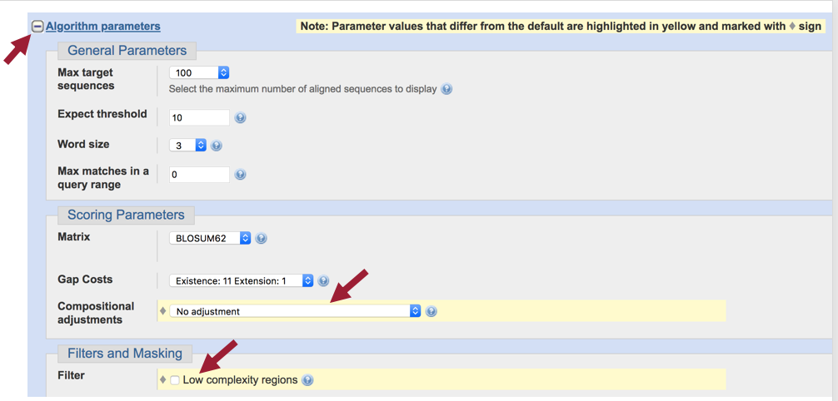
Figure 34 Expand the “Algorithm parameters” section, and then turn off “Compositional adjustments” and the filter for “Low complexity regions” to increase the sensitivity of the tblastn search.
The tblastn results show a single match (E-value: 5e-07; 93.75% identity) to CDS-1.

- Click the “Alignments” tab to view the corresponding tblastn alignment (Figure 35).

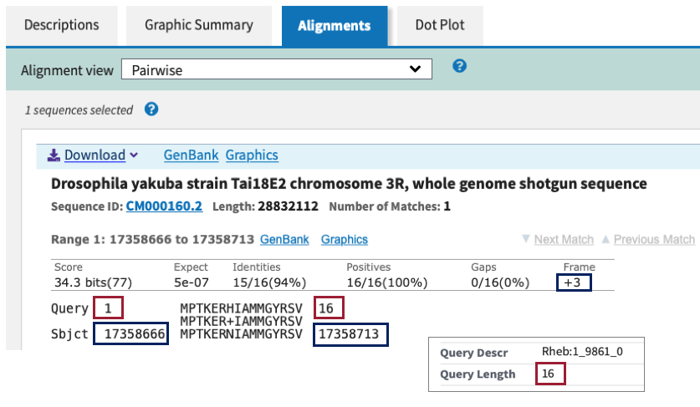
Figure 35 The tblastn alignment between the Rheb CDS-1 (query) and the D. yakuba scaffold (within the subject subrange of 17,300,000-17,400,000) is located at 17,358,666-17,358,713 when the sequence is translated in frame +3. The tblastn alignment has an E-value of 5e-07 and 94% sequence identity. This alignment covers all 16 aa of CDS-1.

The “Query” coordinates show that the alignment covers all 16 amino acids (aa) of CDS-1 (Figure 35).
- NOTE: We can find the length (in aa) of CDS-1 using the Gene Record Finder (CDS usage map under the “Polypeptide Details” tab) or at the top of the tblastn search results.

The “Subject” coordinates correspond to the region within chr3R (i.e., 17,358,666 – 17,358,713) that shows sequence similarity to CDS-1 when it is translated in the third reading frame in the positive strand (i.e., frame +3). Hence, we can place CDS-1 at 17,358,666 – 17,358,713 on chr3R.

We can apply this same procedure to place the other four CDS’s on chr3R.

- Copy the CDS-2 sequence (along with the header) from the Gene Record Finder.
- Return to the tblastn search web browser tab and delete the CDS-1 sequence from the “Enter Query Sequence” textbox.
- Paste the CDS-2 sequence in the textbox.
- Click within the “Job Title” text box and it should automatically repopulate with the CDS-2 sequence header.
  - Leave everything else the same as we had it for CDS-1.
- Click the “BLAST” button to run the tblastn search.
- Click on the “Alignments” tab to view the corresponding tblastn alignment.
The tblastn results show two matches (with E-value 8e-13 and 3.2, respectively) to the CDS-2 sequence. The “Subject” coordinates correspond to two different regions within chr3R (i.e., 17,358,844 – 17,358,912 and 17,347,863 – 17,347,807, respectively) that show sequence similarity to CDS-2 (Figure 36). Since tblastn showed two matches, we need to investigate each match further.

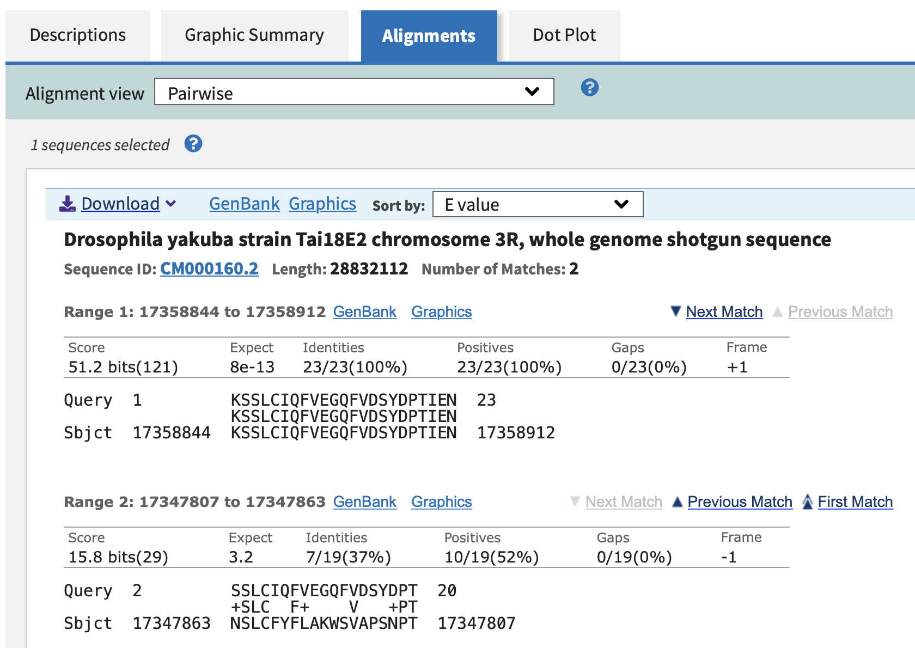
Figure 36 The tblastn search of CDS-2 (query) against chr3R (CM000160.2) (subject) shows two different matches.

The query coordinates show that the alignment for the first match covers all 23 aa of CDS-2, and the subject frame is +1 so it is on the positive strand. The query coordinates for the second match show that this alignment match does not cover the entire length of CDS-2 (only covers amino acids 2-20), and the subject frame is -1 so it is on the negative strand.

The first match has an E-value of 8e-13 and 100% of the two sequences are identical (“Identities” 23/23(100%)). The subject coordinates for this match (17,358,844 – 17,358,912) are near the subject coordinates we found for CDS-1 (17,358,666 – 17,358,713). The second match has a much higher E-value (3.2) and much lower sequence identity (37%), and the subject coordinates are almost 11 kb away from the coordinates we just found for CDS-1. In addition, the second match is in the negative strand (i.e., frame -1), and we already determined that CDS-1 is in the positive strand.

Based on these lines of evidence, we can conclude that the second match is of much lower quality and does not show actual orthology of Rheb between D. melanogaster and D. yakuba. Hence, we can place CDS-2 at approximately 17,358,844 – 17,358,912 on chr3R.

- Repeat this process to BLAST the remaining three CDS’s (Figure 37).

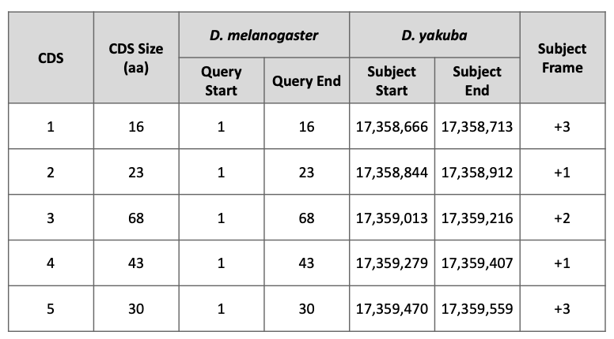
Figure 37 Summary of the tblastn CDS-by-CDS search results.

Examination of the query ranges for the tblastn alignments of the five CDS’s of Rheb shows that they are collinear—CDS’s 1-5 are placed on the positive strand and the query ranges for the CDS's are in ascending order. Consequently, the CDS-by-CDS search results support the hypothesis that the putative (probable) ortholog of Rheb-PA is located at approximately 17,358,666-17,359,556 on chr3R of the D. yakuba genome assembly.

Part 6: Refine coordinates of coding exons (CDS’s)

Now that we’ve mapped each CDS separately to determine their approximate locations (Figure 37), we will now further refine the CDS boundaries by searching for compatible splice donor and acceptor sites by visual inspection using the Genome Browser.

As part of the modENCODE project, the Baylor College of Medicine Human Genome Sequencing Center (BCM–HGSC) has produced RNA-Seq data for D. yakuba using samples from adult females and males. These RNA-Seq reads (100–125 bp in length) are derived primarily from processed mRNA (i.e., after the introns have been removed). Hence, genomic regions with RNA-Seq read coverage usually correspond to transcribed exons, which include both the translated and untranslated regions.

The “modENCODE RNA-Seq” tracks correspond to the samples from adult females (red) and males (blue) where RNA-Seq data is available (Figure 38). The height of the histograms within each track corresponds to the number of RNA-Seq reads that have been mapped to each position of the D. yakuba scaffold. By default, the scale of the “RNA-Seq Coverage” track will change automatically based on the minimum and maximum read depth within the genomic region being viewed.

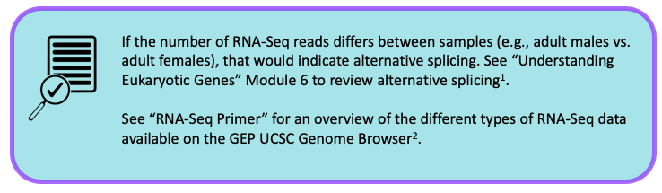
¹Understanding Eukaryotic Genes ²RNA-Seq Primer

Part 6.1: Verify the start codon coordinates for Rheb-PA
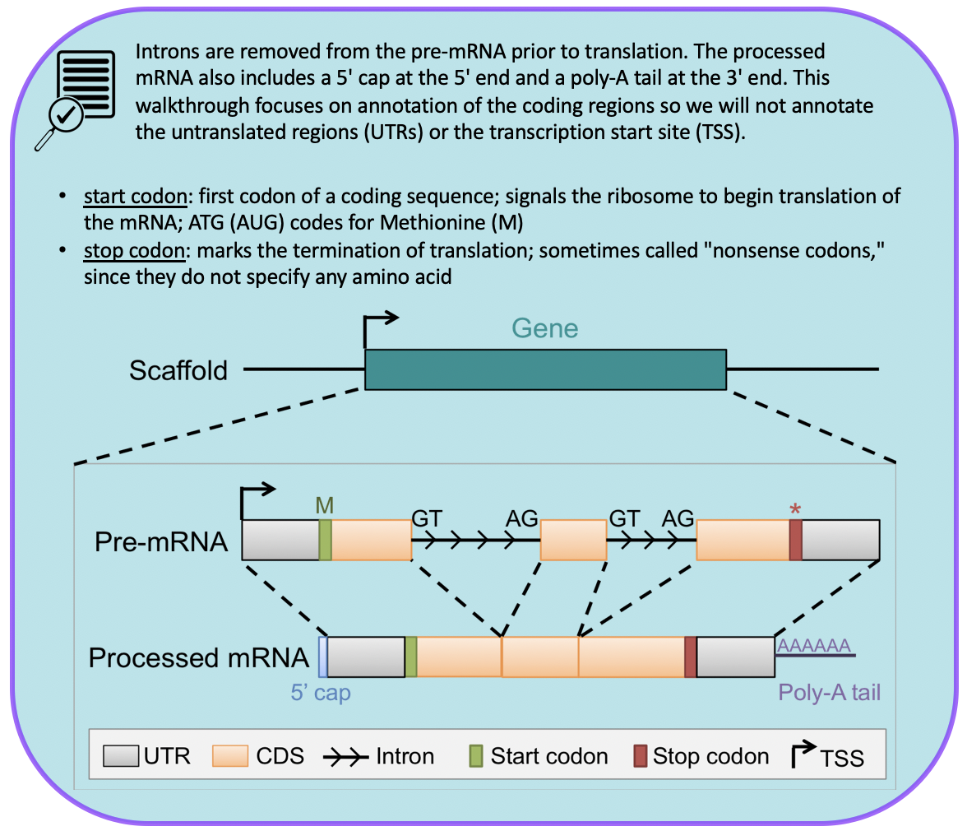
We need to ascertain whether the tblastn alignment for CDS-1 at 17,358,666-17,358,713 (Figure 35) is supported by the RNA-Seq data and determine the location of the start codon.

- Return to the Genome Browser for D. yakuba.
- Under the “Mapping and Sequencing Tracks,” change the “Base Position” track to “full.”
- Click the “refresh” button.
- To examine the region of the tblastn alignment for CDS-1, enter “chr3R:17358666-17358713” into the “enter position or search terms” text box.

The RNA-Seq tracks for both samples show high RNA-Seq read depth within the tblastn alignment block (17,358,666-17,358,713), consistent with the hypothesis that this region is being transcribed in D. yakuba.

- To examine the region surrounding the start of the tblastn alignment to CDS-1, enter “chr3R:17358666” into the “enter position or search terms” text box.
- Click the “go” button.
- Zoom out 3x and another 10x.

In Part 5, we found our tblastn alignment for CDS-1 begins at 17,358,666 when translated in frame +3 (Figure 35). Examination of this region using the Genome Browser shows us that a start codon at this location is supported by multiple evidence tracks—the Spaln alignment of D. melanogaster proteins, as well as the Gnomon, GeMoMa, Geneid, and Augustus gene predictions (Figure 38).

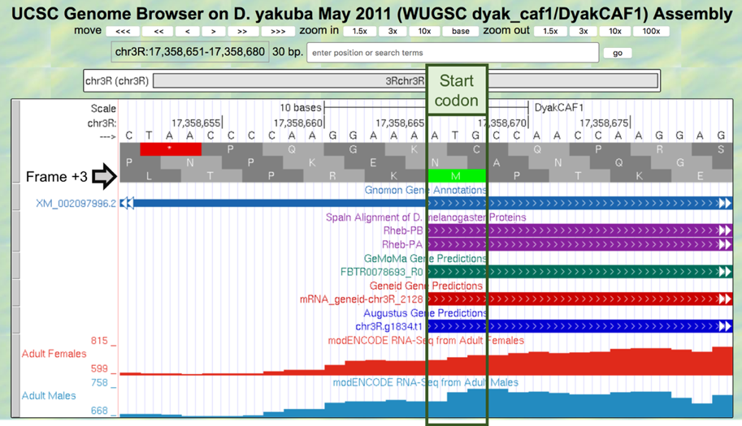
Figure 38 The start codon at chr3R:17,358,666-17,358,668 is supported by the Spaln alignment of D. melanogaster proteins and the Gnomon, GeMoMa, Geneid, and Augustus gene predictions.

Since the RNA-Seq read coverage from the adult females and adult males samples extend upstream beyond the start codon, we need to determine if there are alternative start codon candidates available that could serve as the translation start site for Rheb-PA.

- Zoom out 10x and another 3x.
The contiguous RNA-Seq read coverage extends upstream of the start codon at 17,358,666-17,358,668 to position 17,358,293 in the adult males’ sample (Figure 39). Examination of the “Base Position” track shows that the first stop codon upstream from 17,358,666-17,358,668 occurs at 17,358,477-17,358,479 (remember that we are looking at frame +3 and that a codon consists of three amino acids). Since there are no alternative start codons in frame +3 between this stop codon and the start codon at 17,358,666-17,358,668, the most likely translation start site for the Rheb-PA ortholog in D. yakuba is assigned to the position 17,358,666-17,358,668 on chr3R. Consistent with the gene model for Rheb-RA in D. melanogaster, the RNA-Seq read coverage extending upstream of the start codon likely corresponds to the 5’ untranslated regions of the initial exon of Rheb.
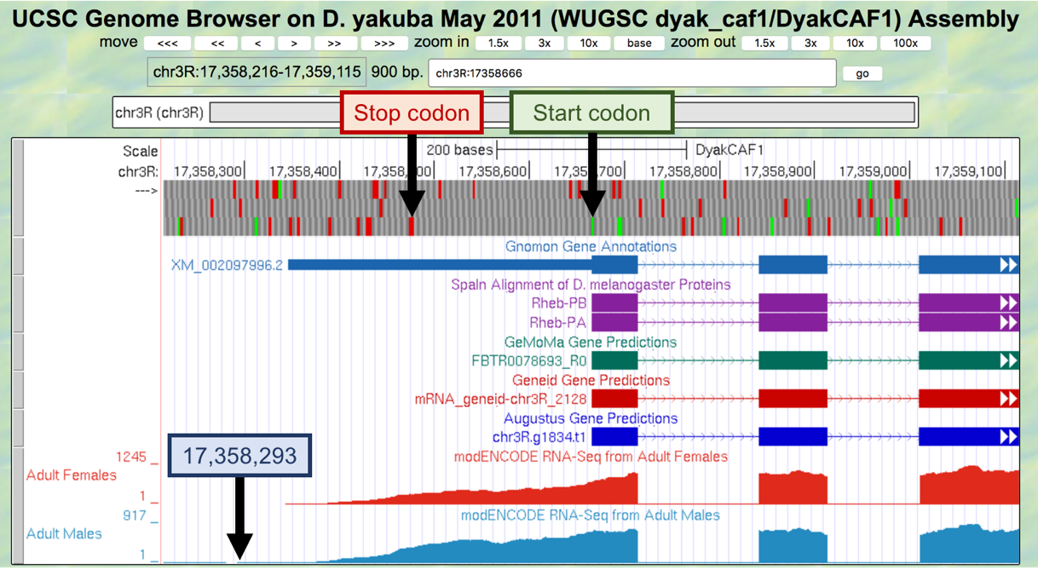
Figure 39 The contiguous RNA-Seq read coverage extends upstream of the start codon at chr3R:17,358,666-17,358,668 to position 17,358,293 in the adult males’ sample (blue box). Within the region from the start of the RNA-Seq read coverage in the adult males’ sample to just before the start codon (i.e., 17,358,293-17,358,665), the first in-frame stop codon is located at 17,358,477-17,358,479 (red box). Since there are no alternative start codons in frame +3 between this stop codon and the start codon at 17,358,666-17,358,668, the translation start site for the Rheb-PA ortholog in D. yakuba is assigned to the position 17,358,666-17,358,668 on chr3R.

Part 6.2: Verify the stop codon coordinates for Rheb-PA

In Part 5, we found our tblastn alignment for CDS-5 ends at 17,359,559 when translated in frame +3. The alignment covers all 30 aa of CDS-5 and ends with a stop codon (Figure 40).
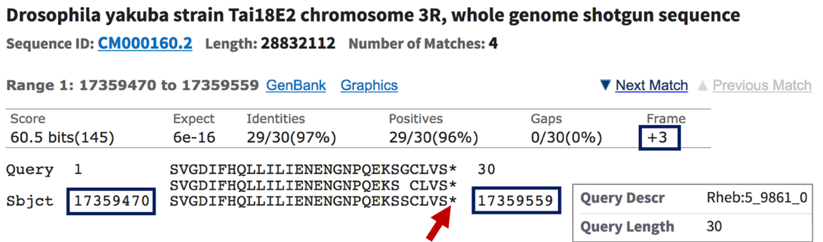
Figure 40 The tblastn alignment of CDS-5 of Rheb-PA (query) against the D. yakuba scaffold chr3R (subject) placed the CDS at 17,359,470 – 17,359,559 when the sequence is translated in frame +3. The tblastn alignment covers all 30 aa of CDS-5, and it ends with a stop codon (‘*’; red arrow).
- To examine the genomic region surrounding the end of the tblastn alignment to CDS-5, enter “chr3R:17,359,559” into the “enter position or search terms” text box.
- Click the “go” button.
- Zoom out 3x and another 10x (Figure 41).

The stop codon at 17,359,557-17,359,559 is consistent with the Spaln alignment of D. melanogaster proteins, and the Gnomon, GeMoMa, and Augustus gene predictions. The stop codon is inconsistent with the Geneid prediction mRNA_Geneid-chr3R_2128, which predicted an intron in this region. However, the coding span for this Geneid prediction extends from 17,358,666-17,366,011, which encompasses regions with sequence similarity to the coding exons of the CRMP gene. Based on the tblastn alignment for CDS-5 and the available evidence on the Genome Browser, the stop codon for the Rheb-PA ortholog is placed at 17,359,557-17,359,559, and the last codon (S; Serine) before the stop codon ends at 17,359,556 (Figure 41).

Note that the RNA-Seq read coverage tracks for both samples indicate that transcription extends beyond the stop codon. Based on the gene structure of Rheb-RA in D. melanogaster, the region with RNA-Seq read coverage that extends beyond the stop codon likely corresponds to the 3’ untranslated region (UTR) of the last exon in Rheb.

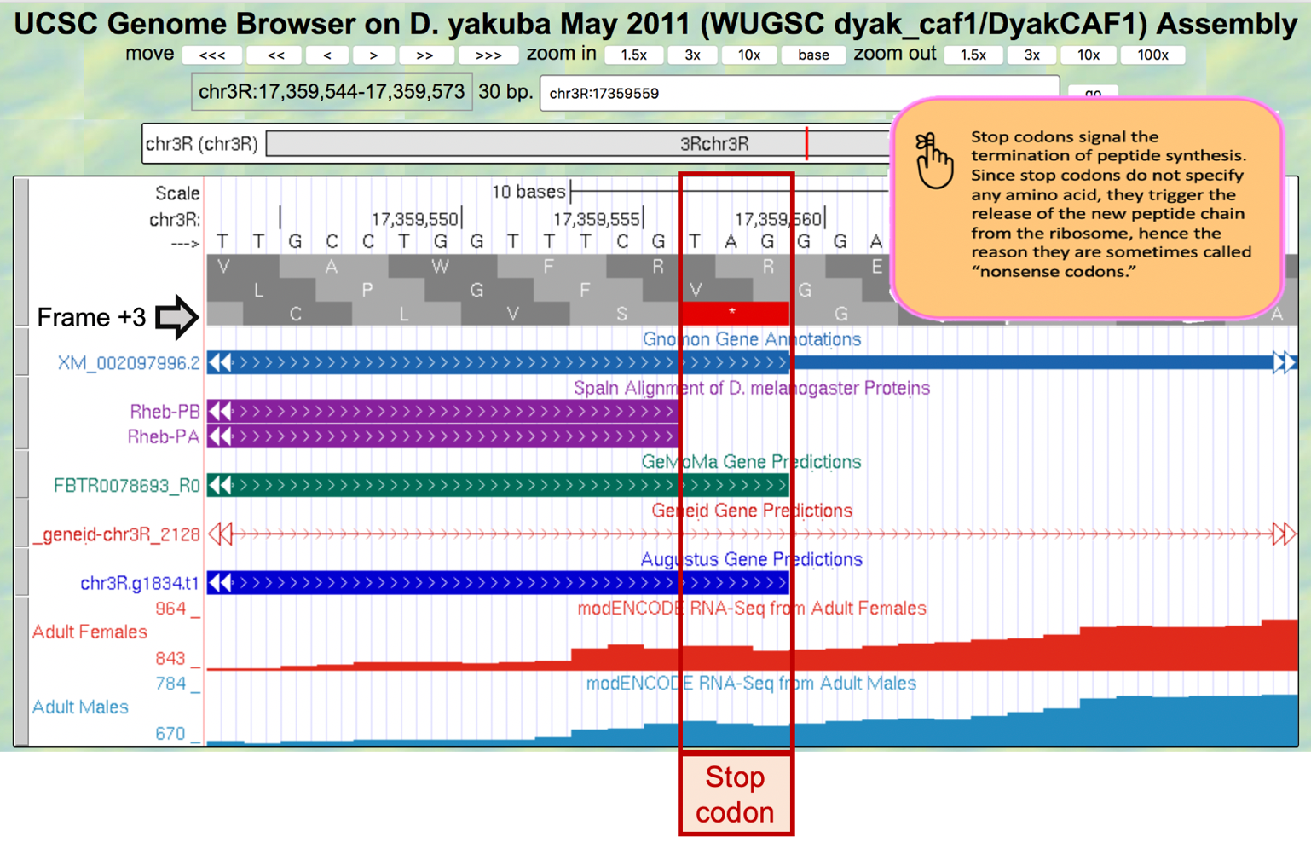
Figure 41 Based on the tblastn alignment for CDS-5 and the available evidence on the Genome Browser, the stop codon for the Rheb-PA ortholog is placed at 17,359,557 – 17,359,559, and the last codon (S; Serine) before the stop codon ends at 17,359,556.

Part 6.3: Determine the phases of the donor and acceptor splice sites
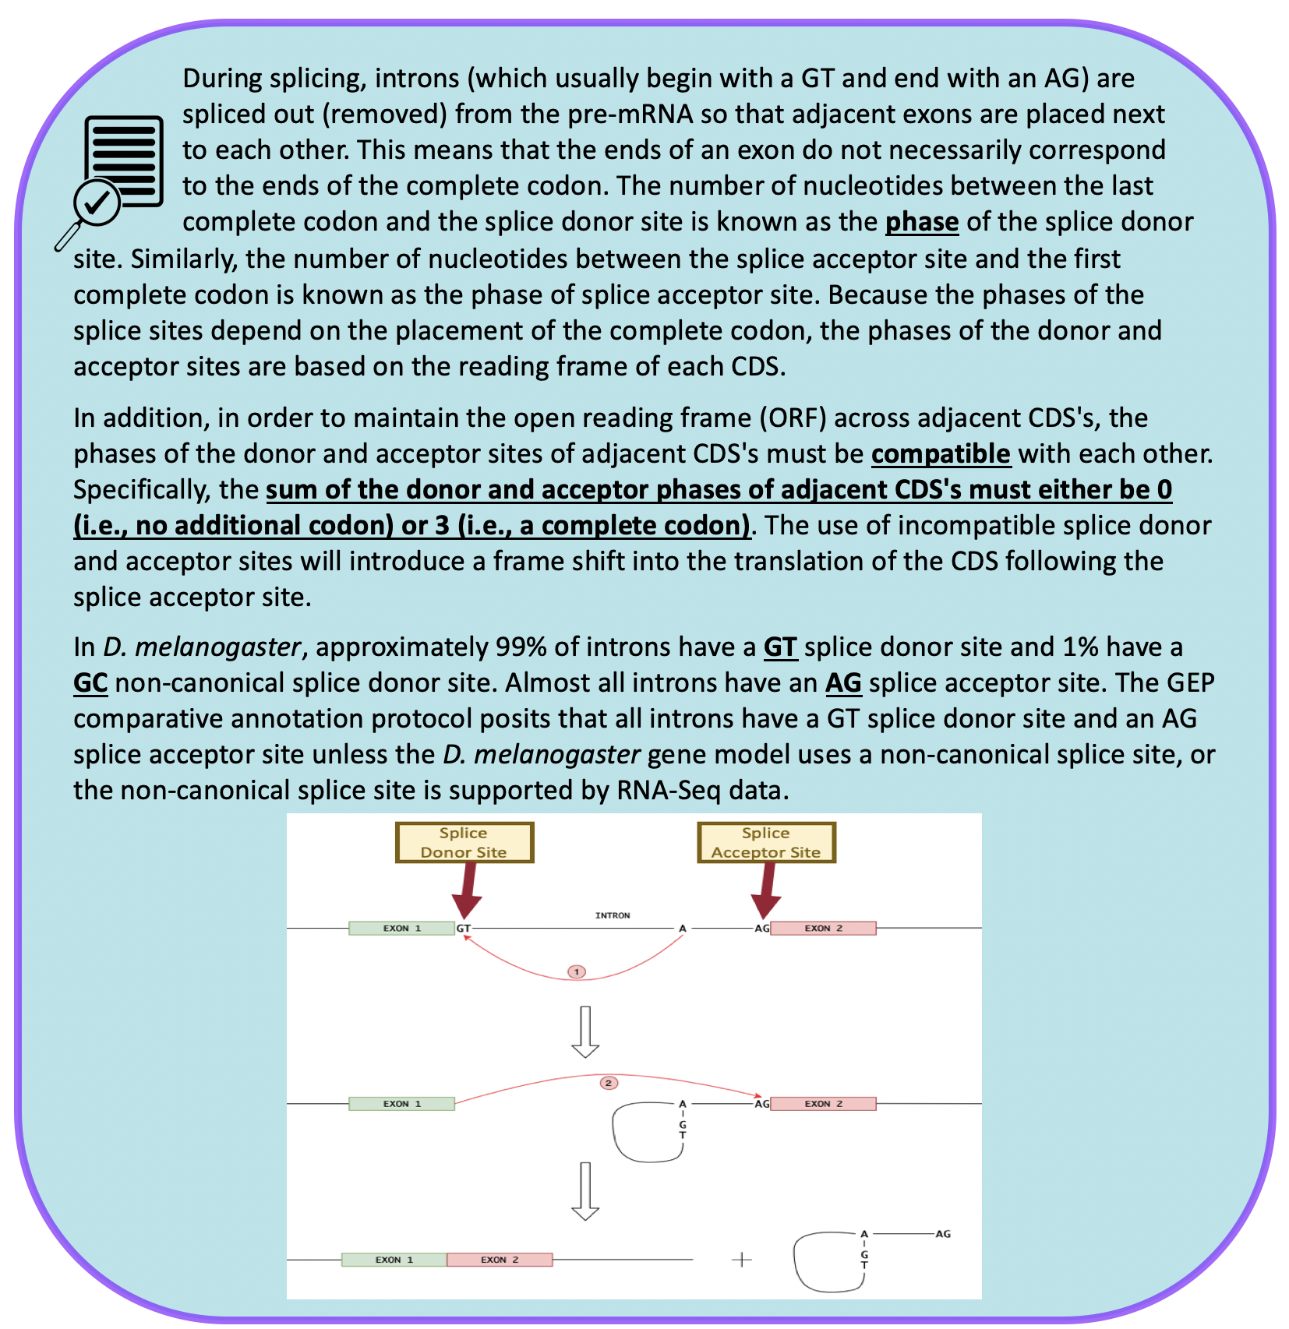
See Understanding Eukaryotic Genes Module 4 to further review splicing.

Because the tblastn alignment for CDS-1 of Rheb terminates at 17,358,713 and the alignment includes the last amino acid of the CDS (Figure 35), we expect to find the splice donor site for CDS-1 at around position 17,358,713.

- To examine the genomic region surrounding the splice donor site of CDS-1, enter “chr3R:17,358,713” into the “enter position or search terms” text box.
- Click the “go” button.
- Zoom out 10x and another 3x to examine the 30 bp surrounding this position.

The GT splice donor site closest to 17,358,713 is located at 17,358,715 – 17,358,716. This splice donor site is in phase 0 relative to frame +1 (Figure 42, top), in phase 2 relative to frame +2 (Figure 42, middle), and in phase 1 relative to frame +3 (Figure 42, bottom). This splice donor site is supported by multiple lines of evidence—Spaln alignment of D. melanogaster proteins, the Gnomon, GeMoMa, Geneid, and Augustus gene predictions, as well as the RNA-Seq read coverage from samples of adult females and adult males.
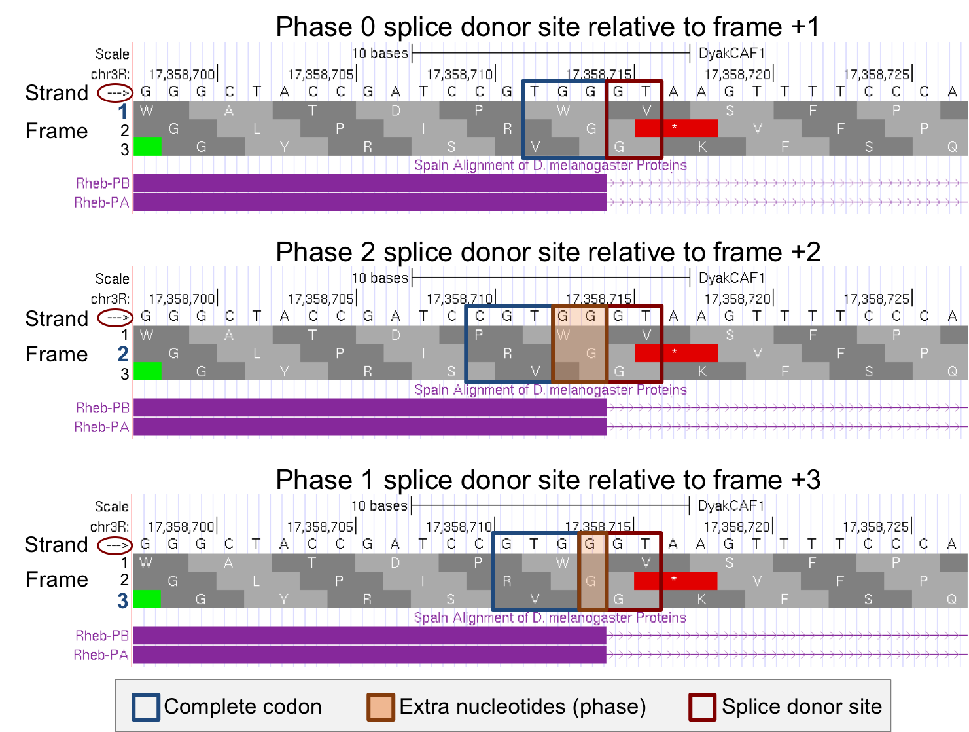
Figure 42 There are three possible phases for the splice donor site (0, 1, or 2), which depend on the reading frame. This splice donor site (at 17,358,715 – 17,358,716) is supported by multiple lines of evidence. Since CDS-1 is in frame +3 and the last complete codon (GTG which codes for V) is located at 17,358,711 – 17,358,713, there is one nucleotide (G at 17,358,714) between the last complete codon and the splice donor site. Hence, this splice donor site is in phase 1 (bottom).

Based on our tblastn alignment in Part 5, CDS-1 is in frame +3.

- Scroll out far enough to see the entire length of CDS-1 and confirm that frame +3 has an open reading frame (ORF) (i.e., no stop codons are shown within frame +3 of CDS-1).

Since CDS-1 is in frame +3, the splice donor site at 17,358,715 – 17,358,716 is in phase 1. This means that the splice acceptor site of CDS-2 must be in phase 2 in order to maintain the open reading frame. Based on our tblastn alignment in Part 5, we placed CDS-2 at 17,358,844 – 17,358,912 in frame +1 (Figure 36).
- To examine the genomic region surrounding the splice acceptor site of CDS-2, enter “chr3R:17,358,844” into the “enter position or search terms” text box.
- Click the “go” button.
- Zoom out 10x and another 3x to examine the 30 bp surrounding this position (Figure 43).

There is only one potential canonical splice acceptor site (AG) in the 30 bp region surrounding the start of the tblastn alignment to CDS-2. This potential splice acceptor site, located at 17,358,840 – 17,358,841, is supported by the Spaln alignment of D. melanogaster proteins, the Gnomon, GeMoMa, Geneid, and Augustus gene predictions, as well as the RNA-Seq read coverage from samples of adult females and adult males.

Since CDS-2 is in frame +1 and the first complete codon (AAA which codes for K) is located at 17,358,844 – 17,358,846, there are two nucleotides (GC at 17,358,842 – 17,358,843) between the potential splice acceptor site and the first complete codon. Hence, this splice acceptor site is in phase 2.
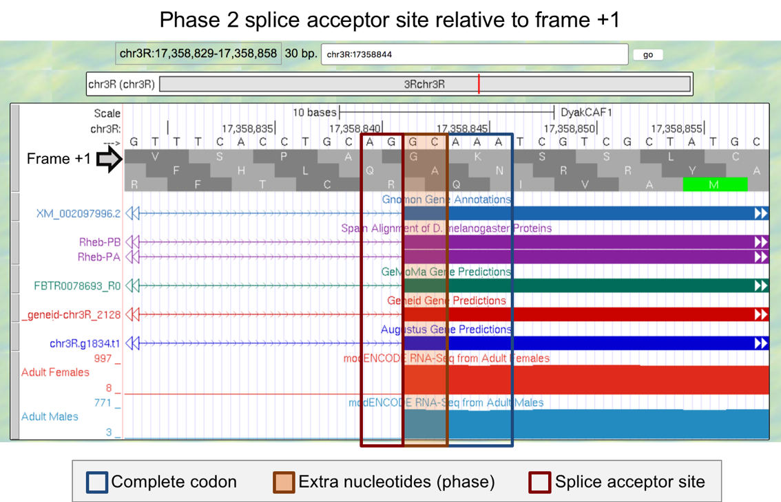
Figure 43 This splice acceptor site (at 17,358,840-17,358,841) is supported by multiple lines of evidence. Since CDS-2 is in frame +1 and the first complete codon (AAA which codes for K) is located at 17,358,844-17,358,846, there are two nucleotides (GC at 17,358,842-17,358,843) between the splice acceptor site and the first complete codon. Hence, this splice acceptor site is in phase 2.
Since the splice donor site for CDS-1 is in phase 1 (relative to frame +3), the splice acceptor site for CDS-2 must be in phase 2 (relative to frame +1) in order to maintain the open reading frame after the intron has been removed. The extra nucleotides near the splice sites (i.e., G + GC) will form an additional amino acid (Glycine/G) after splicing (Figure 44). Collectively, our analysis suggests that CDS-1 ends at 17,358,714 with a phase 1 splice donor site and CDS-2 begins at 17,358,842 with a phase 2 splice acceptor site.
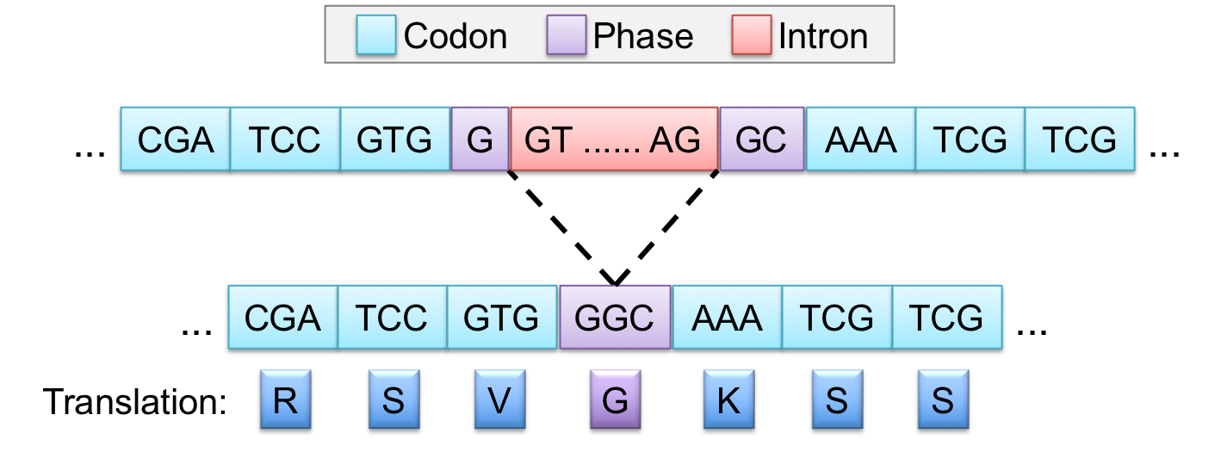
Figure 44 The phase 1 donor site (G) of CDS-1 combines with the phase 2 acceptor site (GC) of CDS-2 to form the codon GGC, which codes for a Glycine (G).

The same annotation strategy can be used to determine the coordinates for the remaining splice donor and splice acceptor sites between CDS-2 and CDS-3, CDS-3 and CDS-4, and CDS-4 and CDS-5, respectively (Figure 45).

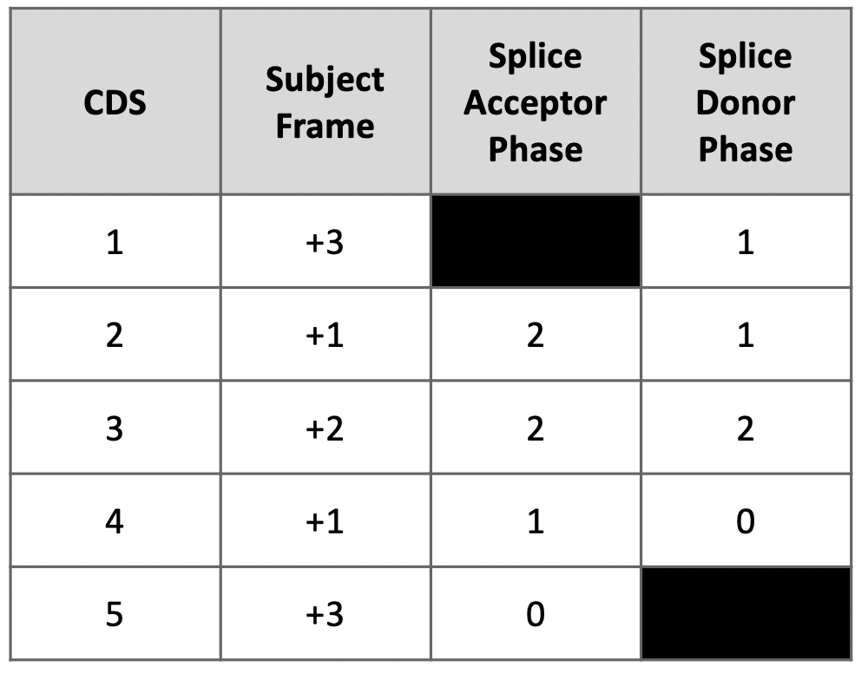
Figure 45 Summary of the phases of each splice donor and acceptor site in Rheb-RA.

Part 6.4: Use spliced RNA-Seq reads to verify the coordinates for the first intron
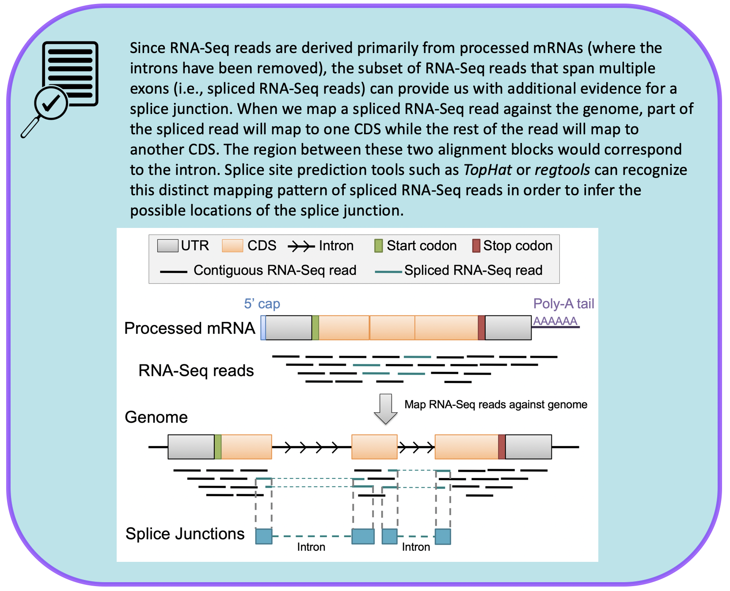
See Understanding Eukaryotic Genes Module 4 to further review TopHat splice junction predictions.

The splice junction between the phase 1 donor site of CDS-1 and the phase 2 acceptor site of CDS-2 is supported by Spaln alignment of D. melanogaster proteins, the Gnomon, GeMoMa, Geneid, and Augustus gene predictions, as well as the RNA-Seq read coverage from samples of adult females and males. We can gather additional evidence to support this splice junction using the RNA-Seq analysis tool called regtools.

- Under the “RNA Seq Tracks,” change the “Splice Junctions” track to “pack.”
  - Note: The “Splice Junctions” track identifies the splice junctions predicted by the regtools program.
- Click the “refresh” button.
- To examine the region surrounding Intron-1 (i.e., intron between CDS-1 and CDS-2), enter “chr3R:17,358,715-17,358,841” into the “enter position or search term” text box.
- Click the “go” button.
- Zoom out 3x to examine the 381 bp surrounding this position (Figure 46).
- To examine the splice donor site predicted by the splice junction JUNC00073911, zoom into the region surrounding the beginning of the intron predicted by this junction (Figure 46, red arrow).
- To examine the splice acceptor site predicted by the splice junction JUNC00073911, zoom into the region surrounding the end of the intron predicted by this junction (Figure 46, blue arrow).

Examination of the features in the “Splice Junctions Predicted by regtools using D. yakuba RNA-Seq” track shows that the splice junction prediction JUNC00073911 is consistent with our splice donor site for CDS-1 at 17,358,715 – 17,358,716 and our splice acceptor site for CDS-2 at 17,358,840-17,358,841 that we annotated in Part 6.3 (Figure 46).

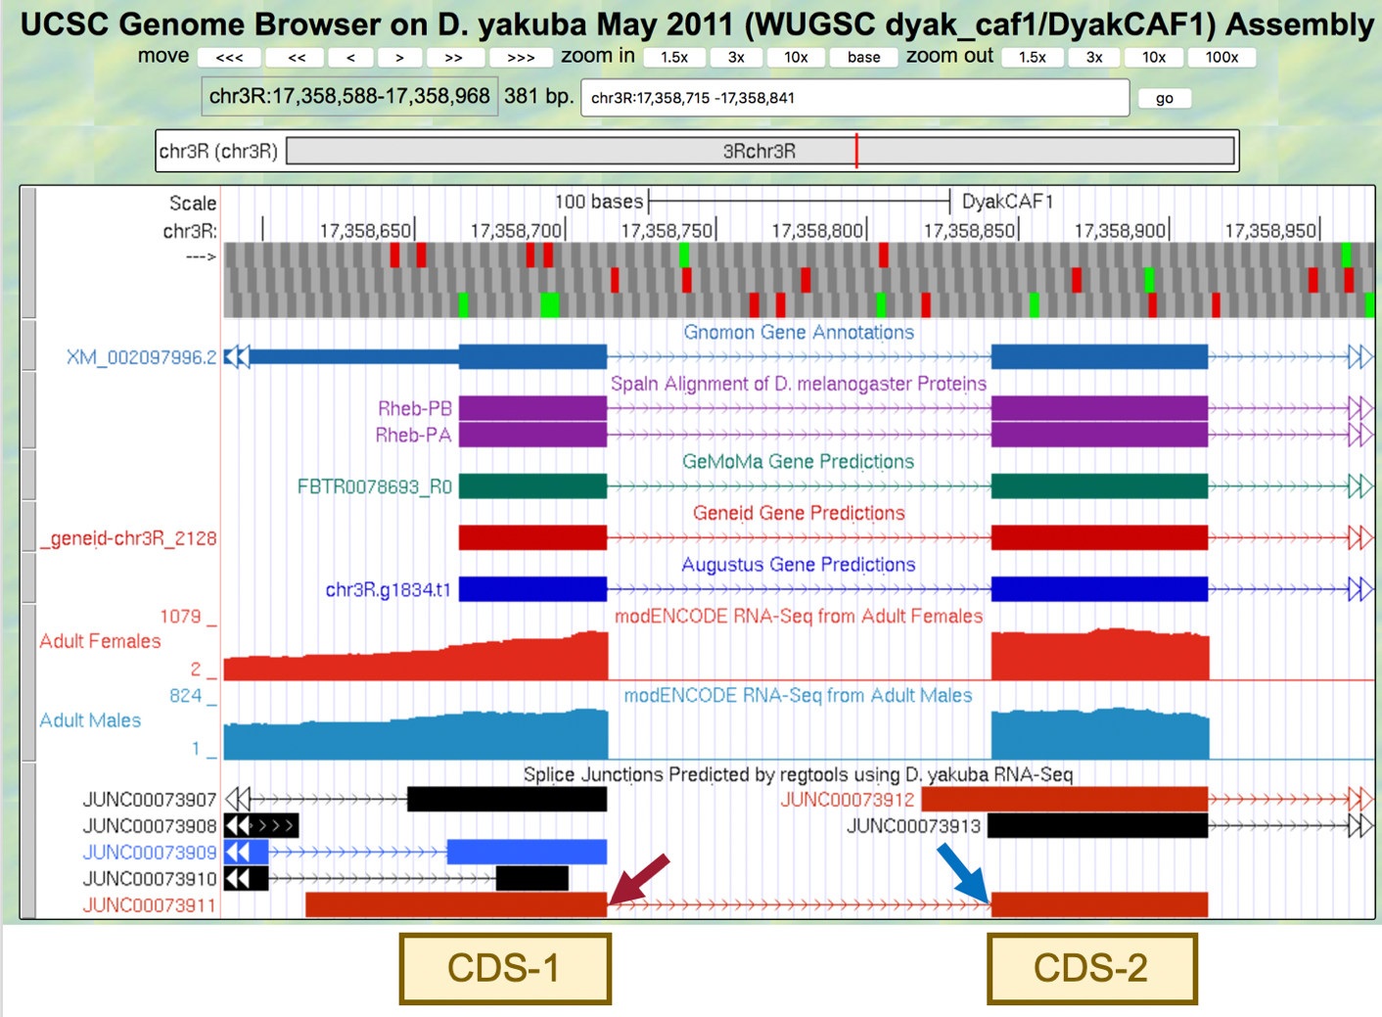
Figure 46 The splice junction JUNC00073911 predicted by regtools connects CDS-1 with CDS-2.

Part 6.5: Use splice junction predictions to verify the coordinates for the second intron

The same annotation strategy can be used to determine the coordinates for the intron between CDS-2 and CDS-3. The tblastn alignment for CDS-2 ends at 17,358,912 (Figure 36). The potential splice donor site at 17,358,914-17,358,915 for CDS-2 is supported by the splice junction prediction JUNC00073912, the Spaln alignment of D. melanogaster proteins, the Gnomon, GeMoMa, Geneid, and Augustus gene predictions, as well as the RNA-Seq read coverage from adult females and males. There is one nucleotide (A at 17,358,913) between the last complete codon (AAC) and the potential splice donor site. Hence, this splice donor site is in phase 1 relative to frame +1.

The tblastn alignment for CDS-3 spans from 17,359,013-17,359,216 in frame +2 (Figure 37). The potential splice acceptor site at 17,359,009-17,359,010 for CDS-3 is supported by the splice junction prediction JUNC00073912, the Spaln alignment of D. melanogaster proteins, the Gnomon, GeMoMa, Geneid, and Augustus gene predictions, as well as the RNA-Seq read coverage from adult females and males. There are two nucleotides (CC at 17,359,011-17,359,012) between the first complete codon (TTC) and the potential splice acceptor site. Hence, this splice acceptor site is in phase 2 relative to frame +2. This phase 2 splice acceptor site is compatible with the phase 1 splice donor site for CDS-2.

In addition to the splice junction JUNC00073912, which supports the proposed splice acceptor site for CDS-3 at 17,359,009-17,359,010, there is another splice junction which suggests a different splice acceptor site (JUNC00073913) (Figure 47).
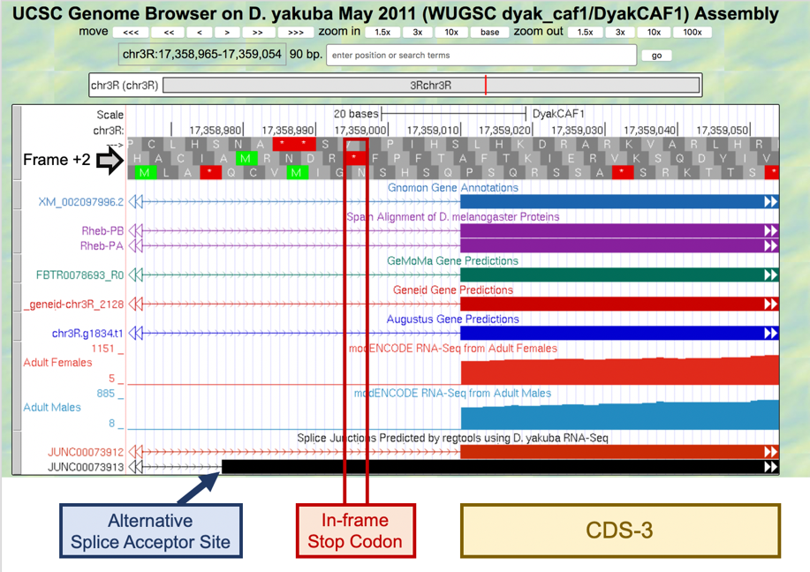

Figure 47 The alternative splice acceptor site proposed by the splice junction JUNC00073913 (at 17,358,976-17,358,977) cannot be a splice acceptor site for CDS-3 since it is located upstream of the in-frame stop codon at 17,358,995-17,358,997.
The CDS-3 in D. yakuba includes two methionine in frame +2 (at 17,359,112-17,359,114 and 17,359,205-17,359,207). Hence, the splice junction JUNC00073913 could indicate the presence of a novel isoform of Rheb in D. yakuba where the translation start site is located within CDS-3, and the region from the end of the splice junction (i.e., 17,358,978) to the start codon (e.g., 17,359,111) would be part of the 5’ UTR.

In order to assess whether there is sufficient evidence to propose a novel isoform of Rheb in D. yakuba, we will need to determine the number of spliced RNA-Seq reads that support the splice junction JUNC00073913.

- Click on the splice junction “JUNC00073913” and then examine the “Score” field (Figure 48).
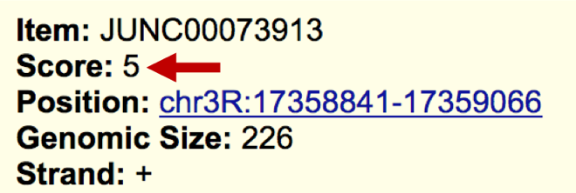
Figure 48 The splice junction JUNC00073913 has a score of 5 (red arrow), indicating that it is supported by 5 spliced RNA-Seq reads.
The bottom of the splice junctions details page for JUNC00073913 includes a “Description” section for the Splice Junctions track. This section includes a table which shows that the color of the feature in this evidence track corresponds to the number of spliced RNA-Seq reads that support the splice junction.

- Click the back button of the web browser to return to the Genome Browser image.
- Click the “JUNC00073912” feature to determine the number of spliced RNA-Seq reads that support this splice junction prediction (Figure 49).
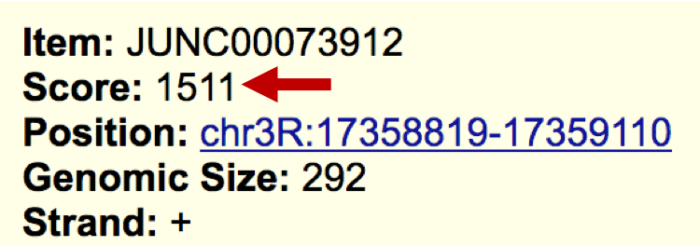
Figure 49 The score for JUNC00073912 shows that this junction is supported by 1,511 spliced RNA-Seq reads.
Since the splice junction JUNC00073913 is only weakly supported by the available RNA-Seq data, there is insufficient evidence to postulate a novel isoform of Rheb in D. yakuba based on this splice junction prediction.

A score filter can be applied to the “Splice Junctions” evidence track to hide the splice junction predictions that are supported by a small number of spliced RNA-Seq reads.

- Scroll down to the “RNA Seq Tracks” section and then click the “Splice Junctions” link.
- Change the “Show only items with score at or above” to “10.”
- Click the “Submit” button (Figure 50).
- To examine the intron between CDS-2 and CDS-3 after applying the filter, enter “chr3R:17,358,914-17,359,010” into the “enter position or search terms.”
- Click the “go” button.
- Zoom out 1.5x.

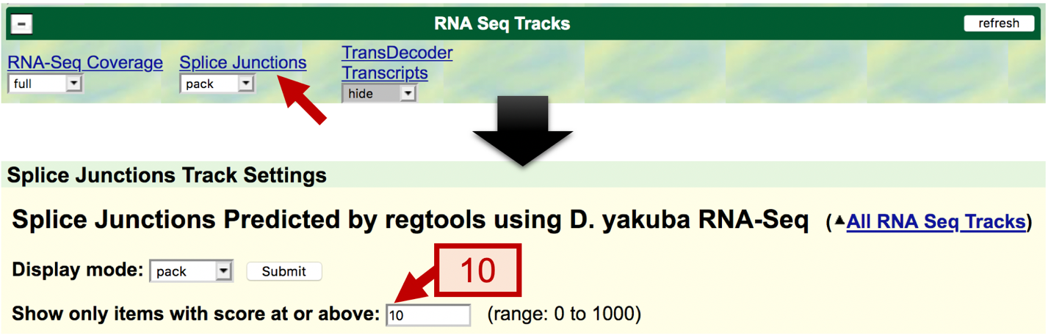
Figure 50 Configure the Splice Junctions track to only display the splice junctions that are supported by at least 10 spliced RNA-Seq reads.

Part 6.6: Use splice junction predictions to verify the coordinates for the third intron

The tblastn alignment for CDS-3 spans from 17,359,013-17,359,216 in frame +2 (Figure 37).

- To examine the region surrounding the splice donor site for CDS-3, enter “chr3R:17,359,216” into the “enter position or search terms” text box.
- Click the “go” button.
- Zoom out 3x and another 10x (Figure 51).

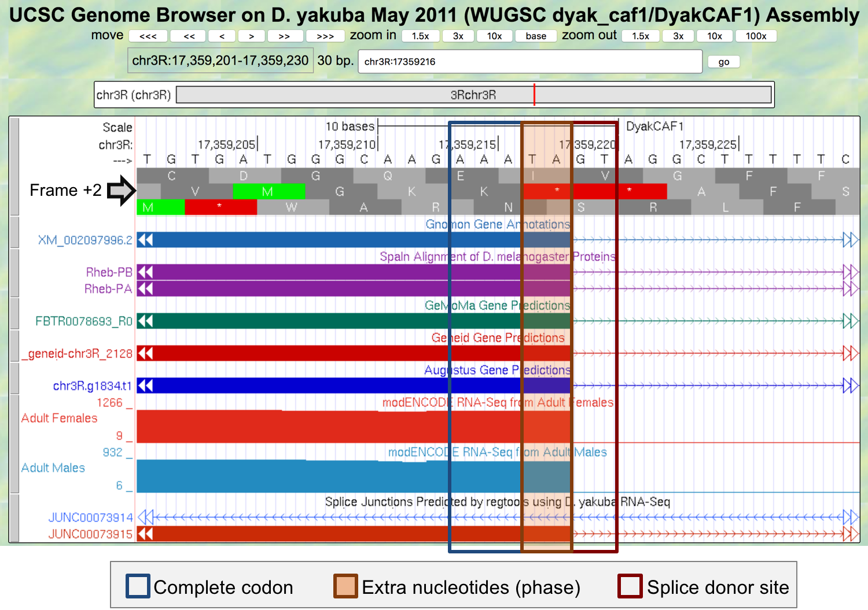
Figure 51 The potential splice donor site at 17,359,219-17,359,220 for CDS-3 is supported by the Spaln alignment of D. melanogaster proteins, the Gnomon, GeMoMa, Geneid, and Augustus gene predictions, as well as the RNA-Seq read coverage from adult females and males, and the splice junction prediction JUNC00073915. There are two nucleotides (TA at 17,359,217-17,359,218) between the last complete codon (AAA) and the potential splice donor site. Hence, this splice donor site is in phase 2 relative to frame +2.
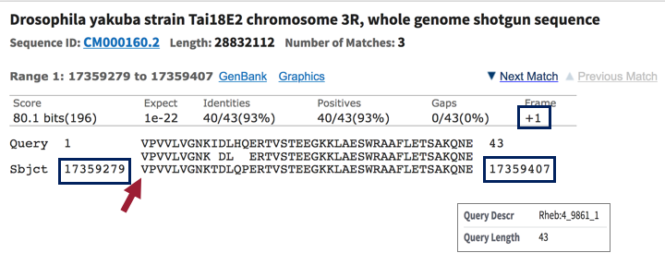
Figure 52 The best tblastn alignment between the Rheb CDS-4 (query) and the D. yakuba scaffold CM000160.2 (chr3R; subject) is located at 17,359,279-17,359,407 in frame +1.
- To examine the genomic region surrounding the start of the tblastn alignment to CDS-4 (Figure 52), enter “chr3R:17,359,279” into the “enter position or search terms” text box.
- Click the “go” button.
- Zoom out 3x and another 10x (Figure 53).

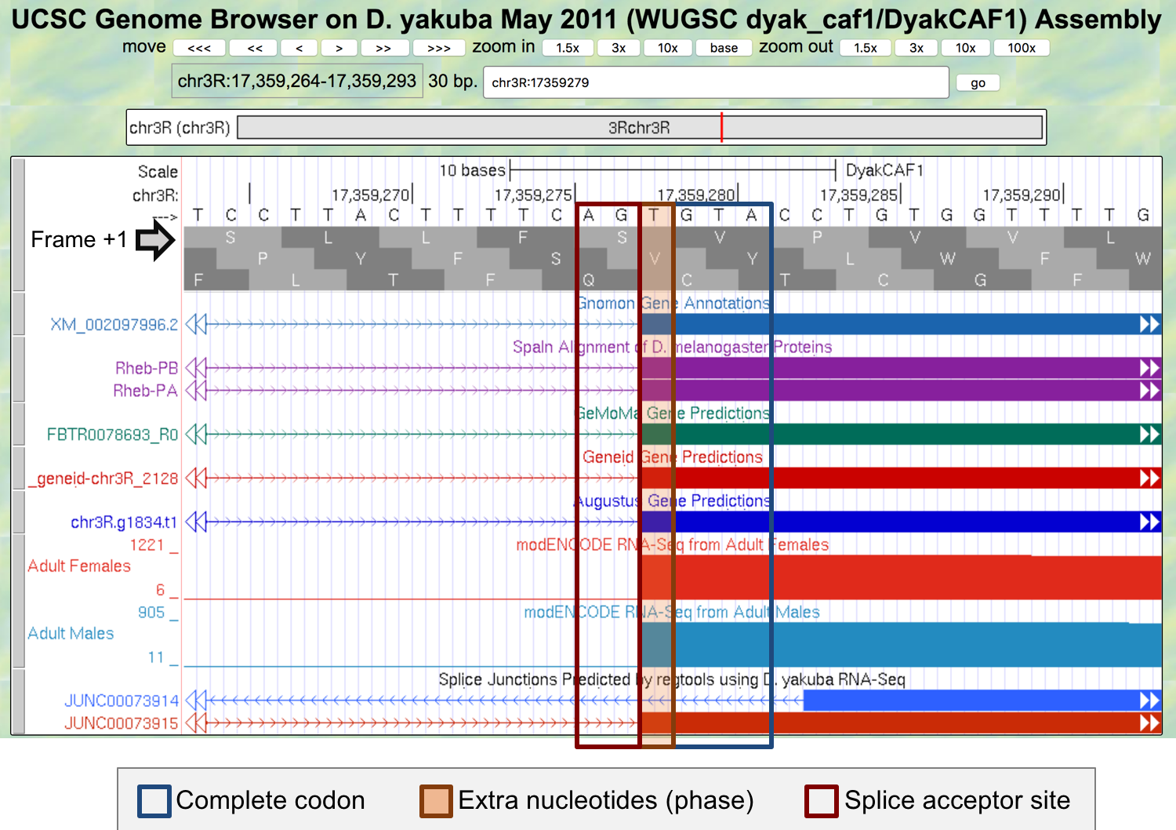
Figure 53 The potential splice acceptor site at 17,359,276-17,359,277 for CDS-4 is supported by the Spaln alignment of D. melanogaster proteins, the Gnomon, GeMoMa, Geneid, and Augustus gene predictions, as well as the RNA-Seq read coverage from adult females and males, and the splice junction prediction JUNC00073915. There is one nucleotide (T at 17,359,278) between the first complete codon (GTA) and the potential splice acceptor site. Hence, this splice acceptor site is in phase 1 relative to frame +1. This phase 1 splice acceptor site is compatible with the phase 2 splice donor site for CDS-3.

The genomic region also contains an additional splice junction prediction JUNC00073914. Since this feature is in blue, this junction is supported by 10–49 spliced RNA-Seq reads. By contrast, the splice junction prediction JUNC00073915 is in red, indicating that the splice junction is supported by more than 1,000 spliced RNA-Seq reads (Figure 53).

- Click on the “JUNC00073914” feature to learn more about this splice junction prediction.
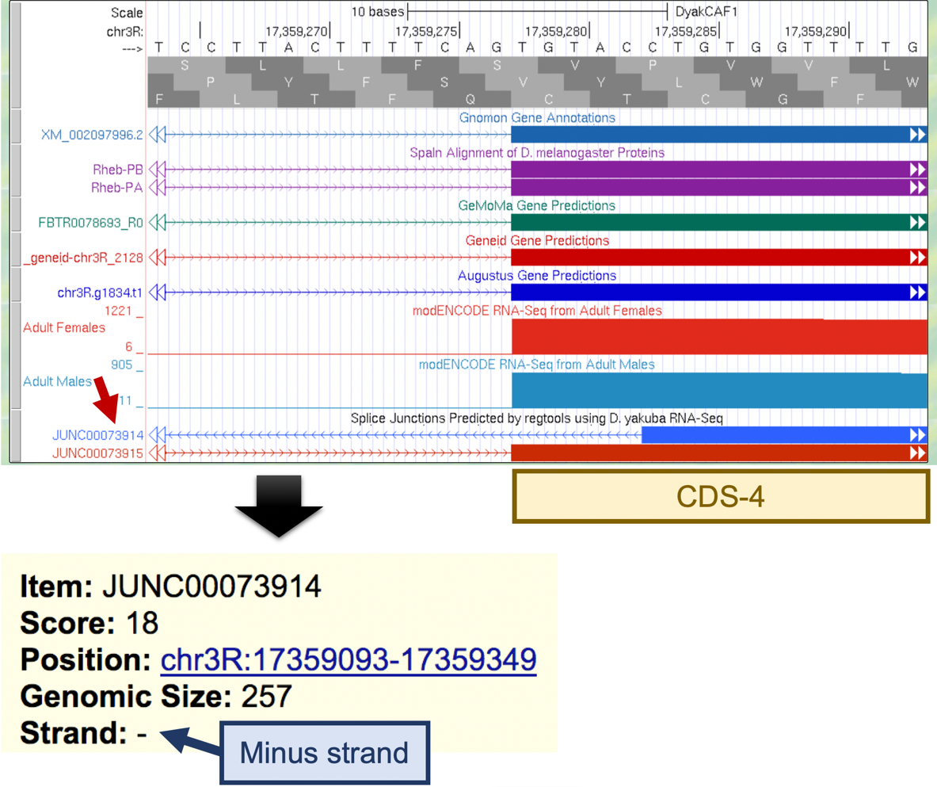
Figure 54 The splice junction prediction JUNC00073914 is supported by 18 spliced RNA-Seq reads. However, the splice junction is in the minus strand whereas the Rheb gene is on the plus strand relative to D. yakuba chr3R.

Because the Rheb ortholog is in the plus strand relative to D. yakuba chr3R and the splice junction JUNC00073914 is in the minus strand, this splice junction is unlikely to be an intron for the Rheb gene (Figure 54). This splice junction could be caused by RNA-Seq reads that have been misplaced, or it could have been derived from a non-coding RNA that overlaps with Rheb.

Based on the low score (18) of the JUNC00073914 splice junction and the lack of evidence for trans-splicing in the D. melanogaster Rheb gene, the splice acceptor site for CDS-4 is assigned to 17,359,276-17,359,277.

Part 6.7: Use splice junction predictions to verify the change in donor site sequence for the fourth intron

Go back to the web browser tab with the Gene Record Finder record for the D. melanogaster Rheb gene. The “Introns with Non-canonical Splice Sites” panel shows that the intron with the FlyBase ID “intron_Rheb:6_Rheb:7” has a GC splice donor site. The FlyBase ID for an intron begins with the prefix “intron_”, followed by the names of the two transcribed exons that flanked the intron. Hence, the FlyBase ID “intron_Rheb:6_Rheb:7” indicates that the splice donor site between the transcribed exons Rheb:6 and Rheb:7 has the non-canonical sequence GC (Figure 55).
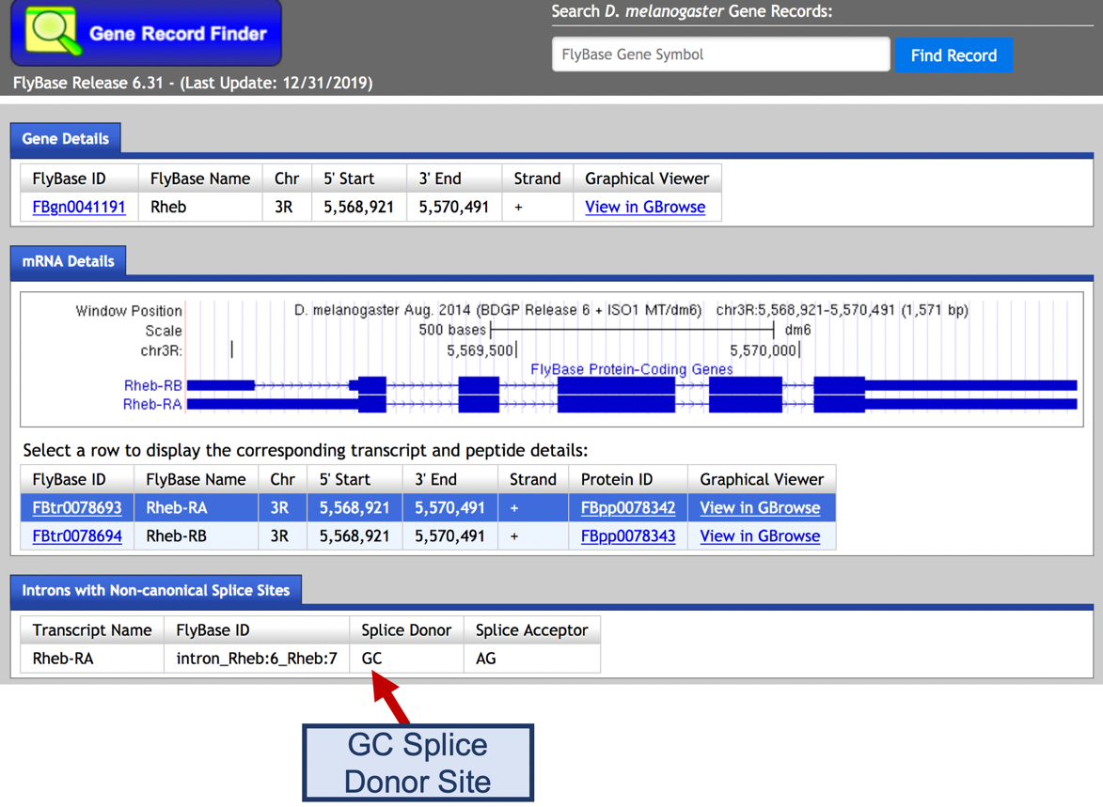
Figure 55 The “Introns with Non-canonical Splice Sites” panel of the Gene Record Finder shows that the intron between the transcribed exons Rheb:6 and Rheb:7 begins with a non-canonical GC splice donor site.
- To determine the IDs of the CDS’s that overlap with the transcribed exons Rheb:6 and Rheb:7, click on the Genome Browser image in the “mRNA Details” panel of the Gene Record Finder.
Comparison of the “FlyBase Transcribed Exons” and “FlyBase Coding Exons” tracks in the Genome Browser for D. melanogaster shows that CDS-4 (Rheb:4_9861_1) overlaps with the exon Rheb:6, and CDS-5 (Rheb:5_9861_0) overlaps with the exon Rheb:7.
- Zoom in to the end of CDS-4 to verify that it has a non-canonical GC donor site (Figure 56).
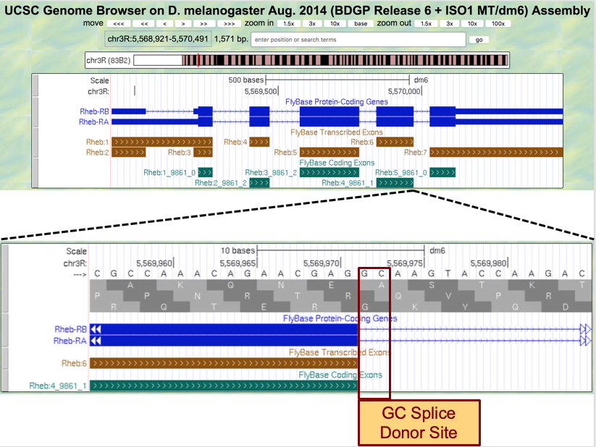
Figure 56 Examination of the region surrounding the end of CDS-4 in D. melanogaster shows that it has a non-canonical GC splice donor site.
Consequently, if the splice sites are conserved between D. melanogaster and D. yakuba, then the splice donor site for CDS-4 would also use a non-canonical GC donor site.

- Go back to the web browser tab with the GEP UCSC Genome Browser for D. yakuba.

The tblastn alignment for CDS-4 ends at 17,359,407 in frame +1 (Figure 57).

- To examine the genomic region surrounding the end of the tblastn alignment to CDS-4, enter “chr3R:17,359,407” into the “enter position or search terms” text box.
- Click the “go” button.
- Zoom out 3x and another 10x.

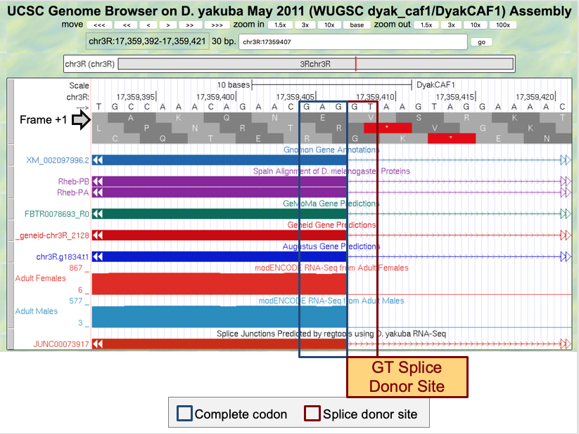

Figure 57 The potential GT splice donor site at 17,359,408-17,359,409 for CDS-4 is supported by the Spaln alignment of D. melanogaster proteins, the Gnomon, GeMoMa, Geneid, and Augustus gene predictions, as well as the RNA-Seq read coverage from adult females and males, and the splice junction prediction JUNC00073917. Hence, the available evidence indicates that the splice donor site for CDS-4 has a canonical GT donor site (instead of the non-canonical GC donor site as seen in D. melanogaster). There are no nucleotides between the last complete codon (GAG) and the potential splice donor site. Hence, this splice donor site is in phase 0 relative to frame +1.
The best tblastn alignment between the Rheb CDS-5 (query) and the D. yakuba scaffold CM000160.2 (chr3R; subject) is located at 17,359,470 – 17,359,559 in frame +3 (Figure 40).

- To examine the genomic region surrounding the start of the tblastn alignment to CDS-5, enter “chr3R:17,359,470” into the “enter position or search terms” text box.
- Click the “go” button.
- Zoom out 3x and another 10x (Figure 58).
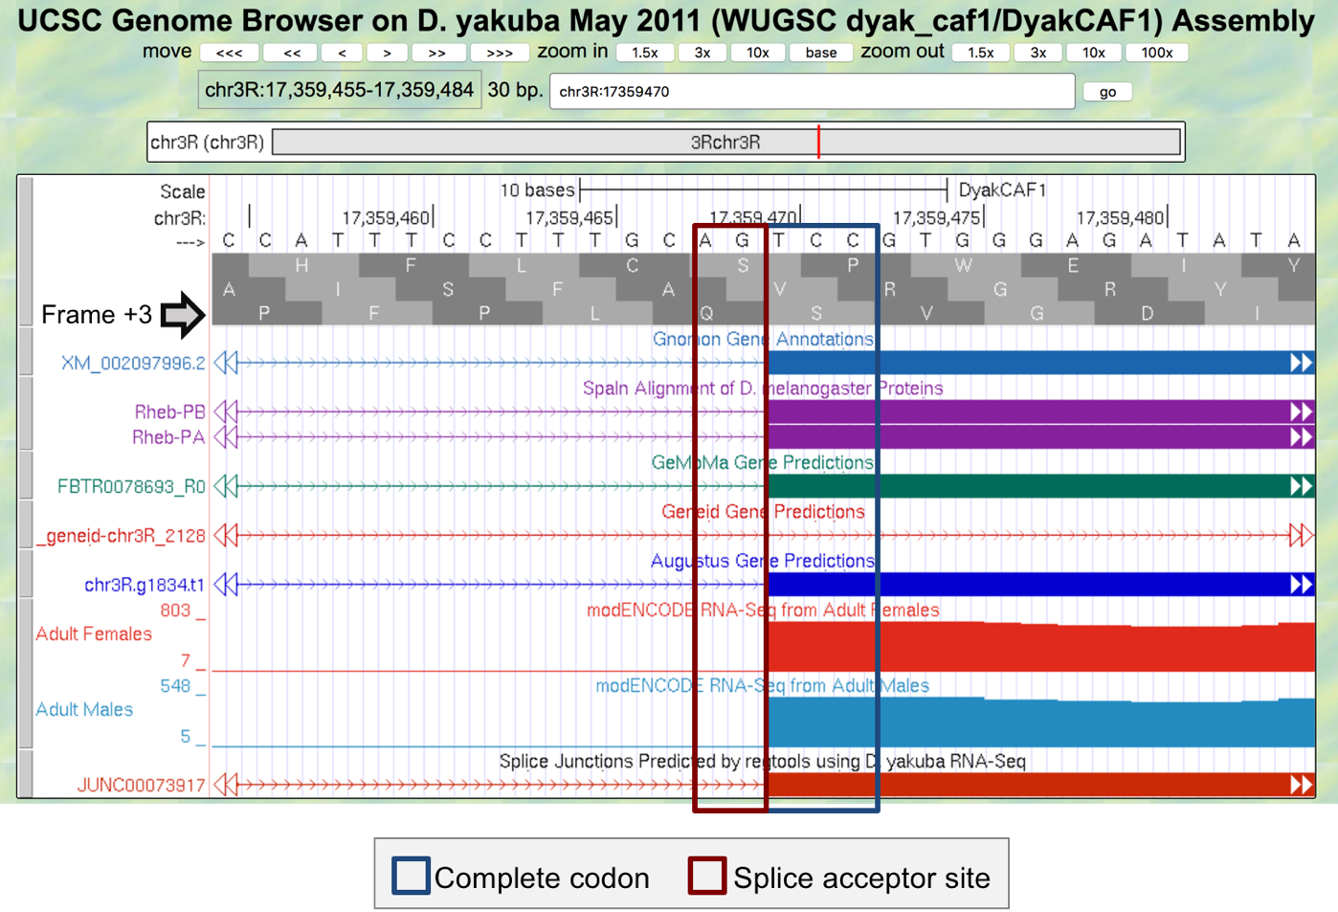
Figure 58 The potential splice acceptor site at 17,359,468-17,359,469 for CDS-5 is supported by the Spaln alignment of D. melanogaster proteins, the Gnomon, GeMoMa, and Augustus gene predictions, as well as the RNA-Seq read coverage from adult females and males, and the splice junction prediction JUNC00073917. The Geneid prediction mRNA_Geneid-chr3R_2128 is inconsistent with the potential splice acceptor site. However, per the previous analysis described in Part 6.2, this Geneid prediction might have combined two adjacent genes (Rheb and CRMP) into a single prediction. There are no nucleotides between the potential splice acceptor site and the first complete codon (TCC). Hence, this splice acceptor site is in phase 0 relative to frame +3. This phase 0 splice acceptor site is compatible with the phase 0 splice donor site for CDS-4.
Taken together, the analysis described above would produce the CDS coordinates for Rheb-PA in D. yakuba chr3R summarized below (Figure 59):

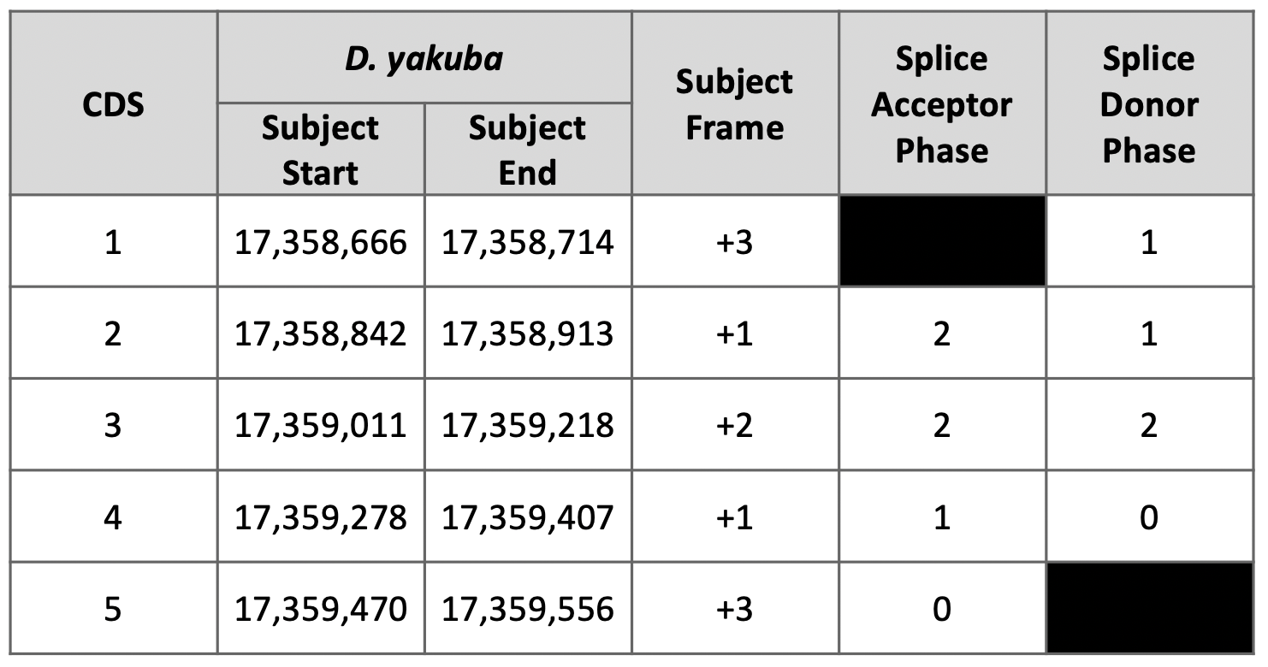
Figure 59 Summary of the five CDS’s in Rheb-PA. Stop codon is located at 17,359,557-17,359,559.

Part 7: Verify gene model

Our analysis of the CDS-by-CDS tblastn alignments and the evidence tracks on the Genome Browser allow us to precisely define the start and end positions of each of the five coding exons (CDS’s) of Rheb-PA. To verify that our proposed gene model satisfies the basic biological constraints (e.g., begins with a start codon, has compatible splice sites, ends with a stop codon), we will check our gene model coordinates using the Gene Model Checker.

- Navigate to Gene Model Checker for Whole Genome Assemblies (Figure 60).
- In the “Project Details” section:
- Species Name: select “D. yakuba”
- Genome Assembly: select “May 2011 (WUGSC dyak_caf1/DyakCAF1)”
- Scaffold Name: enter “chr3R”
- In the “Ortholog Details” section:
- Ortholog in D. melanogaster: enter “Rheb-PA”
- In the “Model Details” section:
- Errors in Consensus Sequence?: select “No”
- Coding Exon Coordinates: enter a comma-delimited list of coordinates for the five CDS’s “17358666-17358714, 17358842-17358913, 17359011-17359218, 17359278-17359407, 17359470-17359556”
- Annotated Untranslated Regions?: select “No”
- Orientation of Gene Relative to Query Sequence: select “Plus” since Rheb-PA is on the positive strand relative to chr3R scaffold
- Completeness of Gene Model Translation: select “Complete”
- Stop Codon Coordinates: click within the textbox and the coordinates will automatically populate
- Click the “Verify Gene Model” button to run the Gene Model Checker.
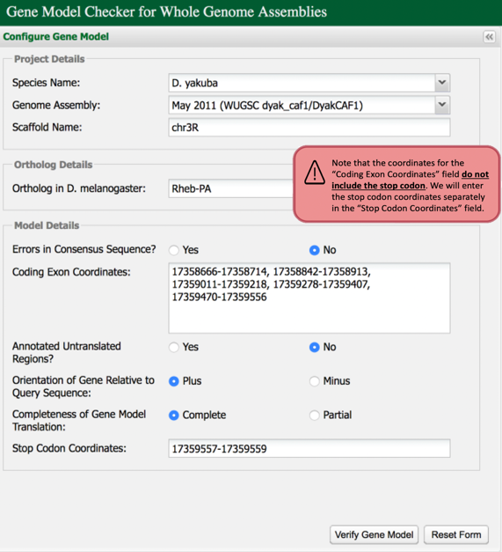
Figure 60 Verify the D. yakuba gene model for Rheb-PA using the Gene Model Checker.
Once the analysis is complete, the right panel of the Gene Model Checker contains the results. The “Checklist” tab enumerates the list of criteria that have been checked by the Gene Model Checker (Figure 61). For example, the Gene Model Checker verifies that our proposed gene model begins with a start codon and ends with a stop codon. It also verifies that the splice junctions contain the standard splice donor and acceptor sites. Some of the items on the checklist have been skipped because they do not apply to a complete gene (e.g., Acceptor for CDS-1).

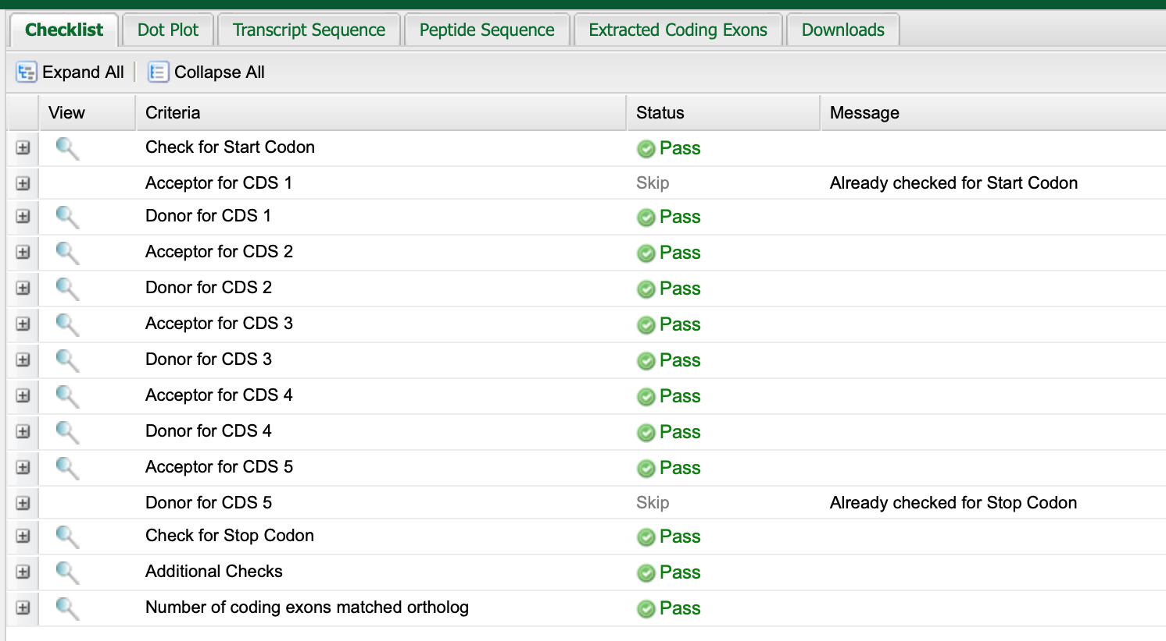
Figure 61 The Gene Model Checker checklist shows that the proposed gene model for Rheb-PA satisfies the biological constraints of most protein-coding genes (e.g., canonical start codon, stop codon, splice sites).

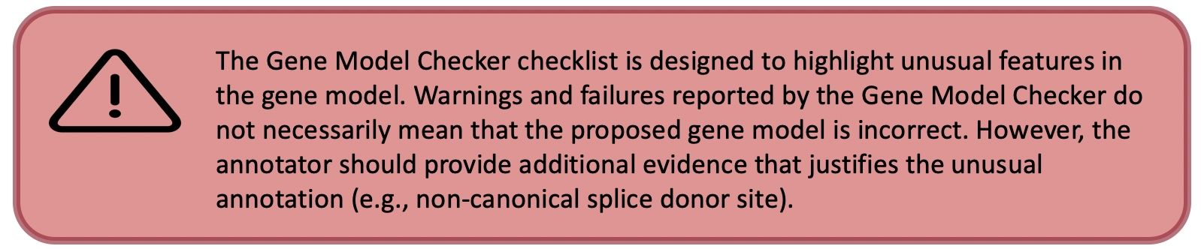
In addition to verifying the basic gene structure, the Gene Model Checker also compares the proposed gene model against the putative D. melanogaster ortholog using a protein alignment and a dot plot.

- Click on the “Dot Plot” tab to examine the dot plot between the D. melanogaster protein (x-axis) and the protein sequence for the submitted model in D. yakuba (y-axis).
The alternating color boxes in the dot plot correspond to the different CDS’s in the two sequences. Dots in the dot plot correspond to regions of similarity between the D. melanogaster protein and the submitted D. yakuba gene model. If the submitted sequence is identical to the D. melanogaster ortholog, then the dot plot will show a straight diagonal line with a slope of 1. Changes in the size of the submitted model compared to the D. melanogaster ortholog will alter the slope of this line.
In this case, the dot plot shows that the five CDS's of Rheb-PA in D. melanogaster and D. yakuba have similar lengths (compare the length shown on the x-axis to the length shown on the y-axis for each CDS). However, within a small region of CDS-4, the dot plot did not detect sequence similarity between the submitted model for D. yakuba and the D. melanogaster ortholog (Figure 62).
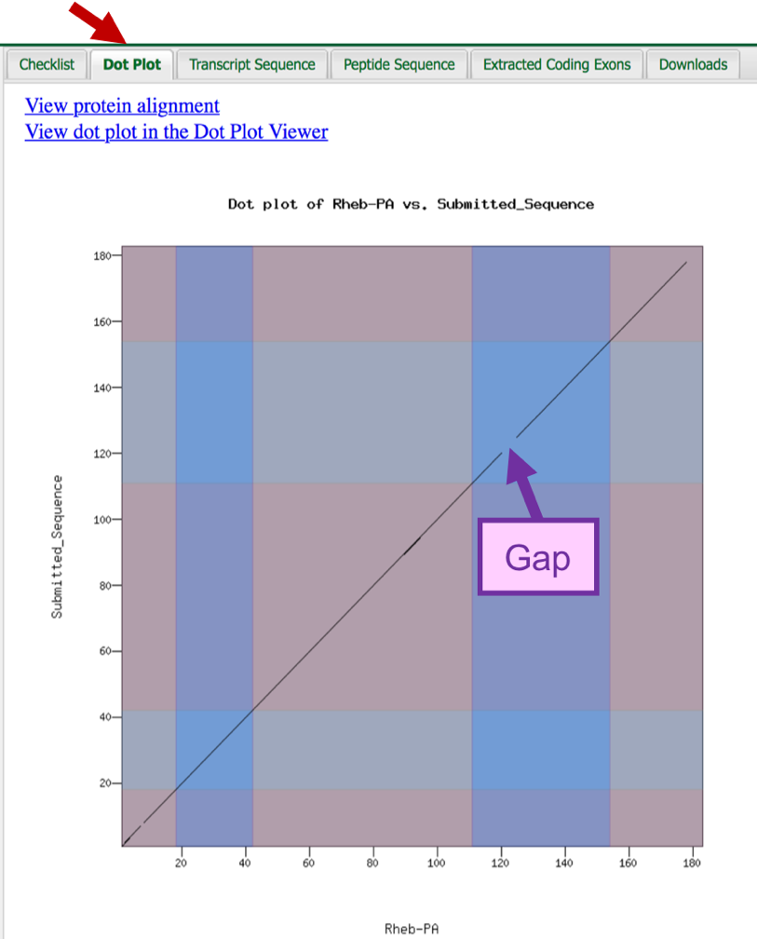
Figure 62 The dot plot comparing the D. melanogaster Rheb-PA (x-axis) with the submitted gene model in D. yakuba (y-axis) shows that the main differences between the two protein sequences are located in CDS-4 and CDS-5.

To further investigate the dot plot, we will examine the protein alignment between the two sequences (Figure 63).

- Click on the “View protein alignment” link above the dot plot.

The alignment shows the comparison of the D. melanogaster protein (Figure 63, top) against the conceptual translation for the submitted D. yakuba gene model (Figure 63, bottom). Similar to the dot plot, the alternating colors correspond to the different CDS’s.

The protein alignment shows that the five CDS's have high levels of sequence similarity between the D. melanogaster ortholog and the D. yakuba gene model. The symbols in the match line denote the level of similarity (“*” indicates conserved amino acids, “:” denotes amino acids with highly similar chemical properties). Hence, the tiny gap in the dot plot within CDS-1 can be attributed to similar, but not identical, amino acids near its center.

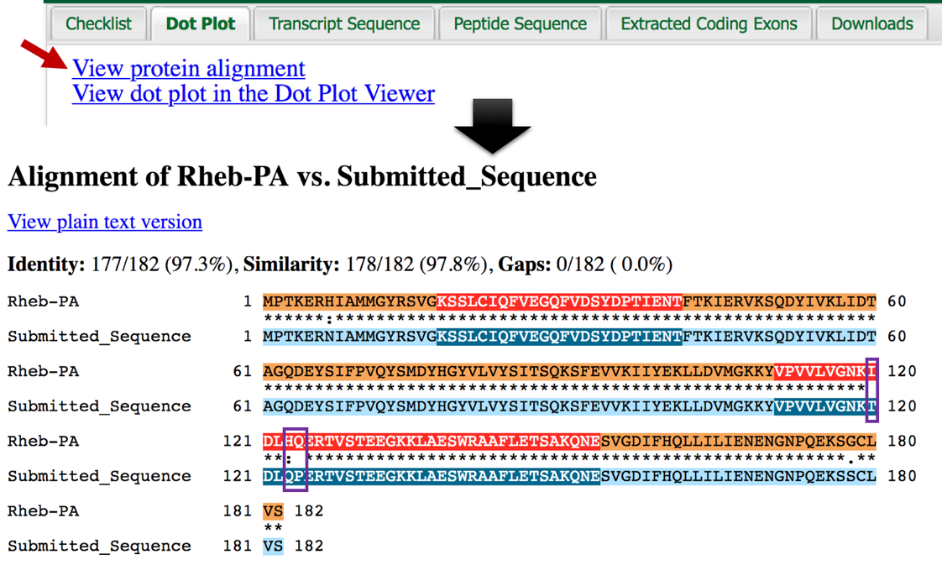
Figure 63 The protein alignment between D. melanogaster Rheb-PA (top) versus the submitted gene model in D. yakuba (bottom) shows that the gap within CDS-4 in the dot plot can be attributed to three amino acid residues that differ between these two species (purple boxes).
The protein alignment between the D. melanogaster Rheb-PA and the submitted gene model in D. yakuba shows that that the gap within CDS-4 in the dot plot can be attributed to differences in three amino acid residues. We need to verify the placement of CDS-4.

- Click on the “Checklist” tab.
- Click on the magnifying glass icon next to the “Acceptor for CDS 4” entry (Figure 64).
  - Note: A new window containing the GEP UCSC Genome Browser will appear with our submitted gene model shown in the red “Custom Gene Model” track.
- Zoom out 3x and another 1.5x so that we can examine the genomic region surrounding CDS-4 of Rheb-PA in frame +1.

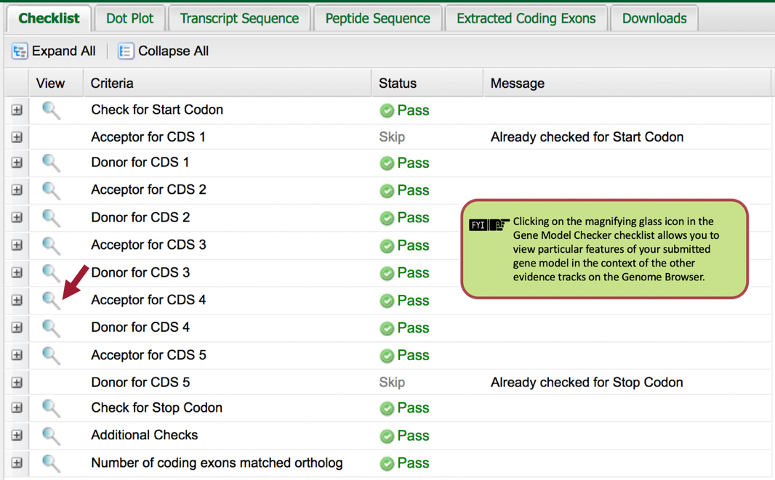
Figure 64 To verify the placement of CDS-4, click the magnifying glass icon next to the “Acceptor for CDS 4” entry.
The placement of CDS-4 in the Custom Gene Model for Rheb-PA is in congruence with the Spaln alignment of D. melanogaster proteins, the Gnomon, GeMoMa, Geneid, and Augustus gene predictions, as well as the RNA-Seq read coverage from adult females and males. The purple arrows in Figure 65 demarcate the three amino acid residues that differ between CDS-4 in D. yakuba and D. melanogaster.

To verify our previous observations, we can view the submitted gene model within the context of the other evidence tracks in the GEP UCSC Genome Browser.

- Zoom out until you can see our entire submitted gene model for Rheb-PA in D. yakuba.

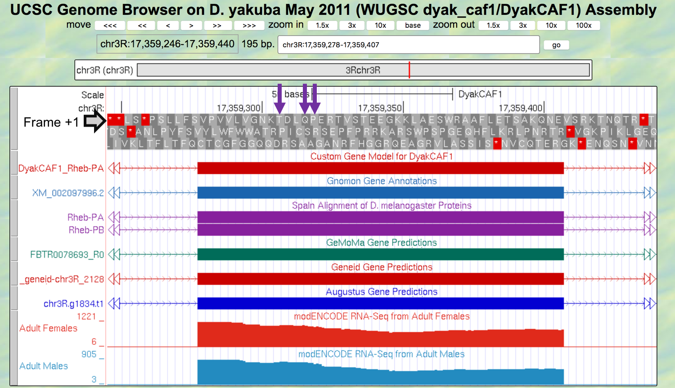
Figure 65 The placement of CDS-4 in the Custom Gene Model for Rheb-PA is in congruence with the Spaln alignment of D. melanogaster proteins, the Gnomon, GeMoMa, Geneid, and Augustus gene predictions, as well as the RNA-Seq read coverage from adult females and males. The purple arrows demarcate the three amino acid residues that differ between CDS-4 in D. yakuba and D. melanogaster.

Part 7.1 Download the files required for project submission

In addition to the GEP Annotation Report form, you must prepare three additional data files to submit a project to the GEP: a General Feature Format (GFF) file, a transcript sequence (fasta) file, and a peptide sequence (pep) file. The Gene Model Checker automatically creates these three files for a specific isoform (e.g., Rheb-PA) when you verify a gene model. We can download these files by selecting the “Downloads” tab (Figure 66) and then right-click (control click on macOS) on each of the links and select “Save Links As…” or “Download Linked File As …” to save each file onto your computer.
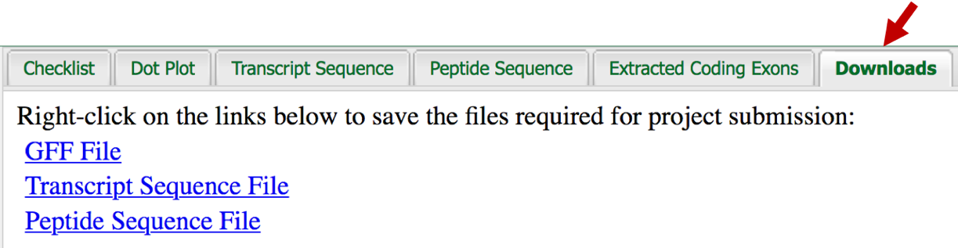
Figure 66 In preparation for project submission, click on the “Downloads” tab and save the GFF, transcript, and peptide sequence files for the gene model onto your computer.
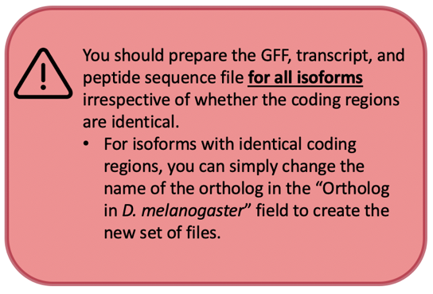

The GFF, transcript, and peptide sequence files for all the genes and isoforms in your project should be combined into a single file prior to project submission. You can use the Annotation Files Merger for Whole Genome Assemblies to create the combined GFF, peptide, and transcript sequence files for your entire project.

Appendix

A. Investigate the other tblastn alignments to D. yakuba chr3R
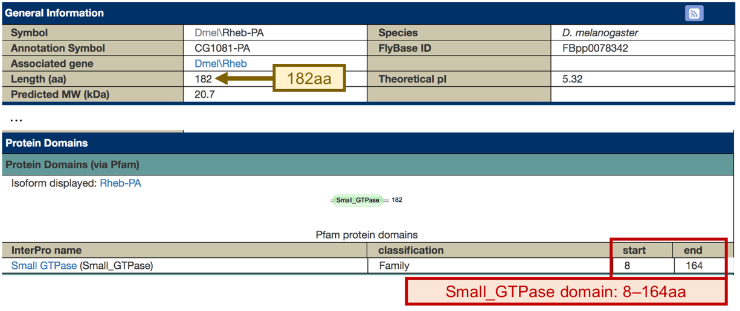
The “Protein Domains” section of the FlyBase Polypeptide Report for Rheb-PA (FBpp0078342) shows a conserved Small_GTPase domain at residues 8-164 aa of the protein.

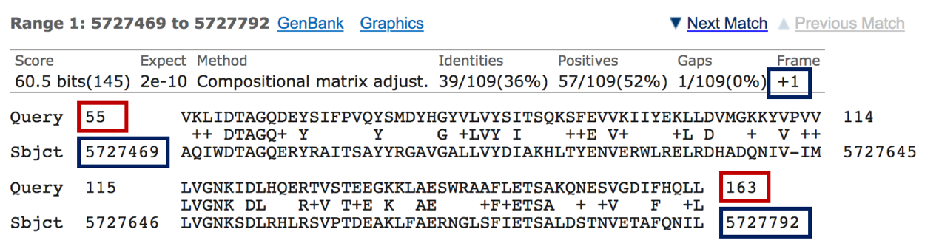
Examination of the query coordinates of the additional tblastn alignments to chr3R shows that they overlap with the Small_GTPase conserved domain. For example, the region at 5,727,469-5,727,792 aligned with amino acid residues 55-163 of the Rheb-PA protein when it is translated on the positive strand in the first reading frame (+1).

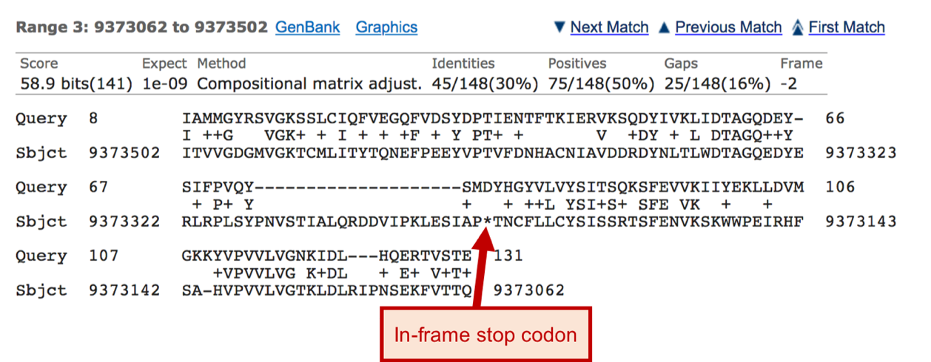
Examination of the tblastn alignment blocks also show three cases where the alignments contain in-frame stop codons (i.e., at 9,373,502-9,373,062, 9,658,240-9,658,575, and 26,681,803-26,681,411). The in-frame stop codons can likely be attributed to homologous overextension of the alignments into the introns.

